**MVC (MODEL VIEW CONTROLLER):**

* Model is responsible for Data.
* View is responsible for UI.
* Controller is responsible for the flow of application by accepting user input.
* MVC is an architectural pattern of application.
* MVC is not a programming language and MVC not a framework, it is a design pattern.
* When we design an application first we create the architecture of that application an MVC plays an important role in architecture of that particular application.

**Advantages:**

* Allows work on individual pieces of the system in isolation.
* Reusability
* Maintainability
* Extensibility
* Better understand the system

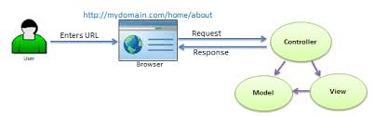

**Middleware:**

* Middleware is piece of code which is used in HTTP pipeline.
* Each piece of middleware is an object, and each has a very specific, focused and limited role.
* This HTTP pipeline is configures in Configure Method in Stratup.cs file.
* All request to the application goes through the HTTP pipeline.
* We can use multiple middleware.
* Middleware has access to all request and response.
* Await next () method written in the middleware for run to the next middleware.

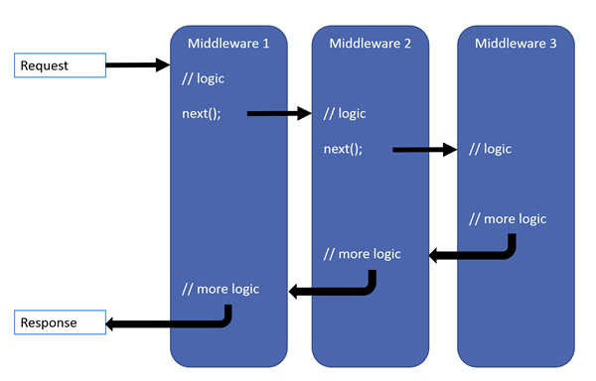

**Run ():** Run method never contains Next method.

**Syntax:** Run (async context => // only one parameter HttpContext

{

..............

});

**Use ():** Use method contains Next method.

**Syntax:** Use (async (context, next) => // Two parameters HttpContext,RequestDelegates

{

...............

});

**Routing:**

Routing is a mechanism in which it will inspect (check) the incoming requests (i.e. URLs) then the mapped that request to the controllers and their action methods.

REQUEST > ROUTING > CONTROLLER > MODEL > VIEW > RESPONSE

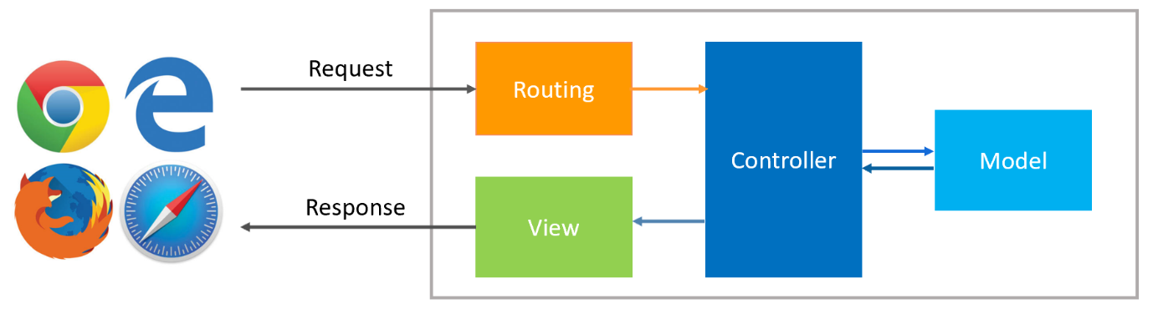

Routing = URL + HTTP METHOD

**HTTP METHOD:**

* + - * + GET : Get the Data from DB
        + POST : Upload the Data in DB
        + PUT : Update the data in DB
        + DELETE : Delete the Data from DB

**Types:**

1. Convention Based Routing (Use for normal Web application)
2. Attribute – Based Routing (Use for normal Web application with API)

**Convention Based Routing:**

* The route is determined based on conventions defined in the route templates which will map the Incoming requests (i.e. URLs) to controller and their action methods.
* The Convention Based Routing are defined with in Startup.cs class file.
* In ASP.NET Core MVC application, it is the controller action method that is going to handle the incoming Requests i.e. URLs.
* For example, if we issue a request to the "/Home/Index" URL, then it is the Index action method of Home Controller class which is going to handle the request.

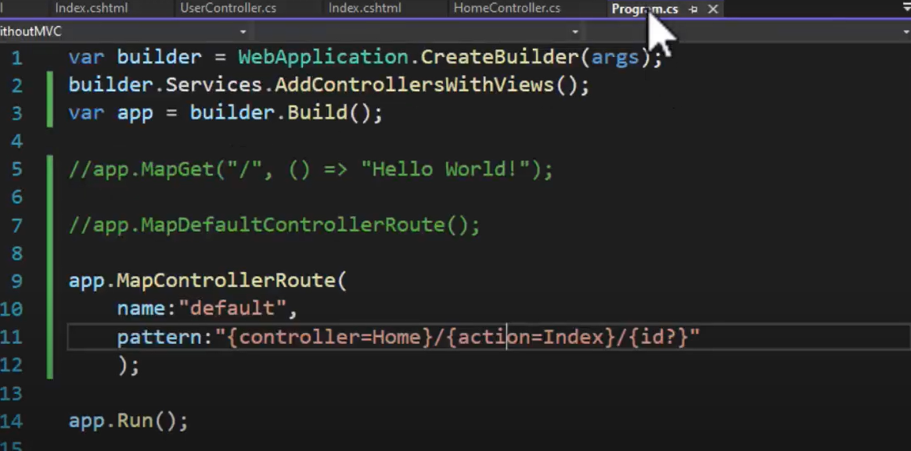

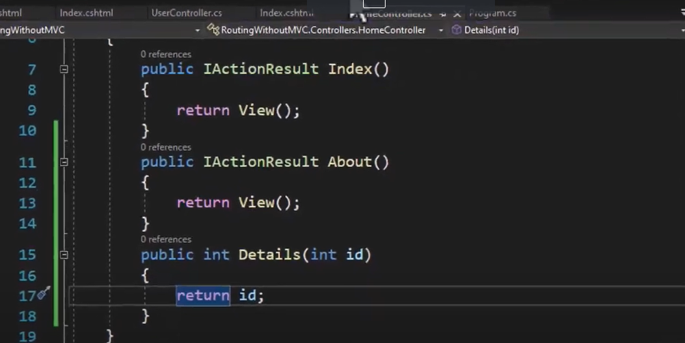

* Similarly, if you issue a request to the "/Home/Details/2" URL, then it is the Details action method of the Home Controller class which is going to process that request.
* Here the parameter value 2 is automatically mapped to the id parameter of the Details action method.

**Attribute – Based Routing:**

* **[Route]** attribute is used to define the routes.

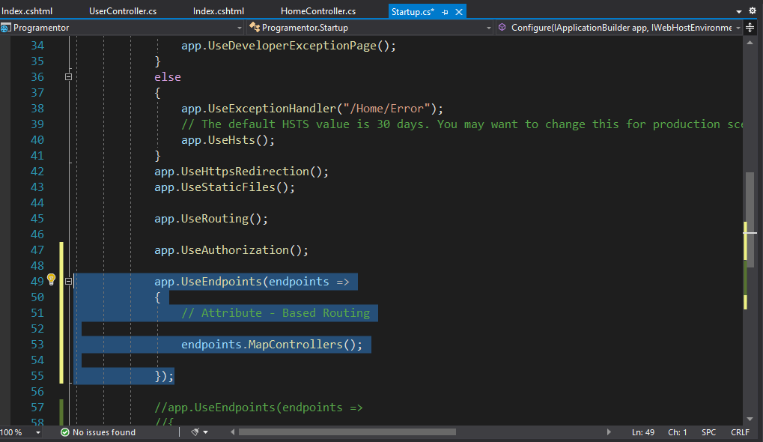

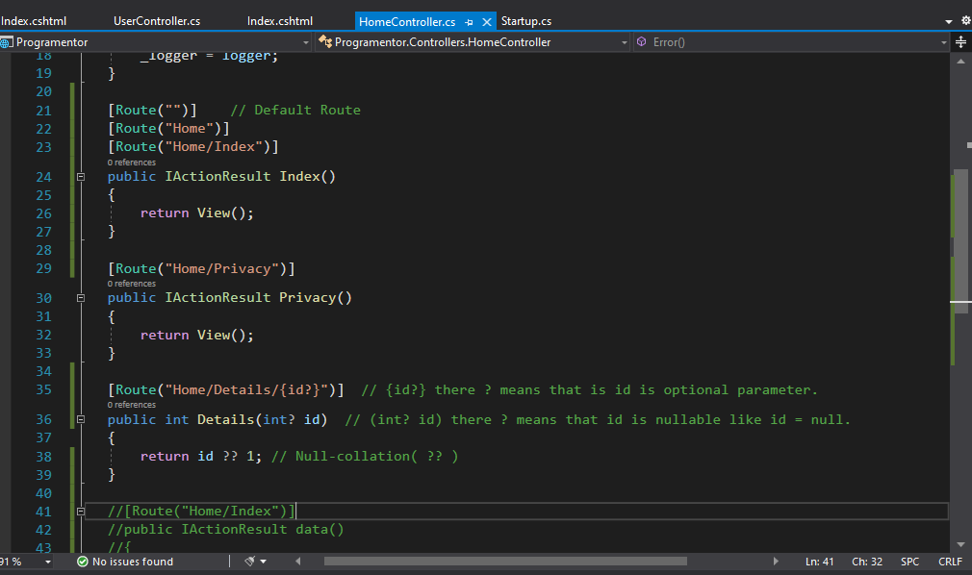

* The route is determined based on the attribute which are configured either at the controller level or at the action method level.

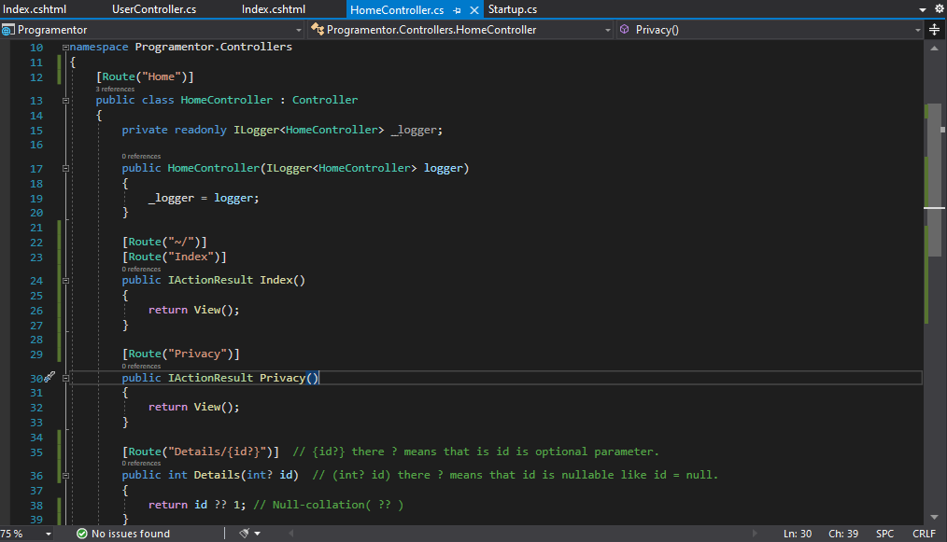

* **We can use both Conventional Based Routing and Attribute – Based Routing in a single application.**

**Ex: aisa route jiske liye attribute rouning nhi h to uski jgh pr conventional routing check kiya jayega.**

* Changing the **controller** or **action name** does not require the route template to changed.
* Ye jo **ROUTE** action method ke upr define krte h vo sirf is **ROUTE** pr focus krta h , wo action method or controller ke naam pr focus nhi krta.

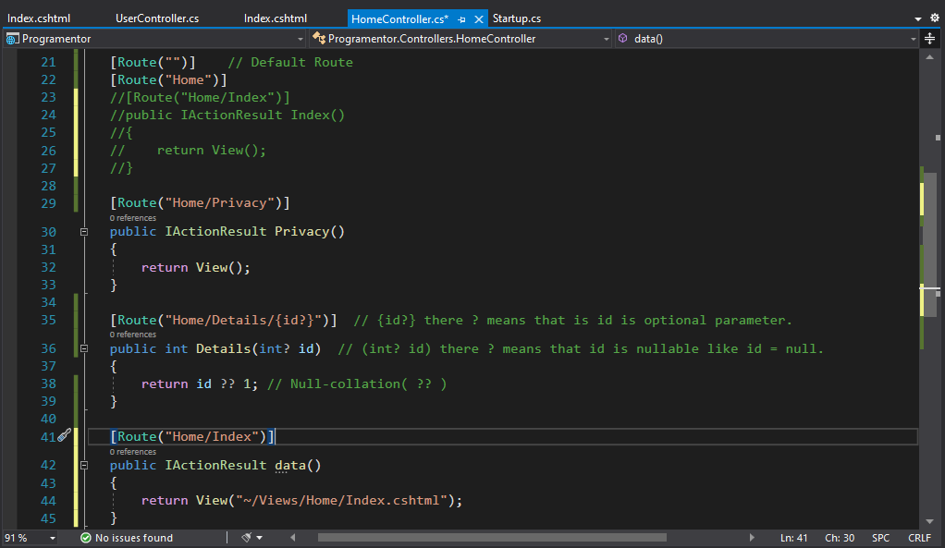

* Token for controllers is **[controller]**
* Token for action method is **[action]**

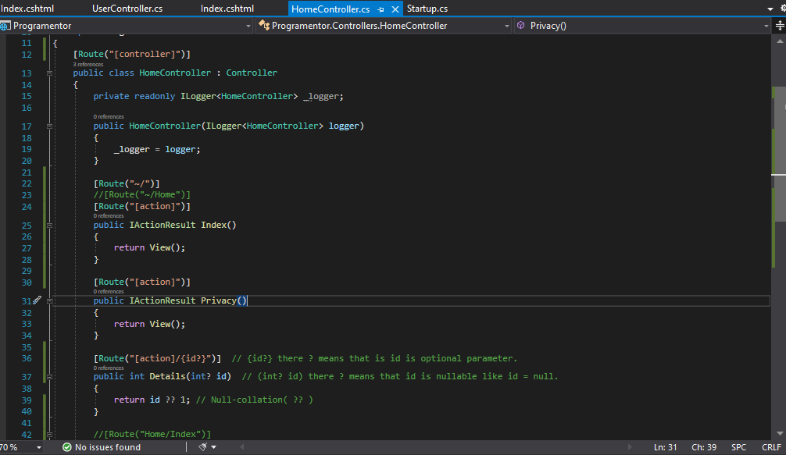

* We can use both tokens together **[controller] / [action]**

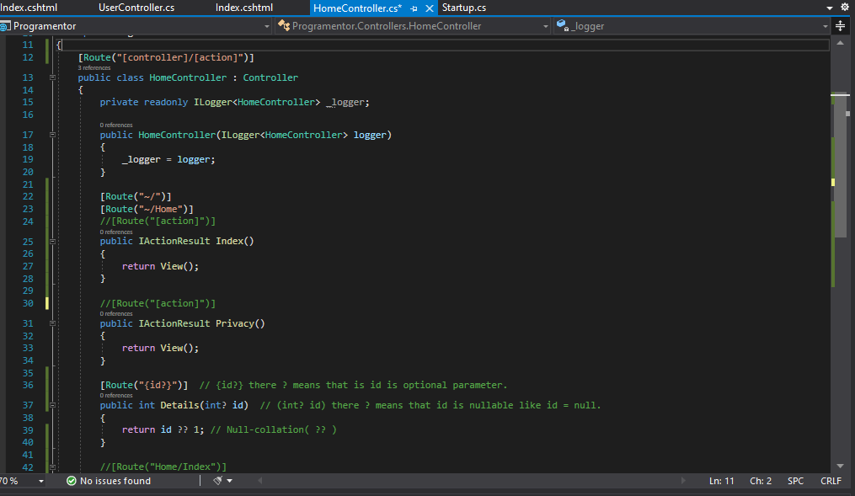

**EndPoint:**

* An Endpoint is something that can be: Selected, by matching the URL and HTTP method.
* The **MapGet** method is used to define an endpoint.
* Executed, by running the delegate.

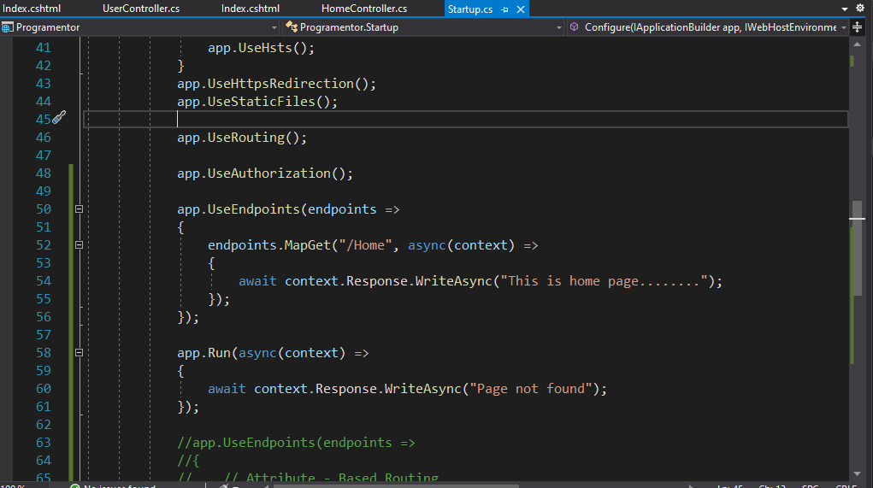

**Controllers:**

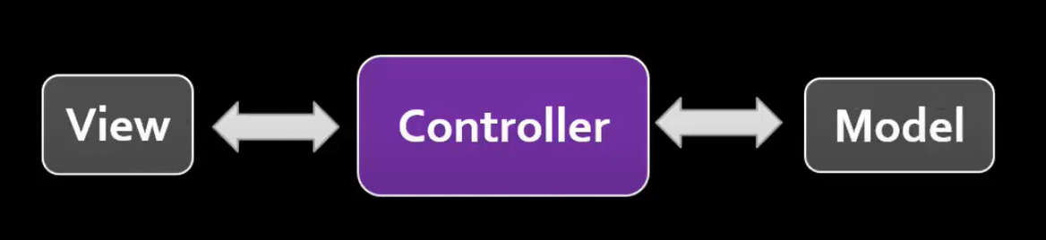

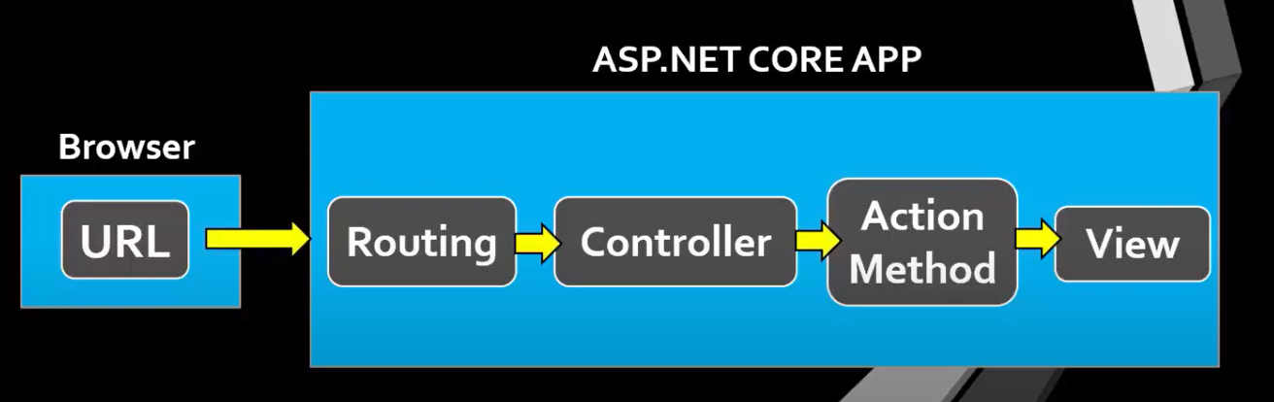

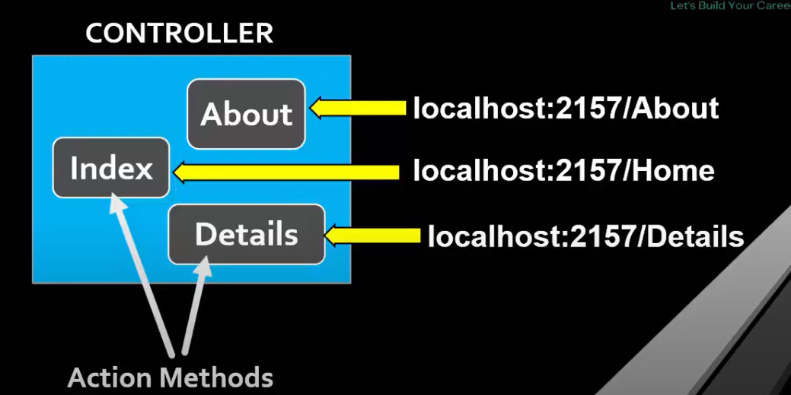

* Controller manages the flow of the application by accepting user input.
* A controller is used to define and group set of actions.
* Is responsible for intercepting incoming requests and executing the appropriate application code.
* Controller is a Backbone of MVC.
* When a request comes on the controller it actually hits an action method.
* A controller is a .cs file which has some method called action method.
* It may returns only view, only data or both of them depends on action method.
* Controllers are basically C# classes that inherit from Inherit from **Microsoft.AspNetCore.Mvc.Controller**
* It is recommended that class name of a controller ends with suffix ‘Controller’.
* Are located in the route - level ‘Controllers’ folder.
* Handle any exception that the requested method throws.

**Action Method:**

* A controller class can contains one or more action methods, also known as controller actions.
* Actions are the methods in controller class which are responsible for returning the **view** or **Json** data.
* Action methods are public methods in Controller classes.
* Action methods are responsible for processing the requests that are sent to the controller.
* Action Method can return multiple types data.
* By Default, it generates a response in the of **lActionResult** interface or **ActionResult** Abstract Class
* Rules that you need to consider while creating an action method are as follows:
* They must be declared as public.
* Action method must be public. It cannot be private or protected.
* They cannot be declared as static.
* All the public methods inside a controller which respond to the URL are known as Action Methods.
* In an ASP.NET MVC application, you can create multiple action methods in a controller.
* You can invoke an action method by specifying a URL in the Web browser containing the name of the controller and the action method to invoke.

**lActionResult:**

* The **lActionResult** return type is appropriate when multiple ActionResult return types are possible in an action.
* ActionResult and ActionResult work as a container for other action results.
* In that lActionResult is an interface and ActionResult is an abstract class that other action results inherit from.

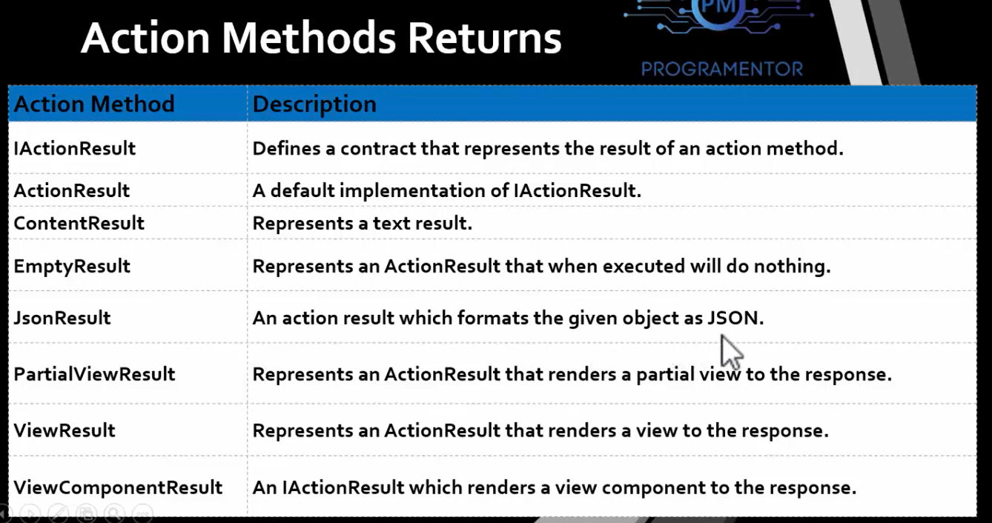

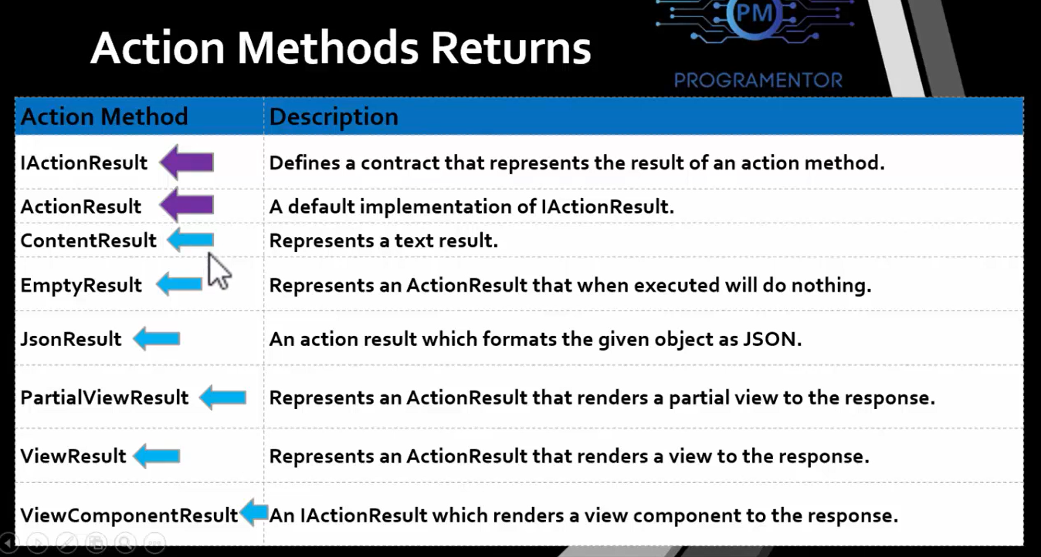

**ContentResult:**

* ContentResult represents a text result.

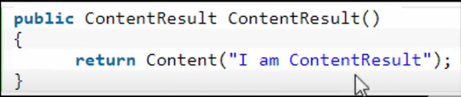

**JsonResult:**

* JsonResult formats the given object as JSON. JsonResult is use to return JSON-formatted data.

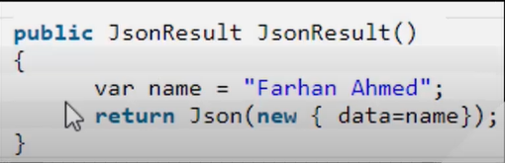

**PartialViewResult:**

* PartialViewResult represents an ActionResult that renders a partial view to the response. PartialViews are essential when it comes to loading a part of page through AJAX, they return raw rendered HTML.

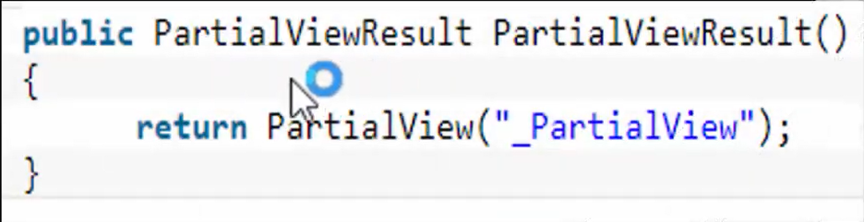

**ViewResult:**

* ViewResult represents an ActionResult that renders a view to the response. It is used to render a view to response, we use it when we want to render a simple .chtml view.

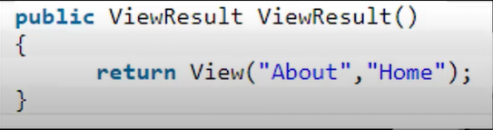

**EmptyResult:**

* Empty Result represents an ActionResult that when executed will do nothing. We can use it when we want to return empty result.

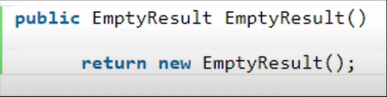

**View:**

* A View provides the User Interface (UI) of the application to the user.
* A View is used to display content of an application and also to accept user inputs.
* View uses model data to create this UI.
* View contains both HTML markup and C# that runs on the Web server.
* View has a file extension .cshtml.

**Razor:**

* Razor is a syntax, based on the ASP.NET CORE Framework that allows creating views.
* Razor is used to simplify the process of creating views.
* Razor is simple and easy to understand for users who are familiar with the C#.NET programming languages.

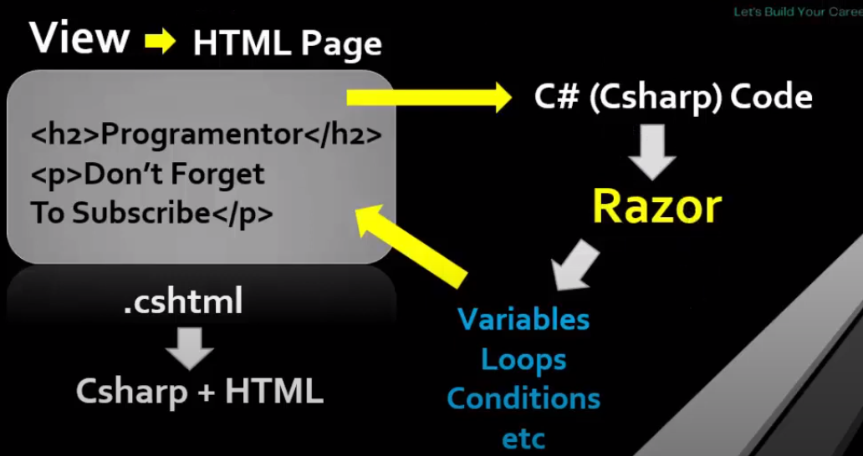

* **While creating a Razor view, you should consider following rules:**
* Start inline expressions with **@**

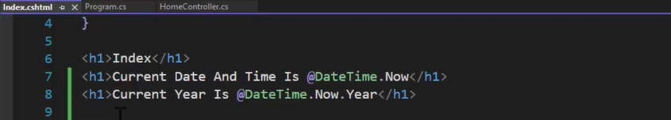

* Enclose code blocks between **@{ and }**
* Variables are declared with the **var** keyword
* Enclose strings in **quotation marks**
* End a Razor code statement with **semicolon (;)**

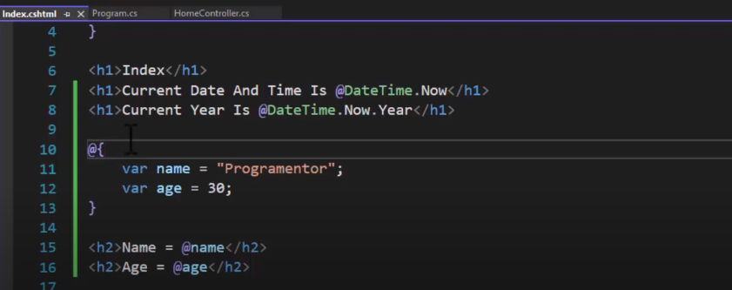

* With If Else

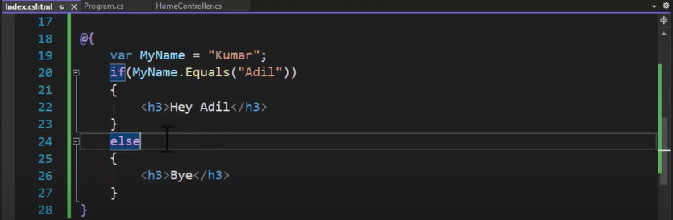

* With for loop

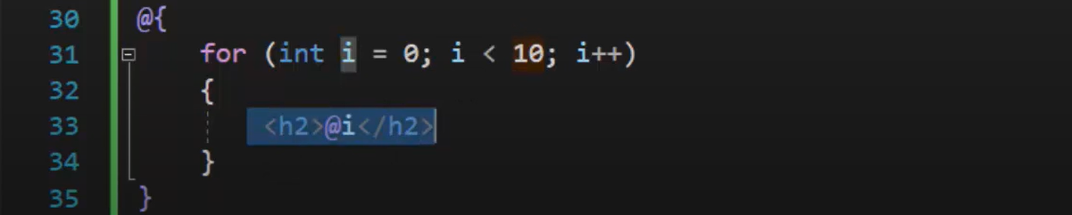

* With for each loop

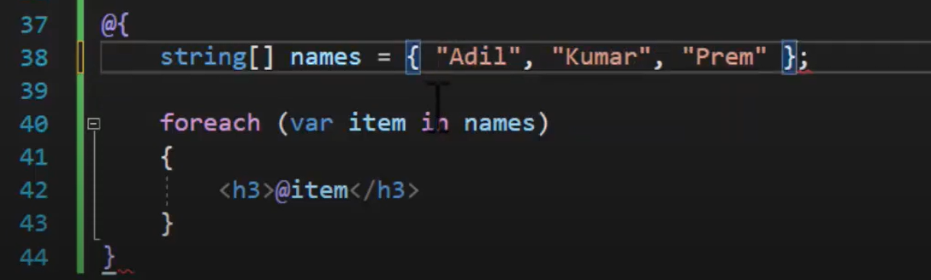

* Use the **cshtml** extension to store a Razor view file that uses **C#. Net** as the programing language.
* Use the .**vbhtml** extension to store a Razor view file that uses **Vb.Net** as the programing language

**Razor Engine:**

* The MVC Framework uses a view engine to convert the code of a view into HTML markup that a browser can understand.
* Razor engine is used as the default view engine by the MVC Framework.
* Compiles a view of your application when the view is requested for the first time.
* Delivers the compiled View for subsequent requests until you make changes to the view.
* Does not introduce a new set of programming language, but provides template markup syntax to segregate HTML markup and programming code in a view.
* First requires identifying the **server-side code** from the **markup code** to interpret the server- side code embedded inside a view file.
* Uses the **@ symbol**, to separate the server-side code from the markup code.

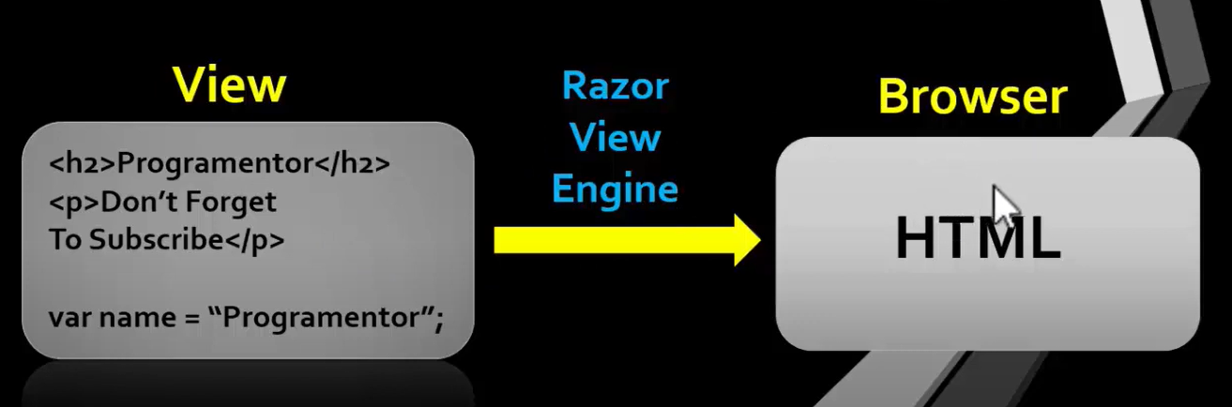

**Layout View (Master Page):**

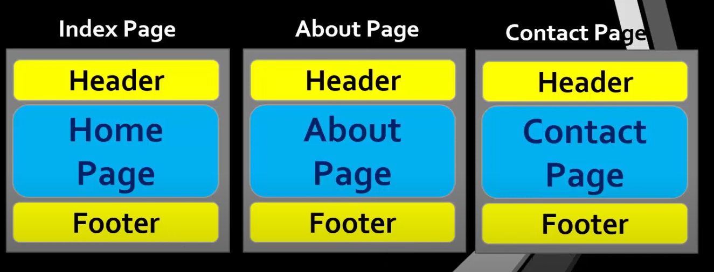

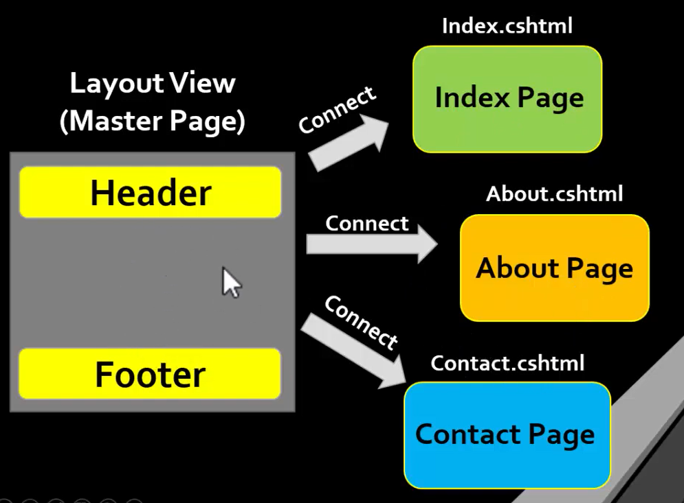

* Layout View provides **Consistent look** for all the views in a web application.
* Layout View is as same as Asp.net Web forms **MASTER PAGE**.
* Extension of Layout View is **.cshtml**
* Default name of Layout View is **_Layout.cshtml**.
* Layout View files is usually located in **Views/Shared**.

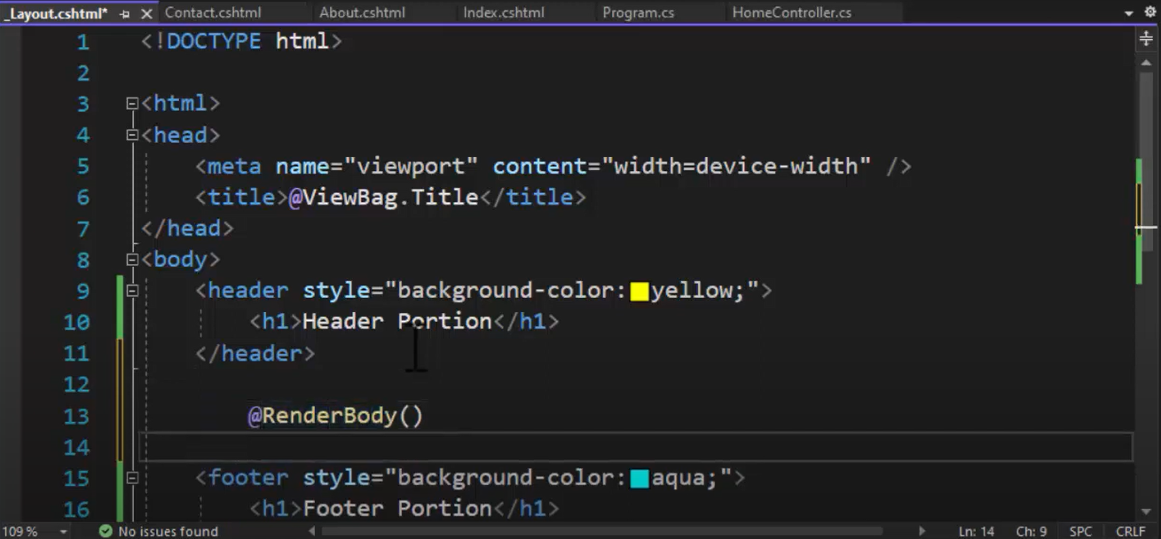

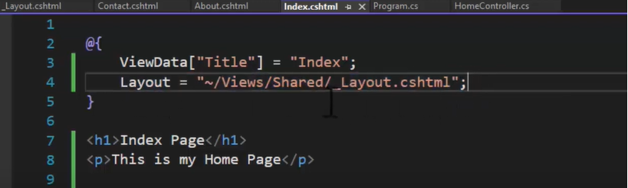

* An Application can have **multiple Layout Views**.
* **Layout property** is used to connect layout View with a view.

**ViewStart:**

* **Why do we need _ViewStart.cshtml file in ASP.NET Core MVC Application?**
* As of now, we have used the **Layout** Property to associate a view with a **layout view** as shown below.
* Layout = "~/Views/Shared/_Layout.cshtml";
* Suppose, we have **100 views** in our application and all the **100 views** want to Use the **same layout file**.
* Then we need to set the **Layout** Property in all the **100 views**.
* This violates the **DRY (Don't Repeat Yourself)** Principle and has the following disadvantages.
  + Redundant Code
  + Maintenance Overhead
* Commonly **_ViewStart.cshtml** file is located in **Views** Folder.

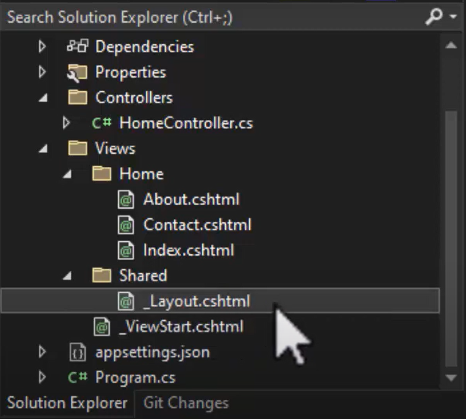

* If we have Multiple Layout Views then how we can use multiple layout views with View Start File.

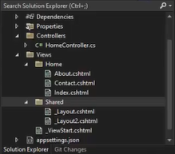

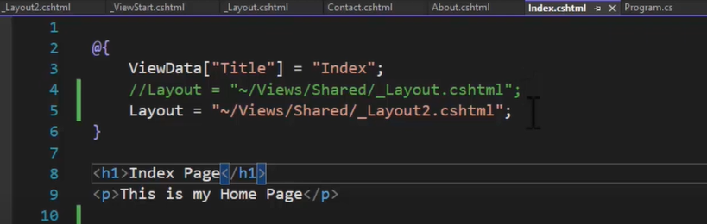

* If we don't want a layout view in a particular view.

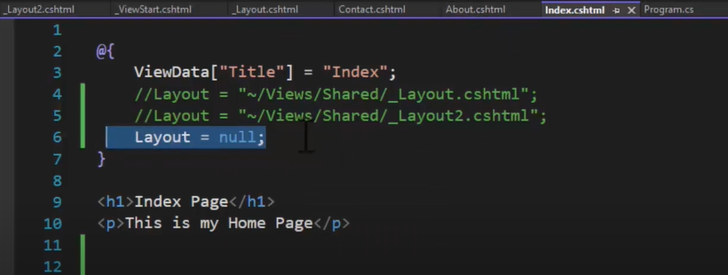

* We can select a layout conditionally in ViewStart file.

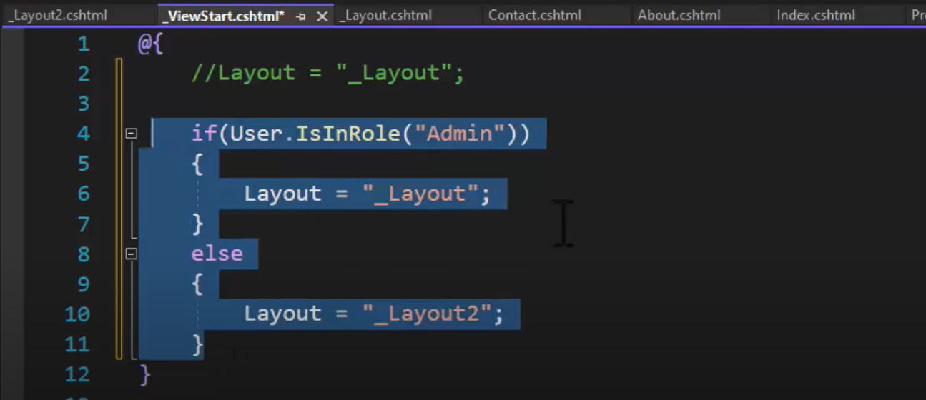

**Passing Data From Controller To View** **In ASP.NET Core 6:**

* In an ASP.NET CORE MVC application, a controller typically performs the business logic of the application and needs to return the result to the user through a view.
* You can use the following objects to pass data between controller and view:

1. ViewData
2. ViewBag
3. TempData
4. Strongly Typed Views

**ViewData:**

* It Passes data from a **controller to a view**.
* Is a dictionary of objects that is derived from the **ViewDataDictionary** class.
* **The general syntax of ViewData is as follows:**
* ViewData["Key"] = Value;
* **Key:** Is a String value to identify the object present in ViewData.
* **Value:** Is the object present in ViewData. This object may be a String, object, list, array or a different type, such as int, char, float, double DateTime etc.

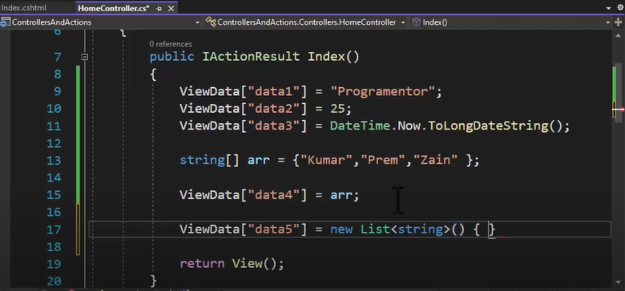

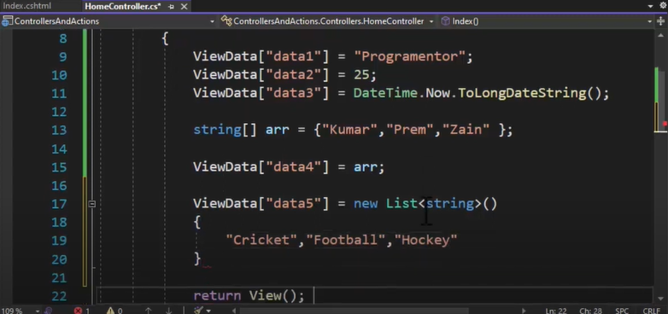

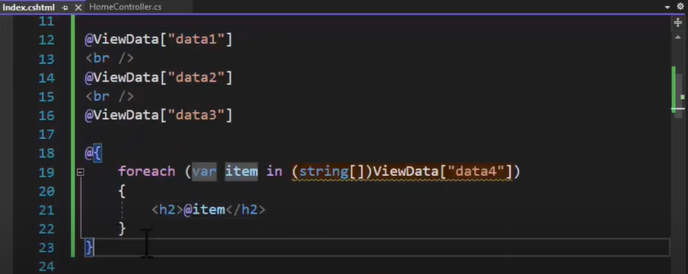

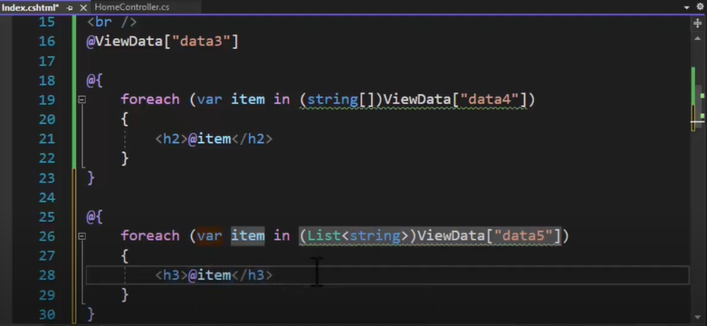

* **Some of the characteristics of ViewData are as follows:**
* The **life of a ViewData** object exists only during the **current request**.
* The value of View Data becomes **null** if the request is **redirected**.
* ViewData requires **typecasting** when you use **complex data type** to avoid error.
* **Note:** ViewData does not provide **compile time error checking**. For Example- if you **mis - spell** **keys** you wouldn't get any compile time errors. You get to know about the error only at **runtime**. 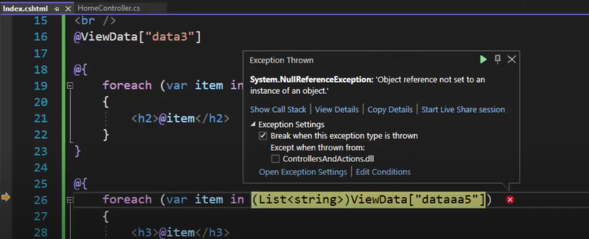

**ViewBag:**

* ViewBag is also used to transfer data from a controller to a view.
* **The general syntax of ViewBag is as follows:**
* ViewBag.PropertyName = Value;
* **PropertyName:** Is a String value that represents a property of ViewBag.
* **Value:** Is the value of the property of ViewBag, Value may be a String, object, list, array or a different type, such as int, char, float, double DateTime etc.
* ViewBag is a **dynamic data type property** of the **base class** of all the controllers, which is the **ControllerBase** class.

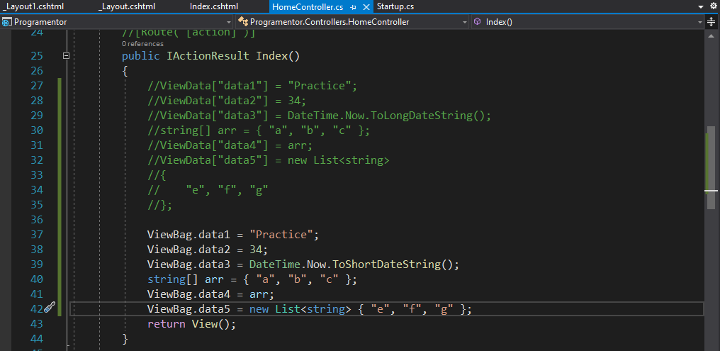

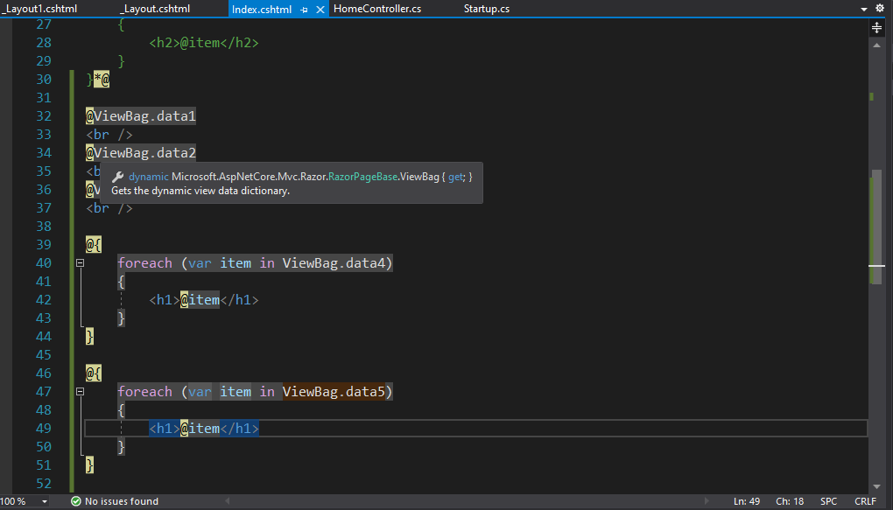

* ViewBag is a **dynamic data type**, which internally uses **ViewData** to store values.
* **ViewData** and **ViewBag** can access each of data interchangeably.

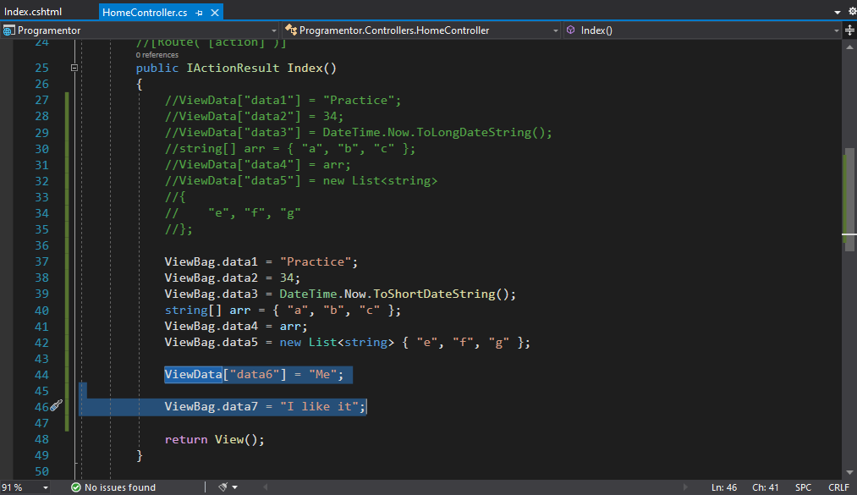

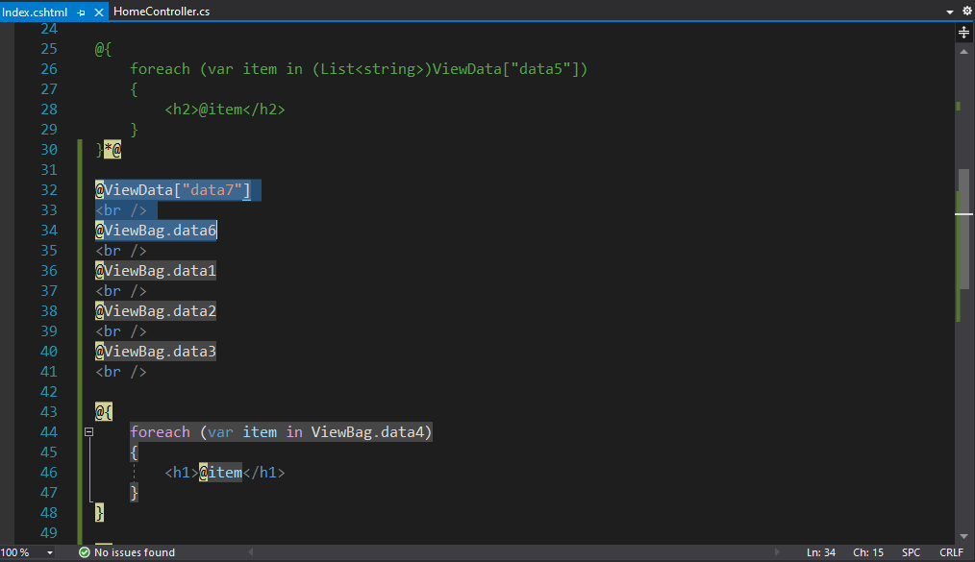

* ViewBag exists only for the **current request** and becomes **null** if the request is **redirected**.
* ViewBag is a dynamic property based on the dynamic features introduced in **C# 4.0.**
* ViewBag does not require **typecasting** when you use **complex data type.**
* **Note:** ViewBag does not provide **compile time error checking**. For Example- if you **mis-spell keys** you wouldn't get any compile time errors. You get to know about the error only at runtime.

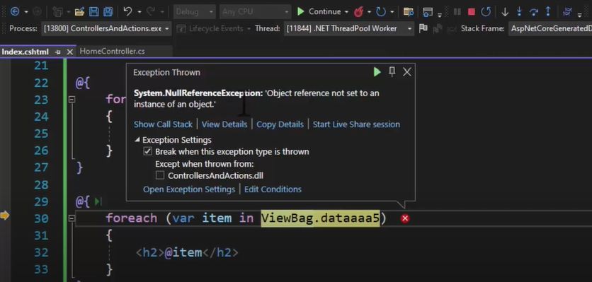

**TempData:**

* It Passes data from a **controller** to a **view**.
* **The general syntax of TempData is as follows:**
* TempData[Key]= Value;
* **Key:** Is a String value to identify the object present in TempData.
* **Value:** Is the object present in TempData.
* TempData is used only for **current or subsequent requests** as it is a very short-lived instance.

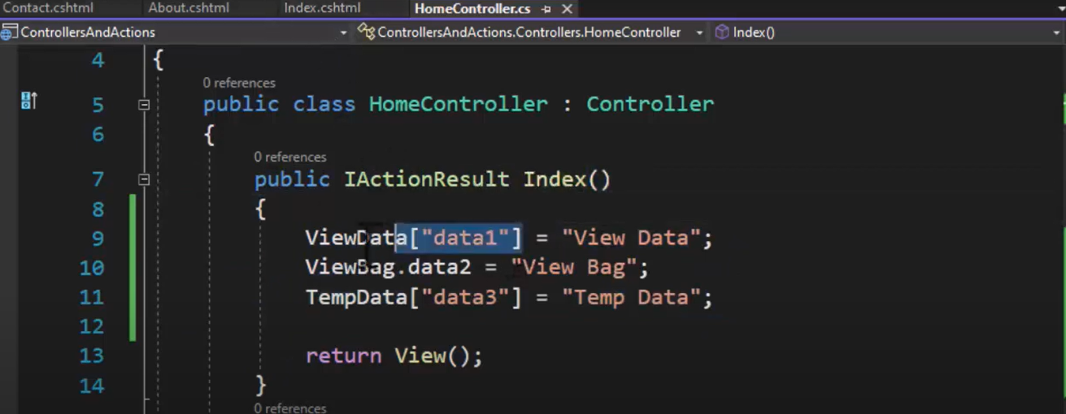

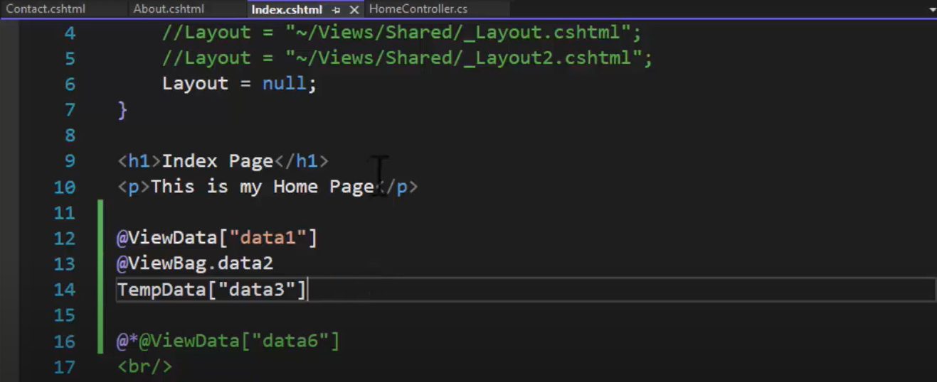

* **Redirecting** is the only case when users can rely on TempData.
* When redirecting, current request is **killed**, and a new request is created on the server to serve the redirected view.





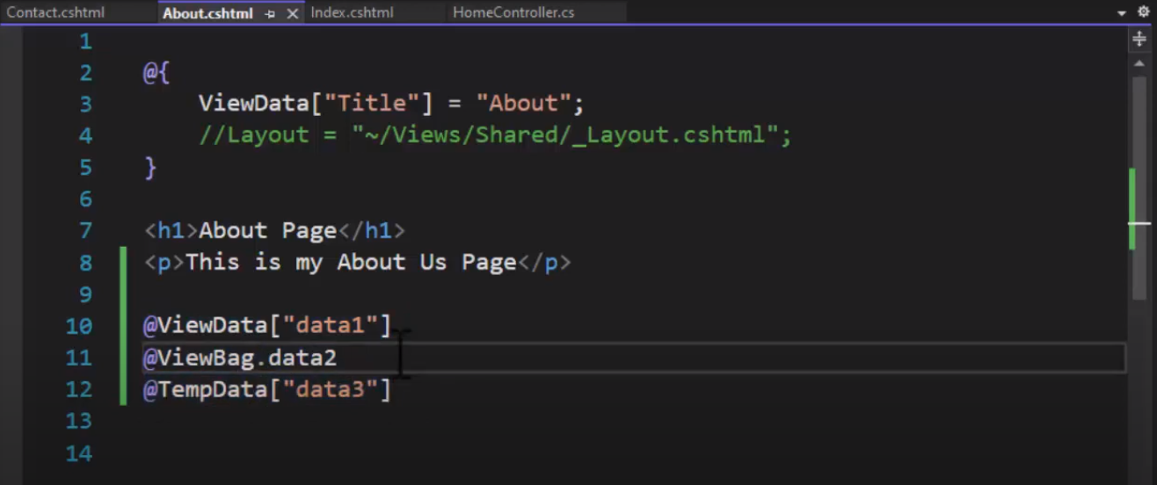

* Sharing data between the controller actions are done through the ASP.NET MVC **TempData** dictionary.
* TempData is a **Dictionary object** derived from the **TempDataDictionary** class.
* TempData stores data as **key-value pairs.**
* TempData value must be **type cast** before use.

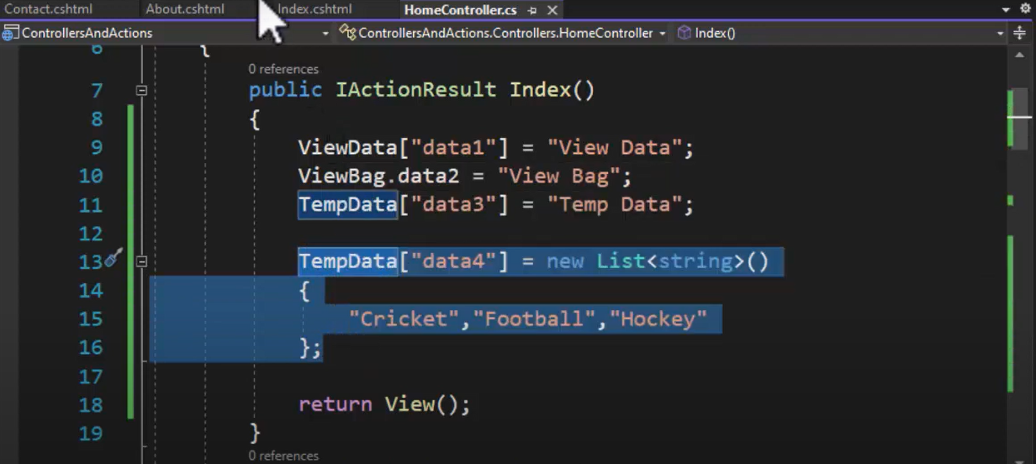

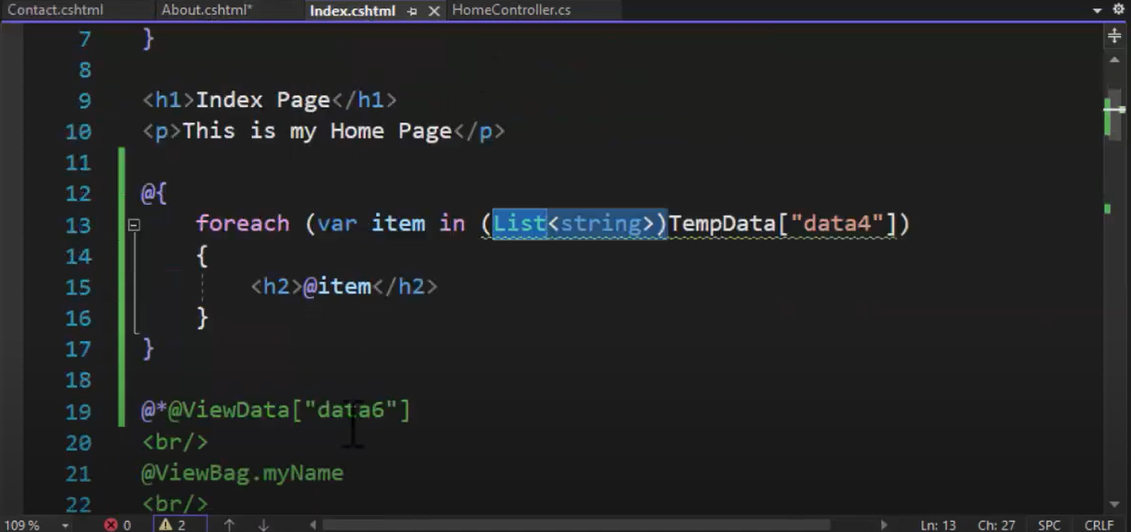

* Check for **null values** to avoid runtime error.

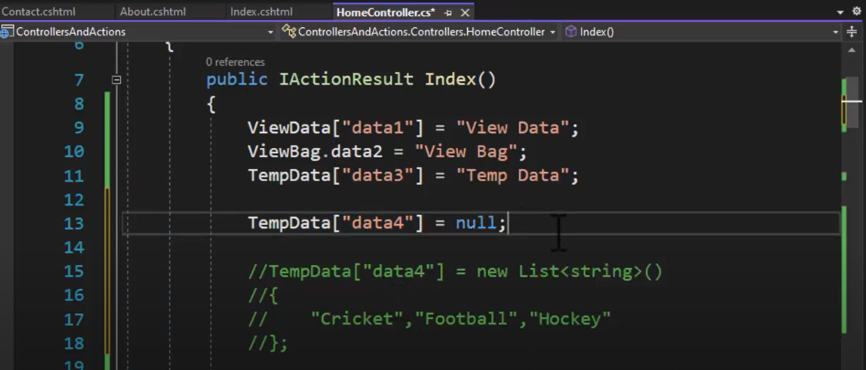

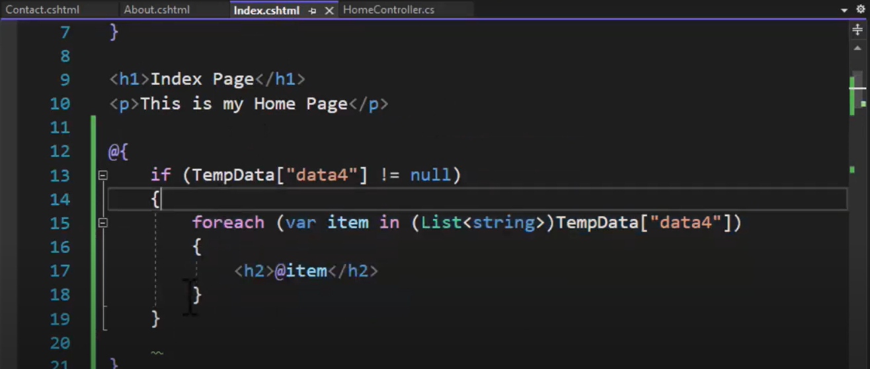

* TempData allows passing data from the **current request to the subsequent request** during request redirection.

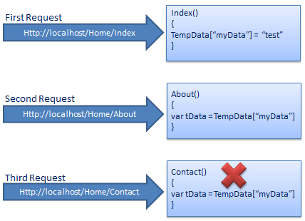

* TempData in ASP.NET MVC can be used to **store temporary data** which can be used in the subsequent request.
* **TempData** will be cleared out after the completion of a subsequent request.
* Call **TempData.Keep ()** to keep all the values of TempData in a third request.

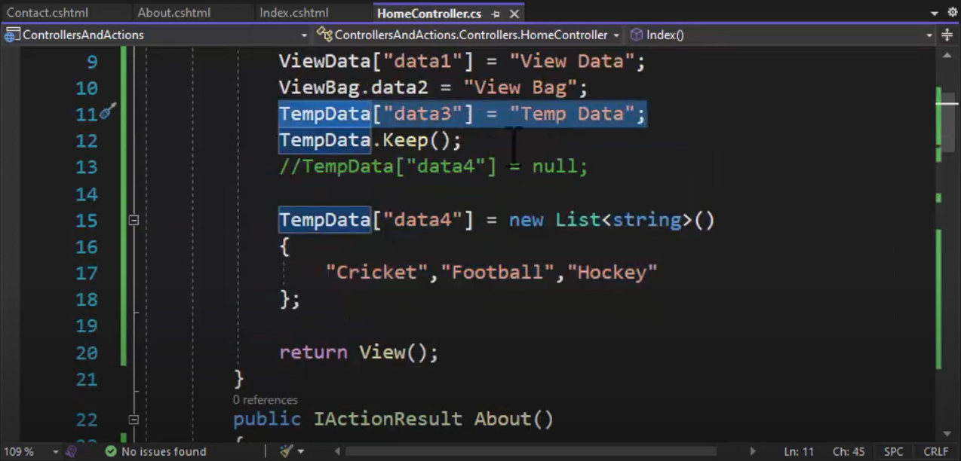

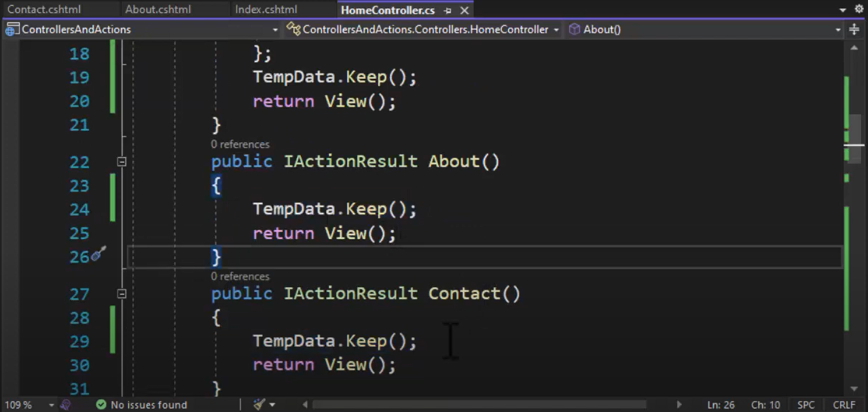



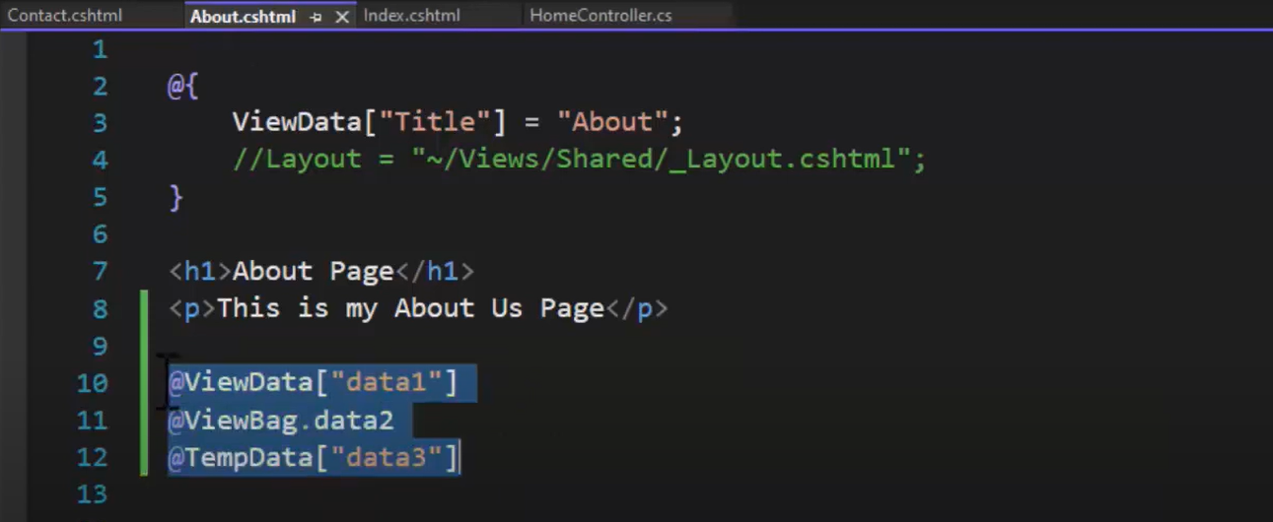

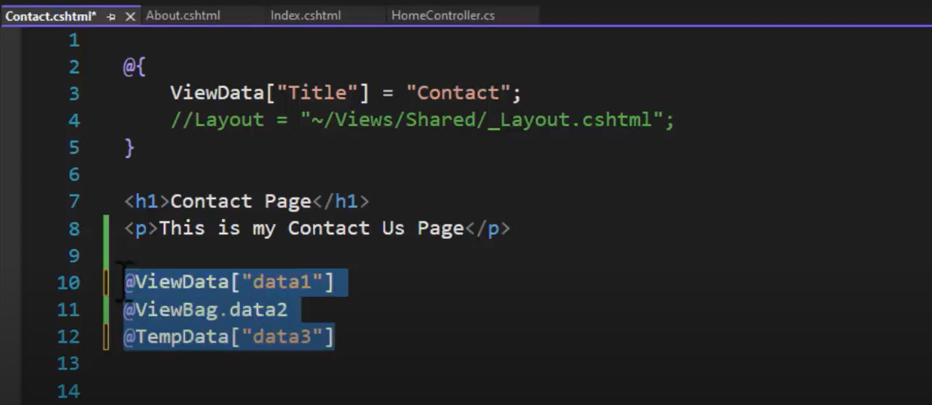

**Strongly Typed View**

* Strongly typed view or **strongly typed object** is used to pass data from controller to a view.
* The **view** **which binds with any model** is called as strongly typed view.
* You can bind any **class as a model to view**.
* You can access **model properties** on that view.
* You can use data associated with model render controls like <H1> tag, etc.
* The view that is designed by targeting specific model class object then that view is called "Strongly Typed View".
* In strongly typed view, view is bind with corresponding model class object or list of objects.

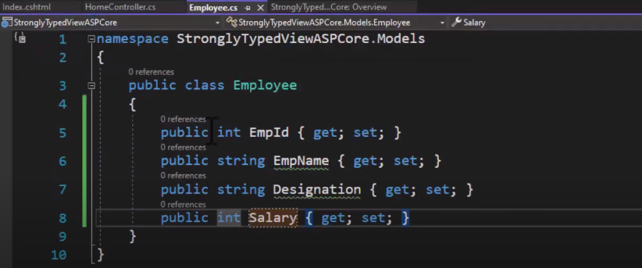

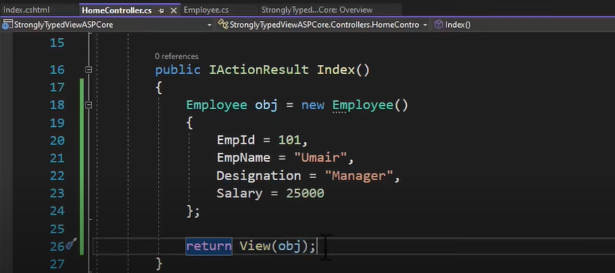

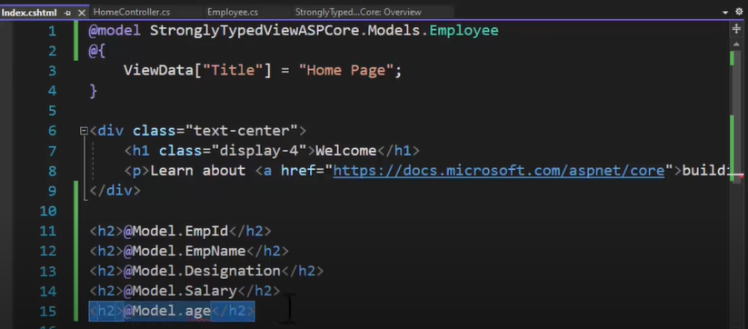

OUTPUT:

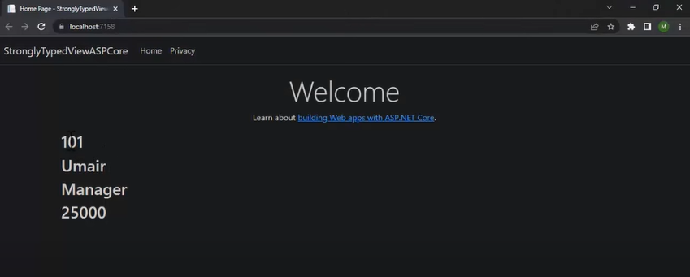

=========================================================================

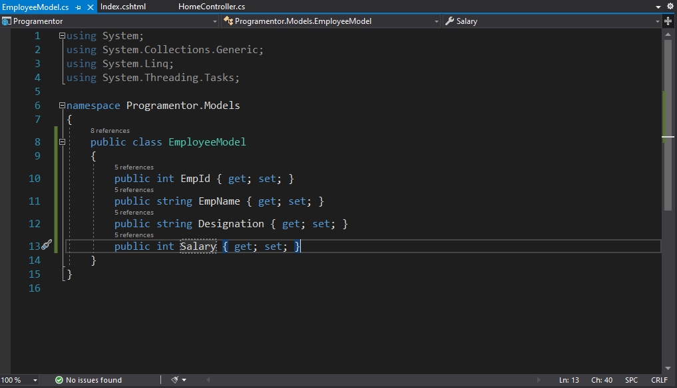

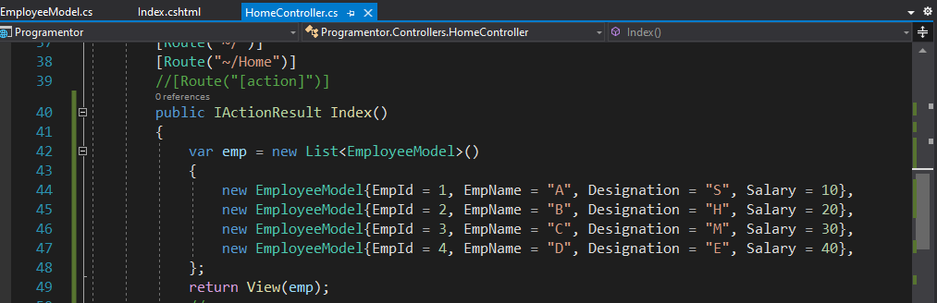

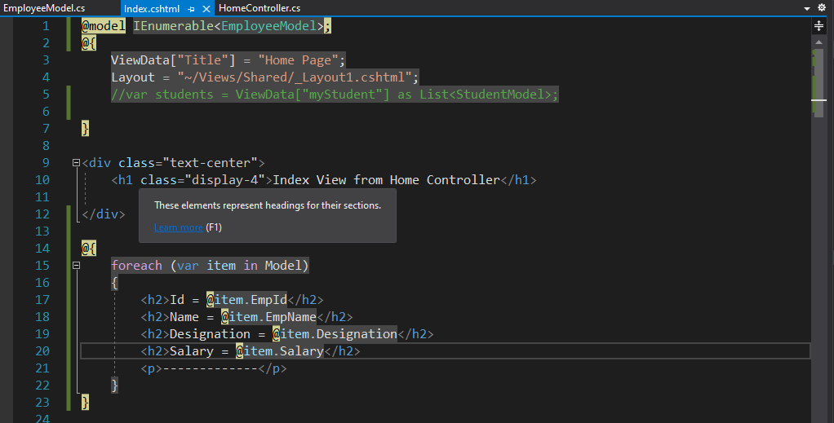

OUTPUT:

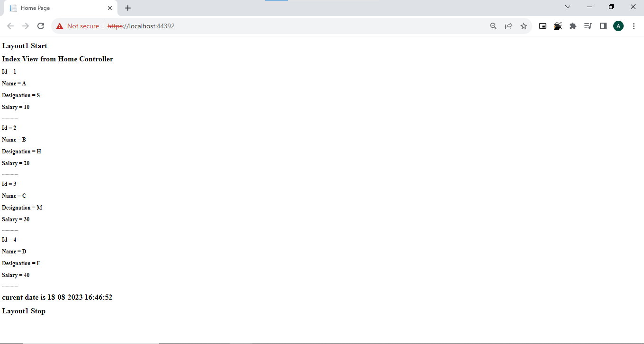

**Models:**

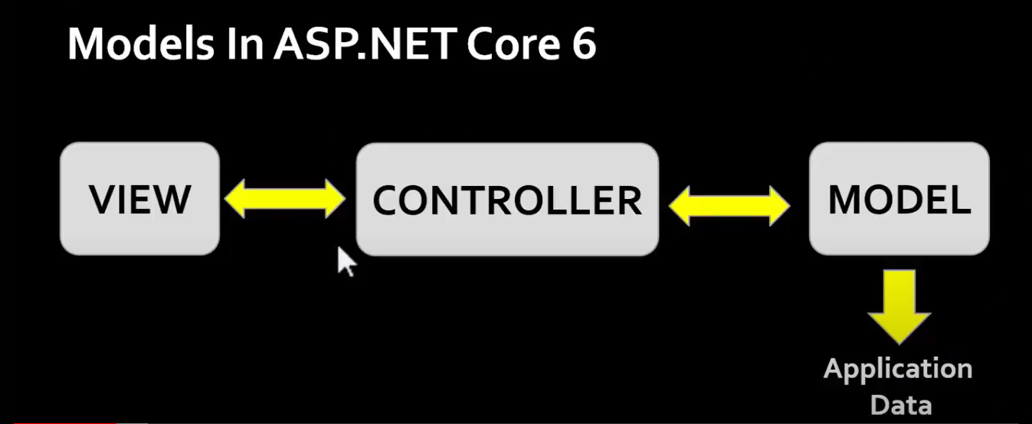

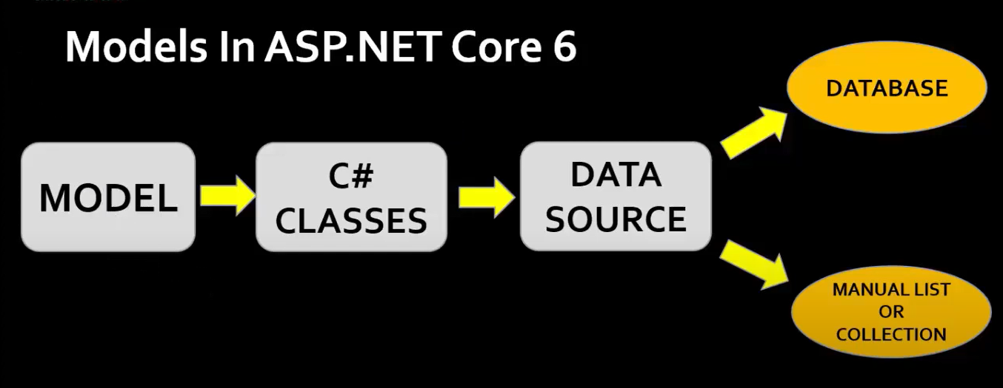

* A **model** is a class with **.cs (for C#)** as an extension having both **properties and methods.**
* STUDENT
  + RollNo
  + Name
  + Gender
  + Class
* Models are used to set or get the data.

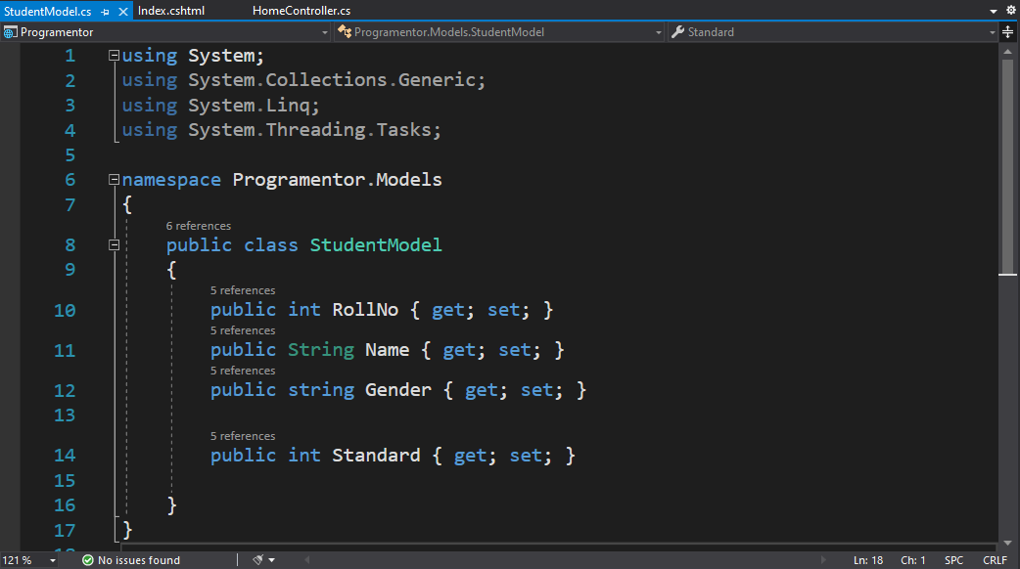

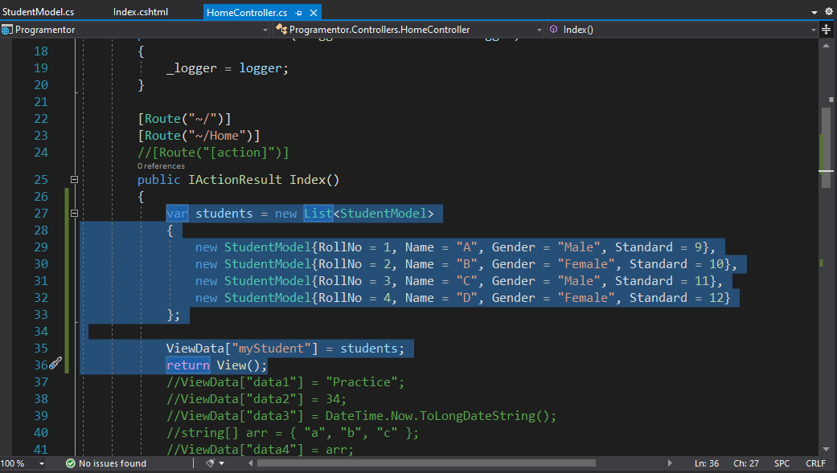

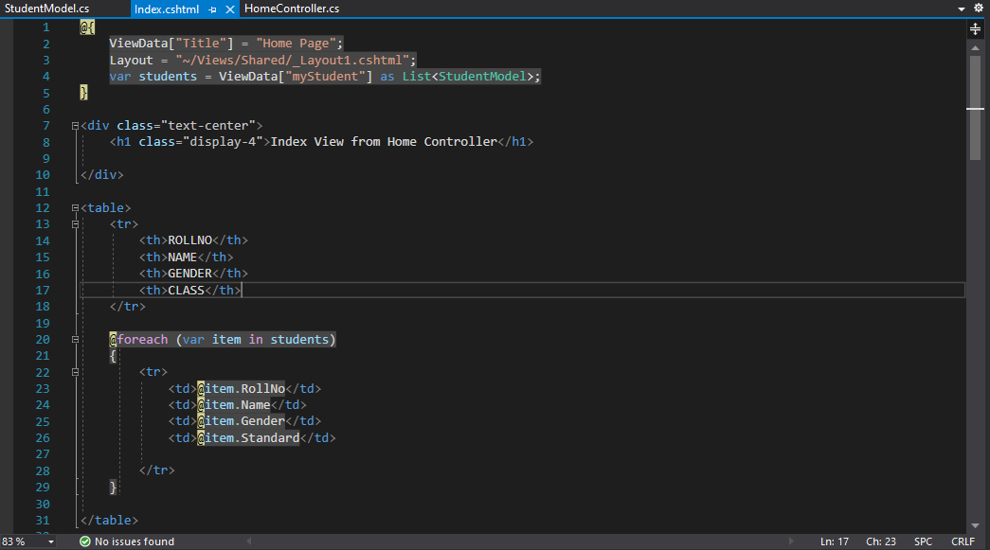

OUTPUT:

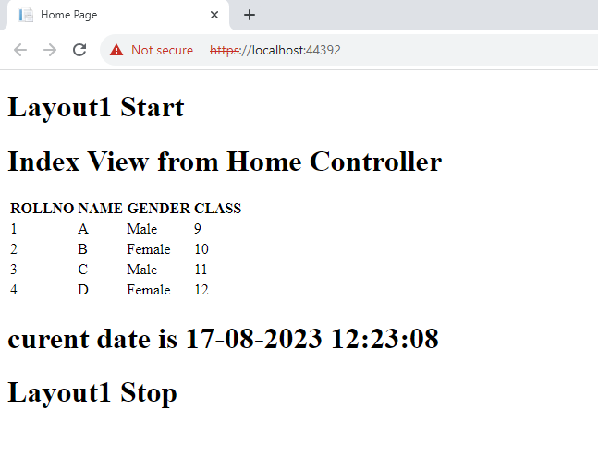

* If your application does not have data, then there is no need for a model.
* If your application has data, then you need a model.
* The Models in ASP.NET Core MVC contains a **set of classes** that are used to represent the domain data **(you can also say the business data)** as well as it also contains logic to manage the domain/business data.
* So, in simple words, we can say that the models in ASP.NET Core MVC Application are **used to manage the data.**
* If you are working with any Web Application that is based on MVC Design Pattern, then in that MVC Application, three things are common i.e. **Model, View, and Controller.**
* The **Controllers** are used to manage the overall flow of the application. **Models** are responsible for the data and these data are used on Views. **Views** are basically the HTML pages that get rendered into the browser of the client.
* We can perform operations like **insert, update, and delete** by using **Models**.
* **Note:** It is not mandatory, but it is a good programming practice to store all the model classes within the **Models folder.**

**Repository Pattern:**

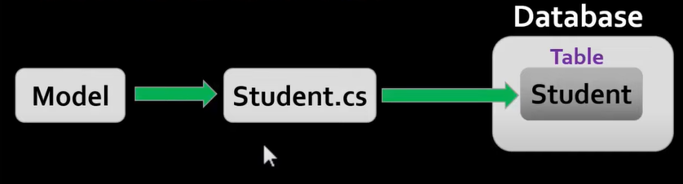

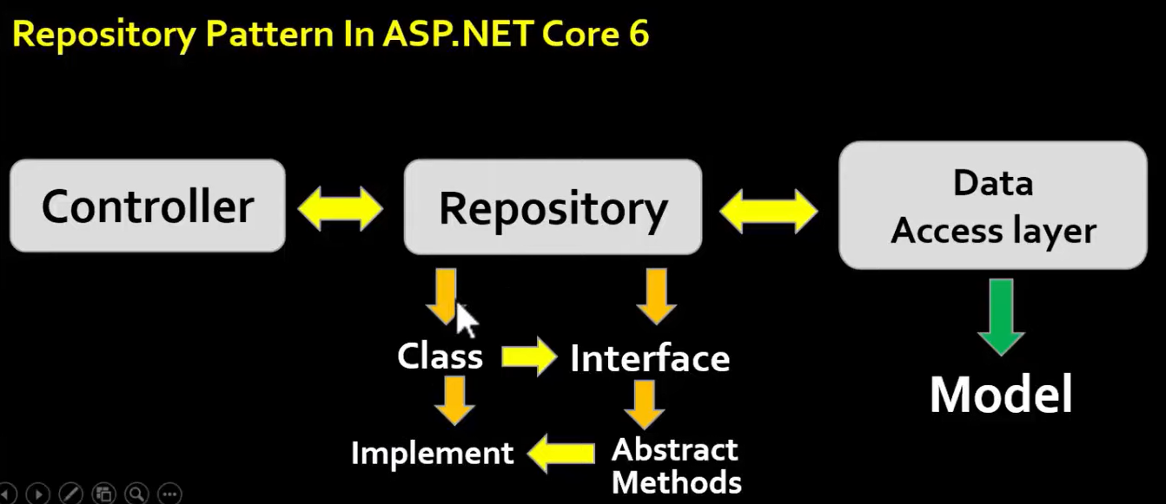

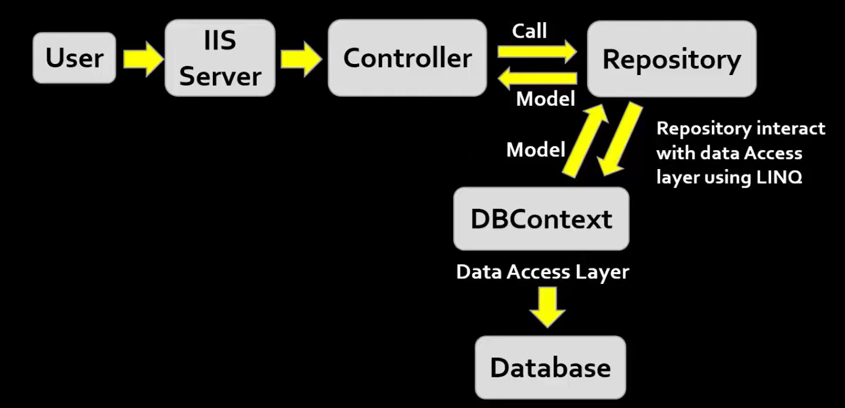

(Language Integrated Query)

* With the **Repository pattern**, we create an **abstraction layer** between the **data access** and the **business logic layer** of an application.
* By using it, we are promoting a more **loosely coupled approach** to access our data from the database.
* Also, the code is cleaner and easier to **maintain and reuse**.

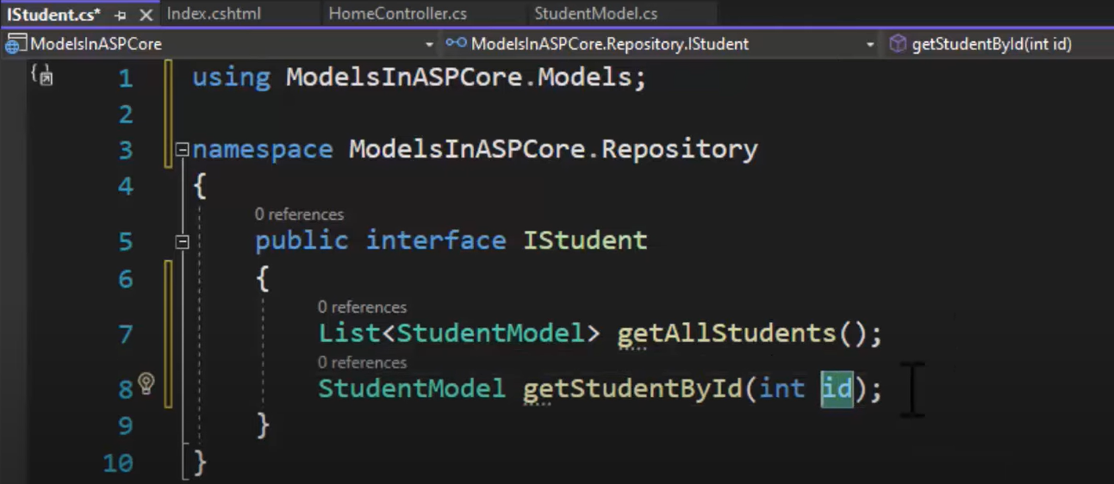

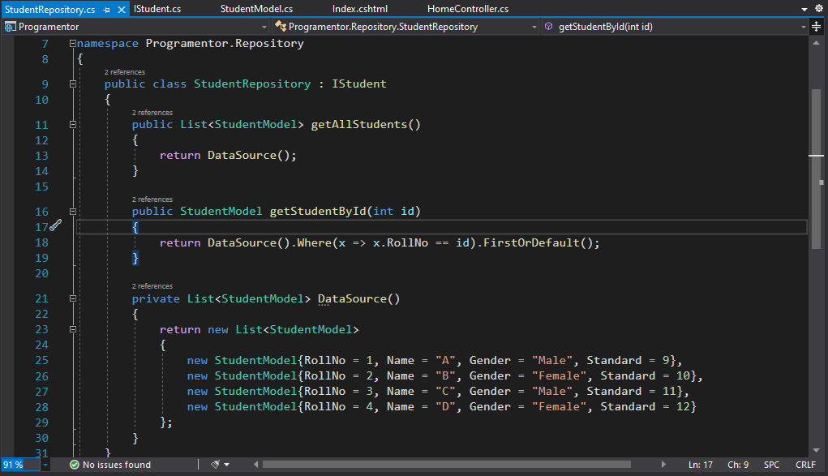

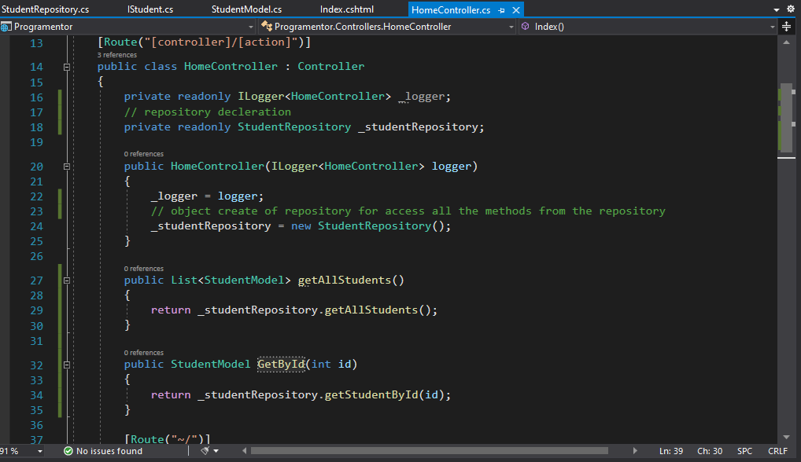

**_Viewlmports:**

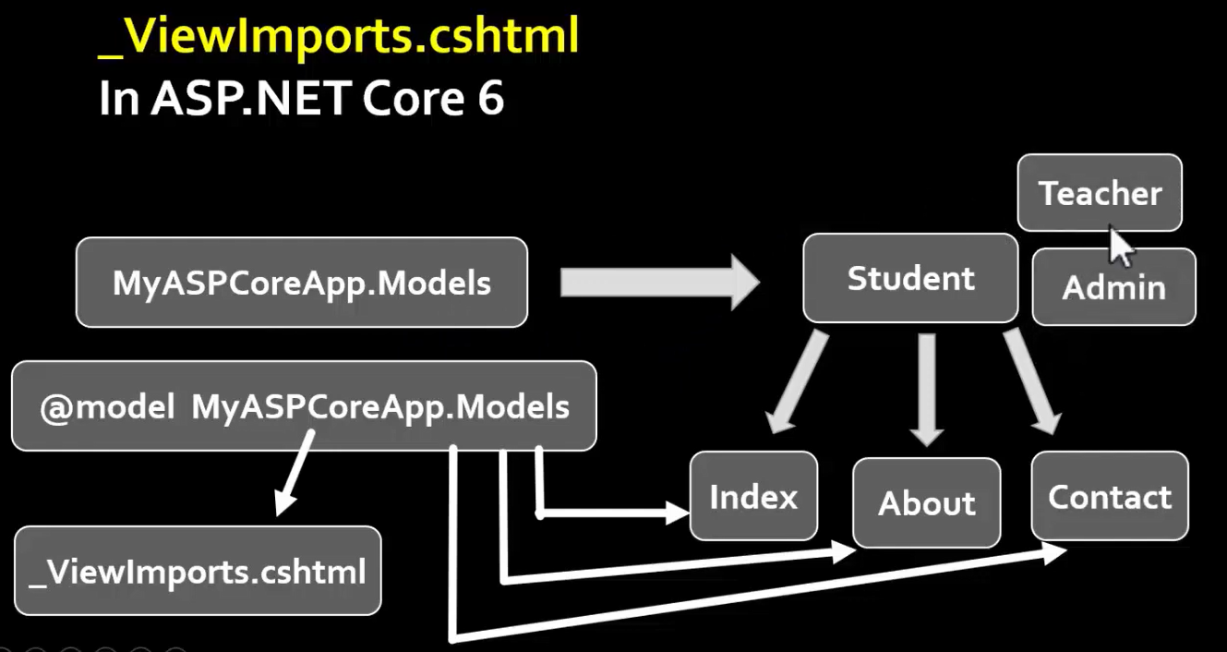

* In ASP.NET Core MVC Application, the **_Viewlmports.chtml** file provides a mechanism to include the **directives globally** for **Razor Pages / Views** so that we don't have to add them individually in each and every page.
* Viewlmports.cshtml file supports the following directives:
  + @addTagHelper
  + @tagHelperPrefix
  + @removeTagHelper
  + @namespace
  + @inject
  + @model
  + @using
* ViewImports file is hierarchical Order:

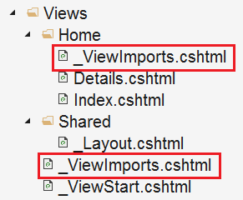

**TAG HELPERS:**

* Tag helpers are basically **special attributes** provided by Asp.net Core.
* Tag Helpers enable server-side components to participate in creating and rendering HTML elements in **Views**.
* **Tag helpers** are a new feature and similar to **HTML helpers (MVC 5)**, which help us render HTML.
* There are many **built-in Tag Helpers** for common tasks, such as **creating forms, hyperlinks, loading assets (Images)** etc.
* Tag Helpers are authored in C#, and they target HTML elements based on the element name.
* For example, the built-in LabelTagHelper can target the HTML <label> element when the LabelTag Helper attributes are applied.
* Before start working with tag helpers, make sure you have included **namespace** for tag helpers in your **Viewlmports** file.
* **Microsoft.AspNetCore.Mvc.TagHelpers**.
* Add this line in in your Viewlmports file.
* **@addTagHelper *, Microsoft.AspNetCore.Mvc.TagHelpers**
* @addTagHelper is a **directive**.

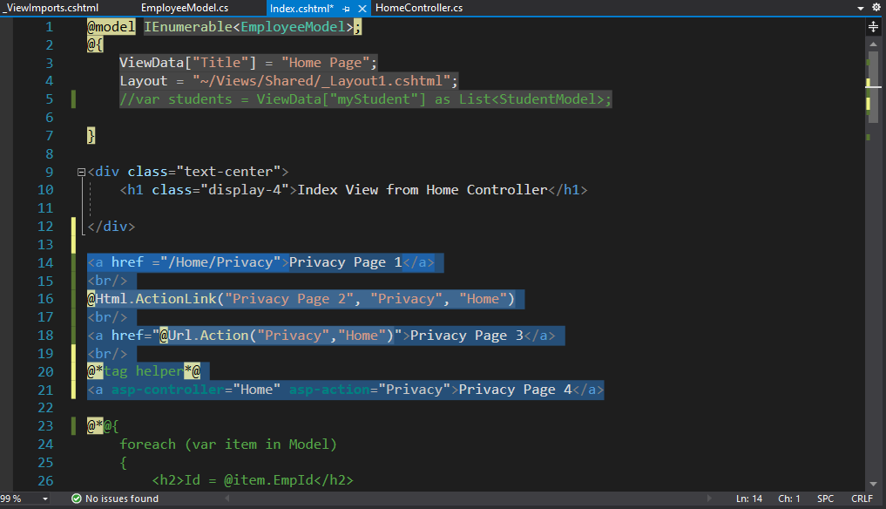

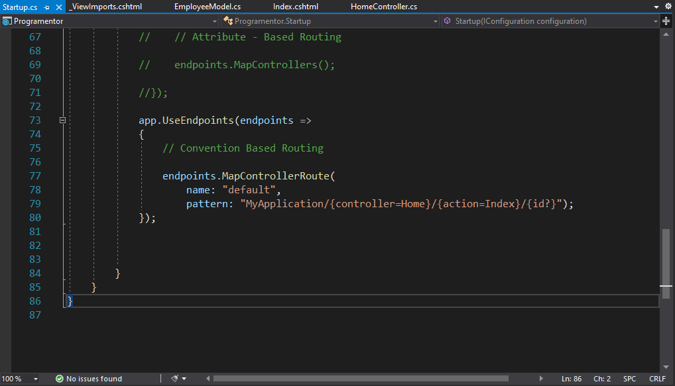

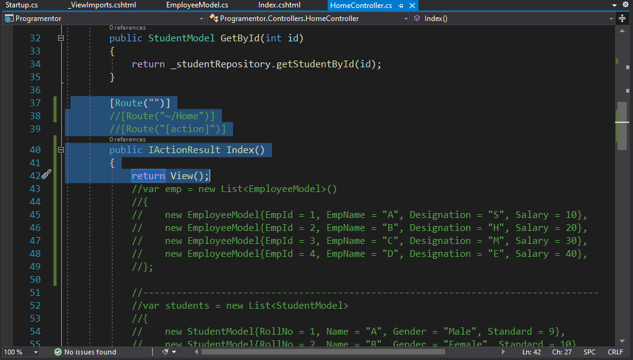



**Image Tag Helper:**

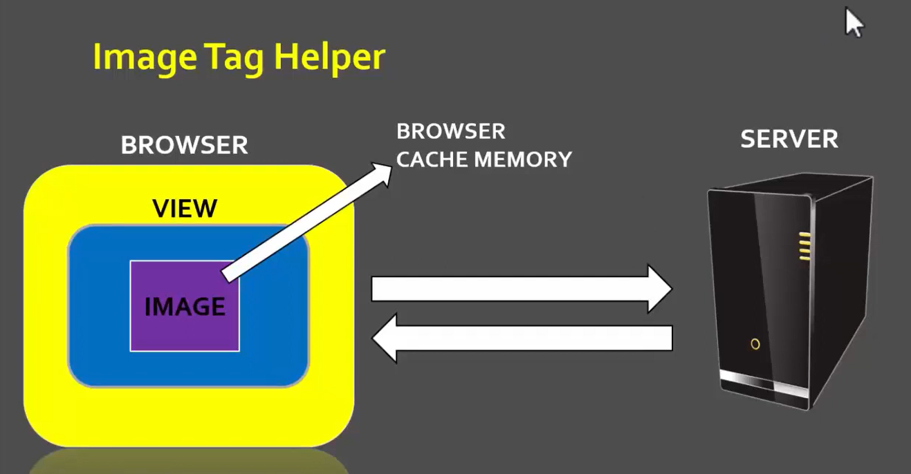

* In order to use the Image Tag Helper in ASP.NET Core Application, you need to add the **asp-append-version** attribute to the <img> tag and need to set the **value to true.**
* Image tag helper provides cache busting behaviour within asp.net core application.

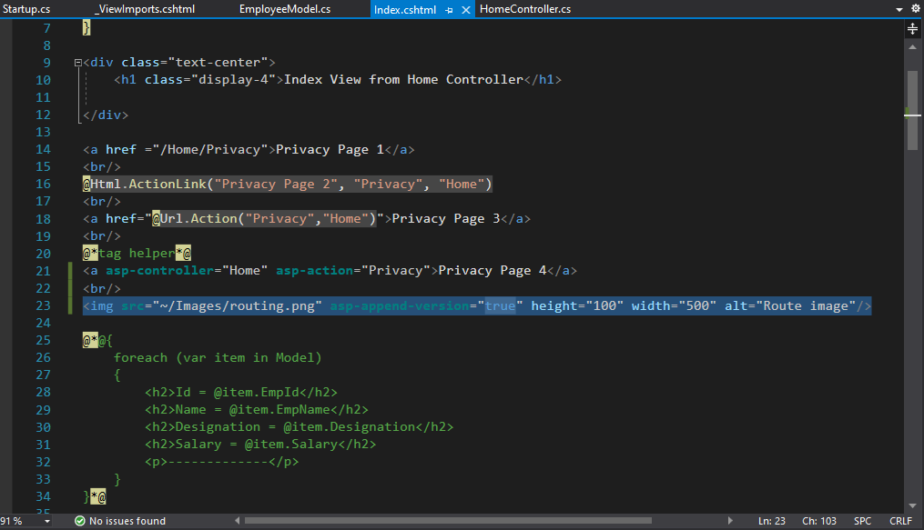

* **Understanding the Browser Cache**
  + In general, when you visit a web page and if that web page contains some image, then most of the modern web browser cache the images for later use.
  + In the future, when you revisit to that web page, then the browser loads the images from cache instead of downloading the images from the server.
  + In most of the caches, this is not an issue as the images are not changes that often for a web page.
* **How to Disable Browser Cache?**
  + Press F12 key to launch the Browser Developer Tools.
  + Then click on the "Network" tab and finally, check then "Disable Cache" checkbox as shown in the below image

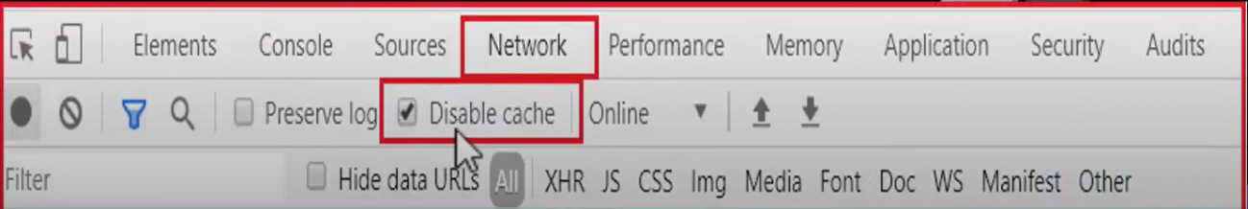

**Asp-For Tag helper:**

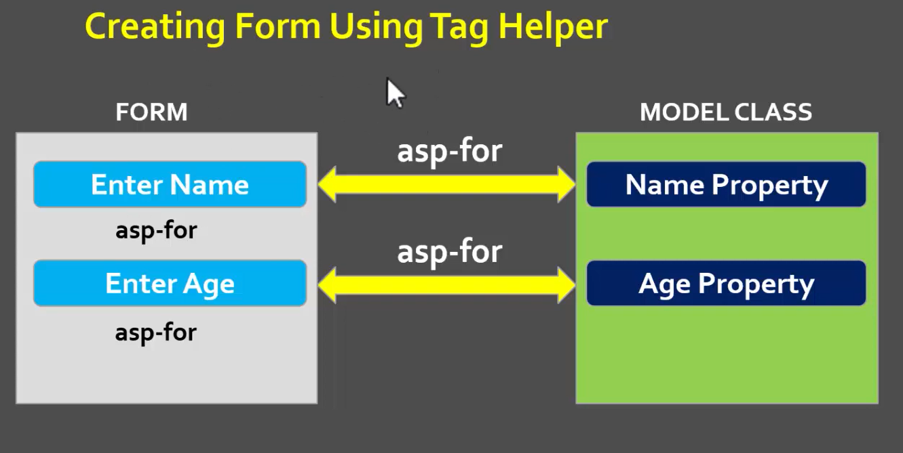

* The **asp-for** attribute is arguably one of the most common tag helpers that you'll encounter, and its primary purpose is to handle binding a **specific property** to the element that it decorates.
* **asp-for tag helper** is used for an **<input>**, it sets the **name attribute**, so that it can be bound to model class.
* e.g. asp-for="Movie.Year" when retrieving data from a POST request.
* asp-for sets the **id, name and validation** related attributes.
* **Creating Form Using Tag Helper** 
  + The Form Tag Helper.
  + The Form Action Tag Helper.
  + The Input Tag Helper.
  + The Textarea Tag Helper.
  + The Label Tag Helper.
  + The Validation Tag Helpers.
  + The Select Tag Helper

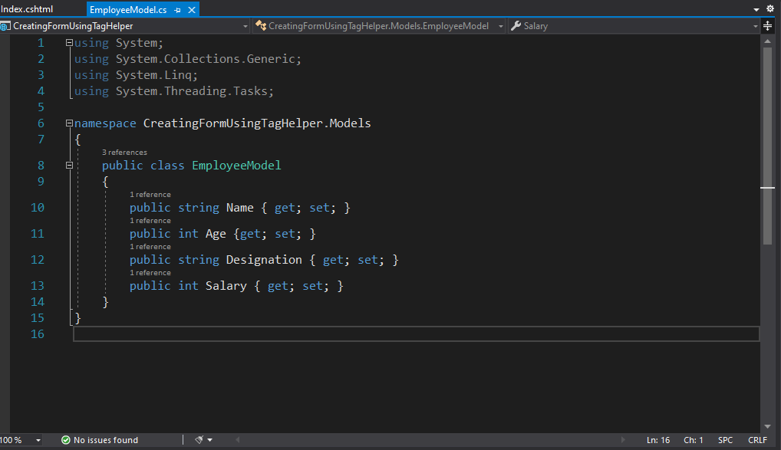

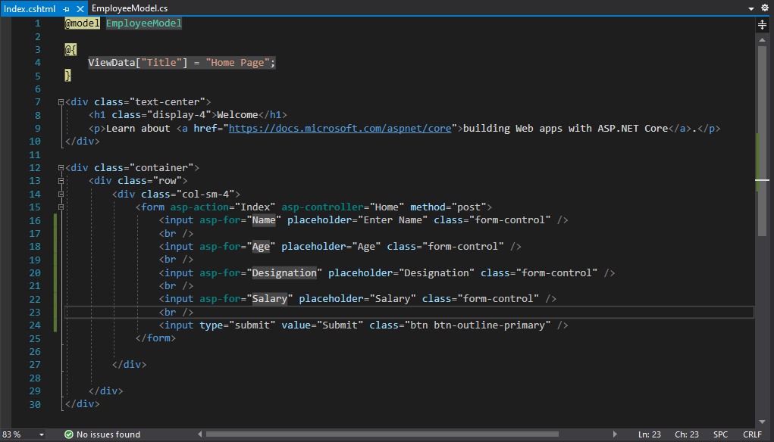

===========================================================================

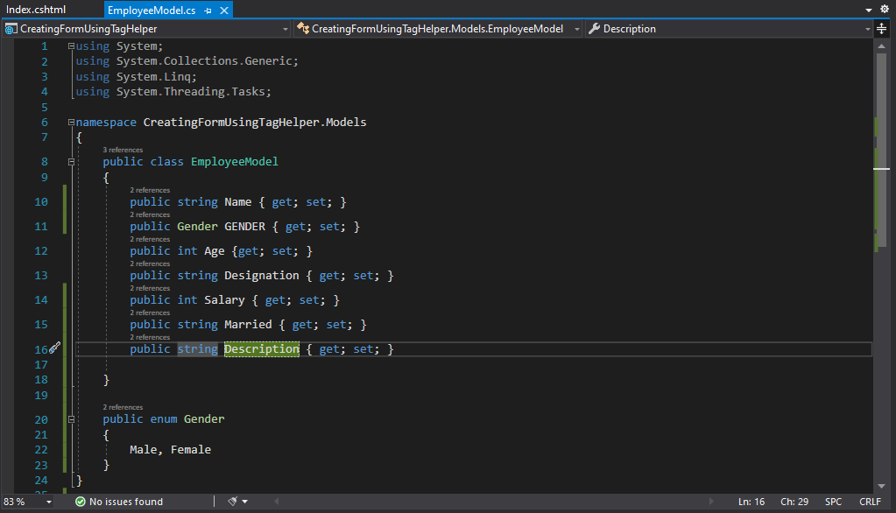

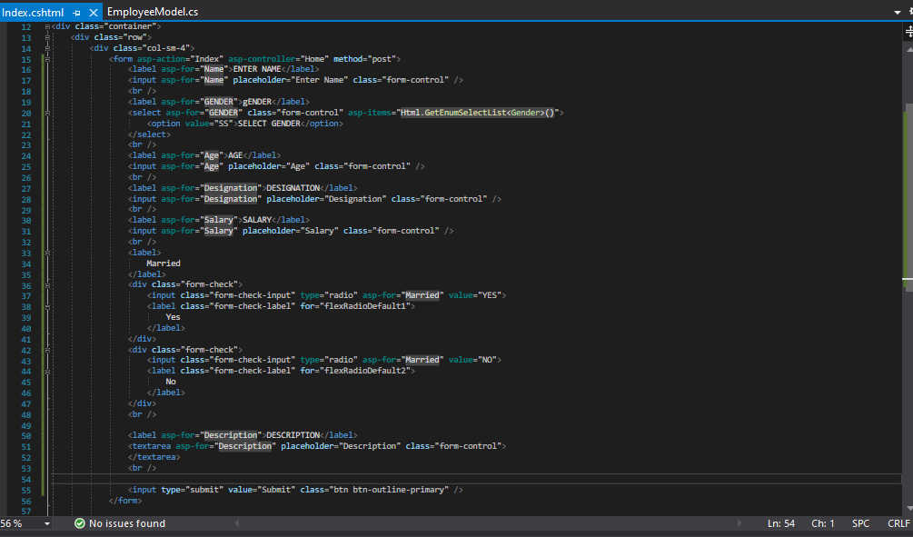

**Model Binding:**

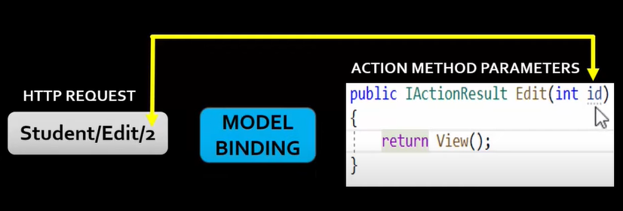

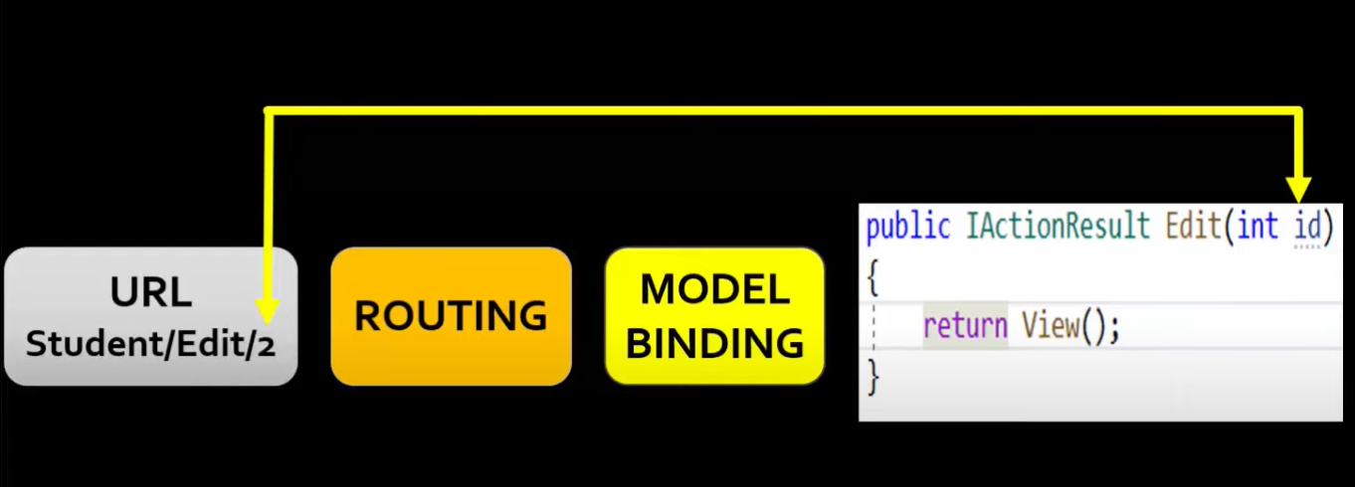

* **Model binding** in ASP.NET Core MVC maps data from **HTTP requests** to **action method parameters**.
* The **parameters** may be **simple data types** such as strings, integers, or floats, or they may be **complex types** like Student, Employee, Customer, Order etc.
* How model binding works:
  + When MVC receives an HTTP request, it routes it to a specific **action method** of a **controller.**
  + It determines which **action method** to run based on what is in the **route data**, then it binds **values** from the HTTP request to that action method's **parameters**.
  + In addition to route values MVC will bind data from various parts of the request and it does so in a set order. Below is a list of the data sources in the order that model binding looks through them:

**1. Form values:** These are form values that go in the HTTP request using the

POST method.

**2. Route values:** The set of route values provided by routing.

**3. Query strings:** The query string part of the URI.

* **NOTE**: Form values, route data, and query strings are all stored as **name-value pairs**.

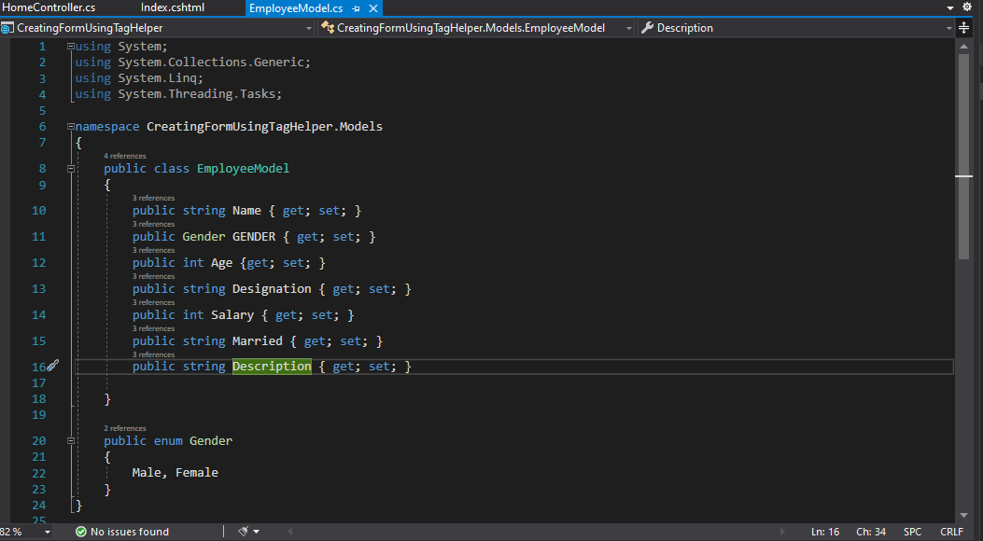

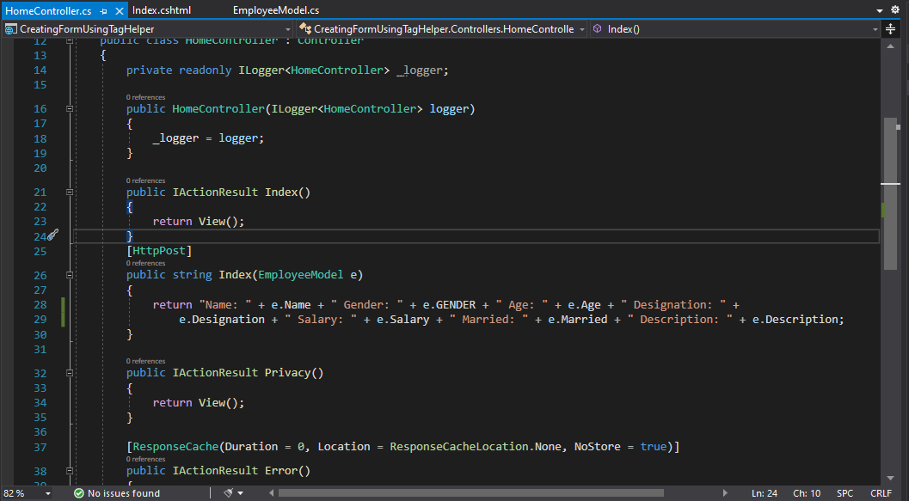

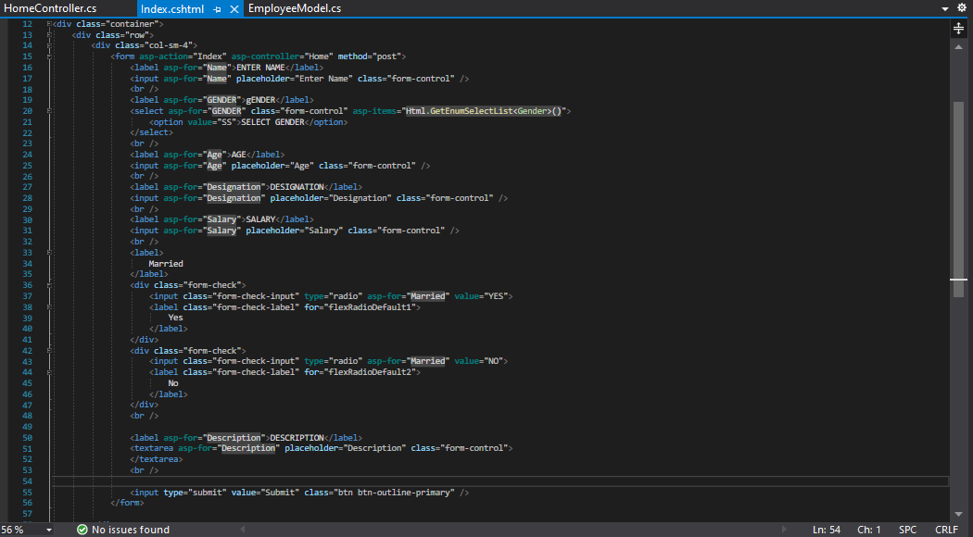

**Model Validation:**

* Often the data entered by the user is not valid and cannot be saved into the database.
* The entered data may contain a typo or user may intentionally enter the inappropriate data.
* Hence, we need to validate the user input before storing it in the database.

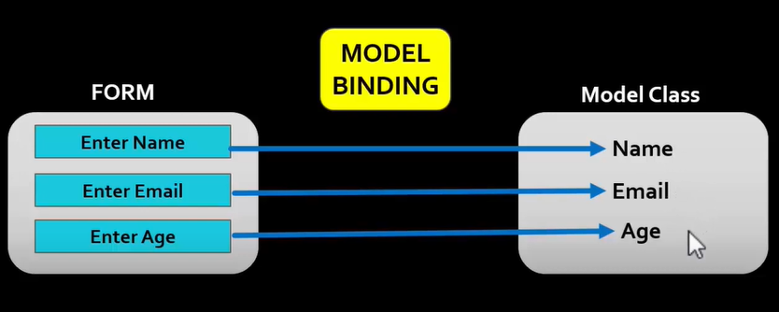

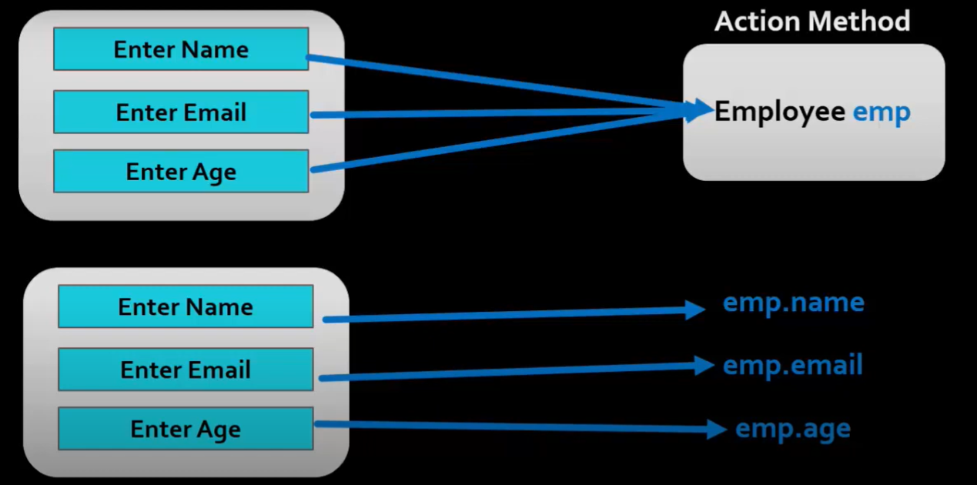

* The ASP.NET Core gives Us **Model Validator**, which uses the validation **attributes** to validate the model, which makes our task easier.
* We also take a look at **ModelState** and how to use it. Finally, we look at the list of Validation attributes.
* The Form Data is posted to **Controller action** is automatically mapped to the **action parameter** by the **Model Binder**. We already looked at how **Model Binding** works in ASP.NET Core.
* The **Model** needs to be validated for the **correctness**.
* These validations can be done at the **client side** before sending data to the server **or** at the **server side** when the data is received from the client.
* **Explicitly Validating a Model**
* Once you received the model in the controller, you can validate the model programmatically as shown below:

if (string. IsNullOrEmpty(model.Name))

{

//Validation Failed

//Send the list of errors to client

}

* **How Model Validation works**
* We learnt how Model binding works in ASP.NET Core applications. When the **HTTP Request** arrives **Model binder** is invoked before passing the control to controller action method.
* The **Model binder** not only binds the value to the **action parameter** but also validates them by using the **Model Validator**.
* The **Model Validator** runs **after** the model binding and runs a series of validations on each **property** of the **model** based on the attributes that you set on the model property.
* These attributes are called **Validation** **attributes** and contain the code, which is use by the Model Validator to validate the model.

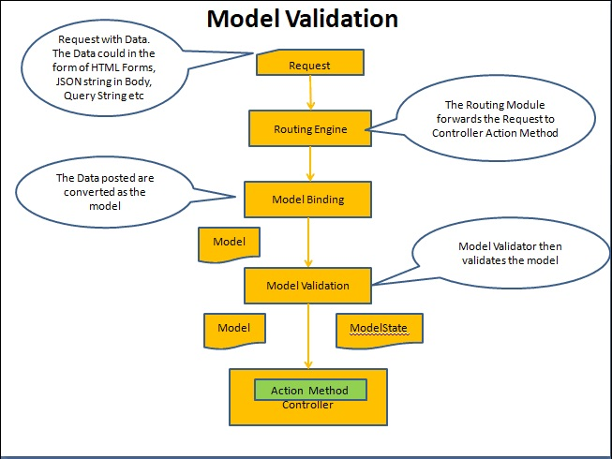

**Built-in attributes:**

* All these validation attributes are located in **System.ComponentModel.DataAnnotations;**
  + [Required]: Validates that the field is not null.
  + [StringLength]: Validates that a string property value doesn't exceed specified length limit.
  + [EmailAddress]: Validates that the property has an email format.
  + [Range]: Validates that the property value falls within a specified range.
  + [RegularExpression]: Validates that the property value matches a specified regular expression.
  + [Compare]: Validates that two properties in a model match.
  + [Phone]
  + [Url]: Validates that the property has a URL format.
  + [MinLength]: Validates the property minimum length.
  + [MaxLength]: Validates the property maximum length.

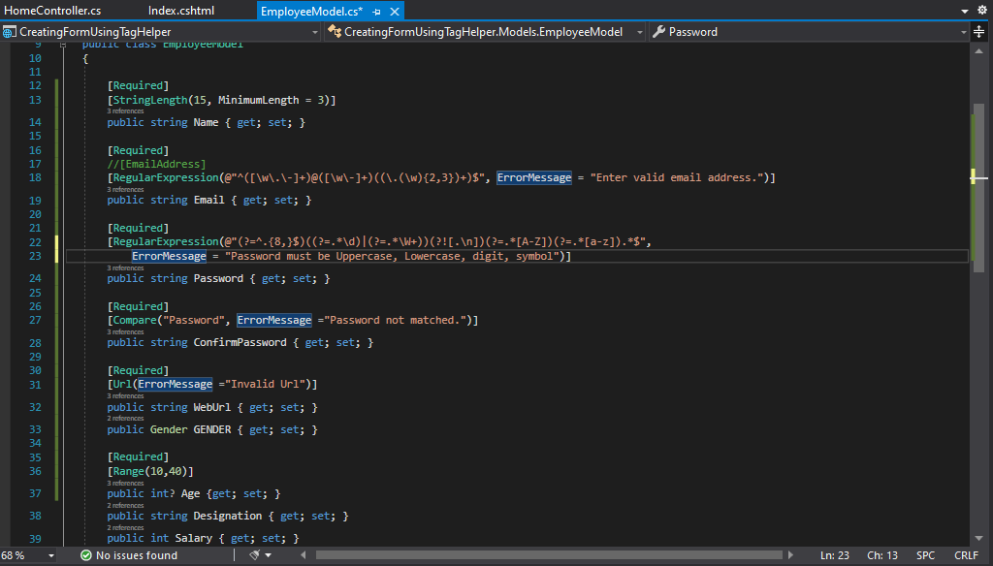

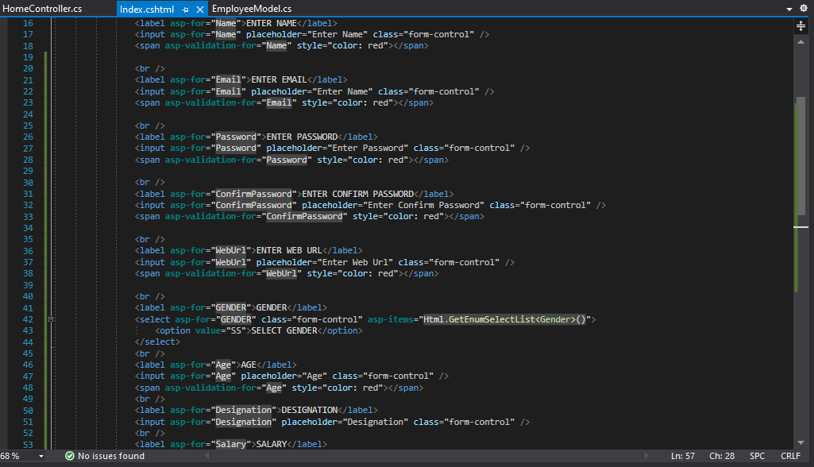

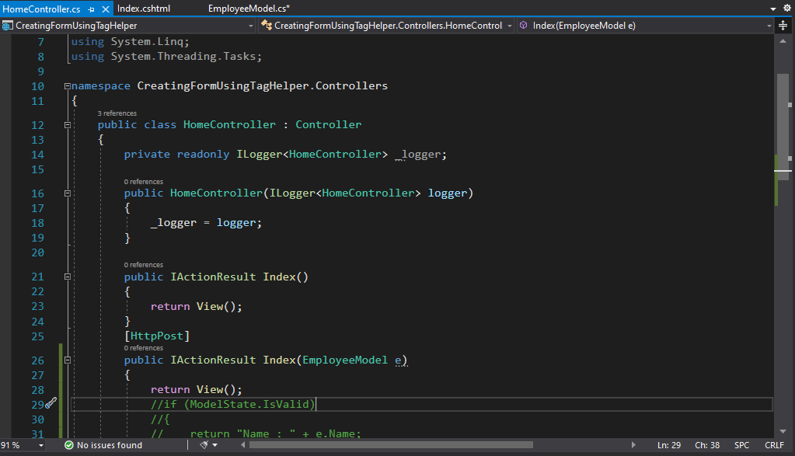

**Validation Tag Helpers:**

* There are 2 validation tag helpers in asp.net core mvc.
* **Validation Message Tag Helper:** It displays the validation message for a single property of a Model. E-g: **asp-validation-for**
* **Validation Summary Tag Helper:** It displays a summary of validation messages for all the properties of a Model.
* **E-g: asp-validation-summary**

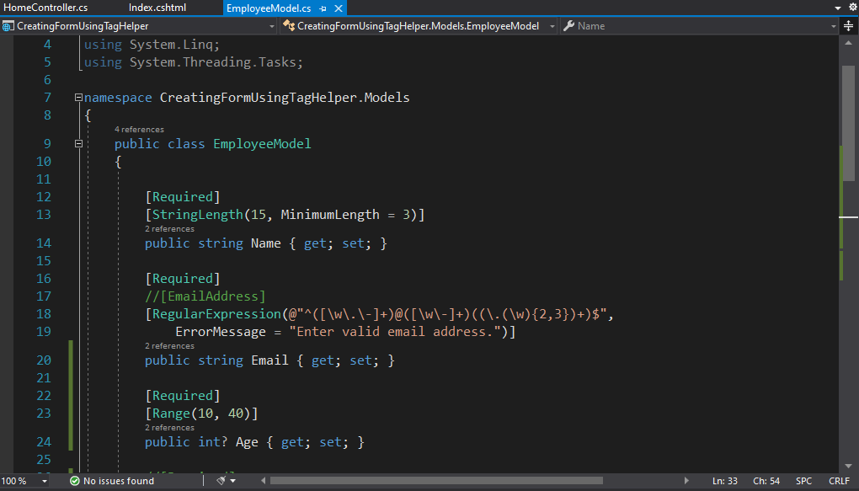

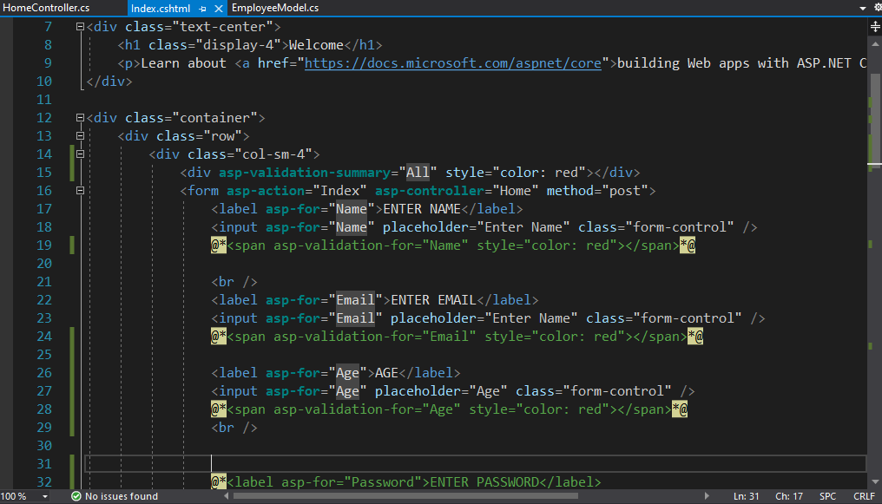

**ADO.Net:**

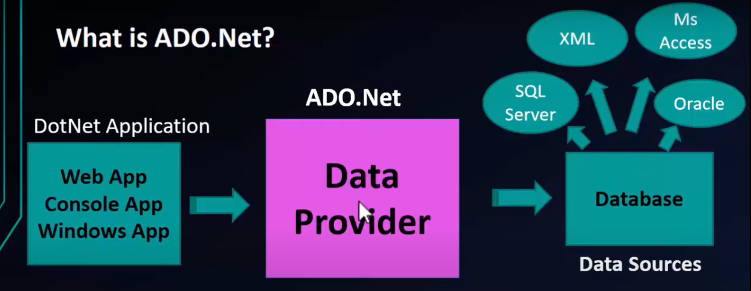

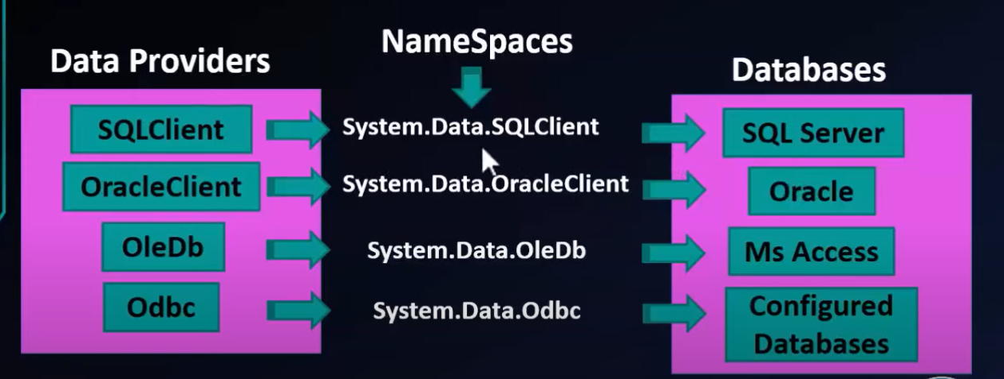

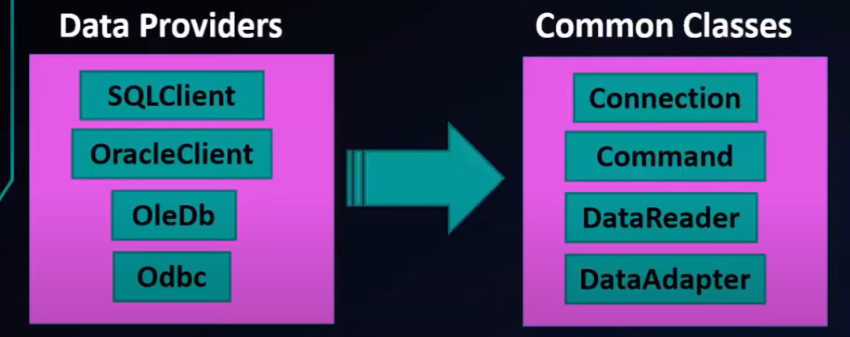

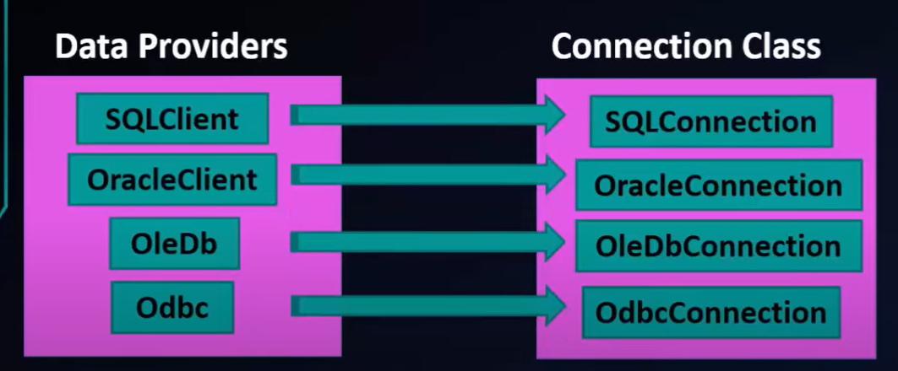

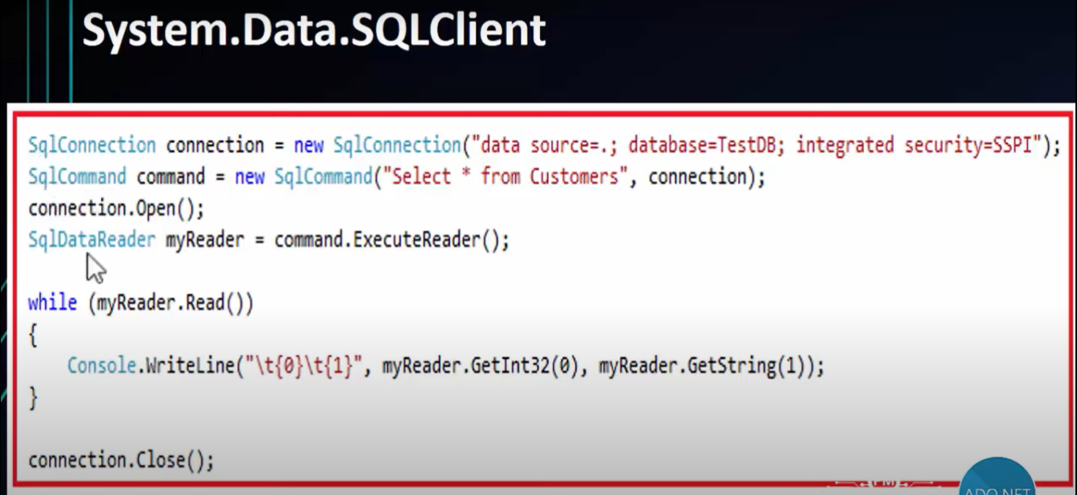

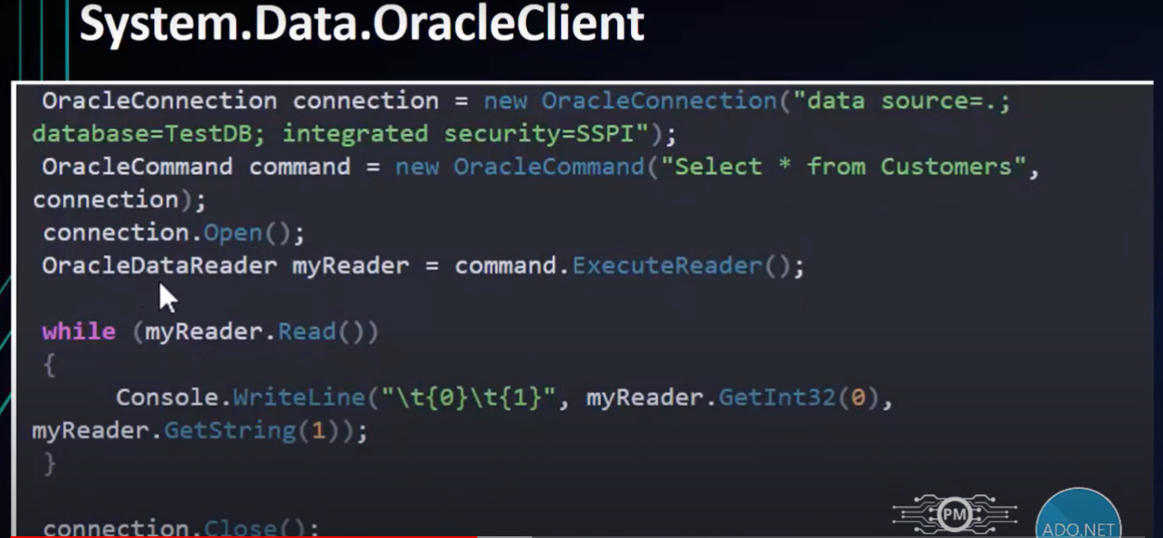

* ADO.NET stands for Active Data Object.
* ADO.NET provides a bridge between the frontend controls and the backend database.
* ADO.NET is a module of .Net Framework which is used to establish connection between application and data sources.
* Data sources can be such as **SQL Server** and **XML**.
* ADO.NET consists of classes that can be used **to connect, retrieve, insert** and **delete** data.
* All the ADO.NET classes are located into **System.Data.dll** and integrated with XML classes located into **System.Xml.dll**.
* It is a database access technology created by Microsoft as part of its .NET framework that can access any kind of data source.
* It's a set of object-oriented classes that provides a rich set of data components to create high-performance, reliable and scalable database applications.
* The ADO.NET is one of the Microsoft's data access technology which is used to communicate between the .NET Application (Console, WCF, WPF, Windows, MVC, Web Form, etc.) and data sources such as SQL Server, Oracle, MySQL, XML document, etc.
* ADO.NET consists of a set of classes that can be used to connect, retrieve, insert, update and delete data (i.e. performing CRUD operation) from data sources.
* ADO.NET mainly uses **System.Data.dll** and **System.Xml.dll**.
* **What types of Applications use ADO.NET?** 
  + ADO.NET can be used to develop any type of .NET application. The following are some of the .NET applications where you can ADO.NET Data Access Technology to interact with a data source.
  + ASP.NET Web Form Applications
  + Windows Form Applications
  + ASP.NET MVC Application
  + Console Applications
  + ASP.NET Web API Applications
* **Components of ADO.NET**
  + Components are designed for data manipulation and faster data access.
  + **Connection, Command, DataReader, DataAdapter, DataSet, and DataView** are the components of ADO.NET that are used to perform database operations. ADO.NET has two main components that are used for accessing and manipulating data. They are as follows:
    - Data provider
    - DataSet.
* **What is NET Data Providers?**
  + The .Net Application cannot directly execute our SQL code, it only understands C#. So, if a .NET application needs to retrieve data or to do some insert, update, and delete operations from or to a database, then the NET application needs to
    - Connect to the Database
    - Prepare an SQL Command
    - Execute the Command Retrieve the results and display them in the application

**SqlConnection class:**

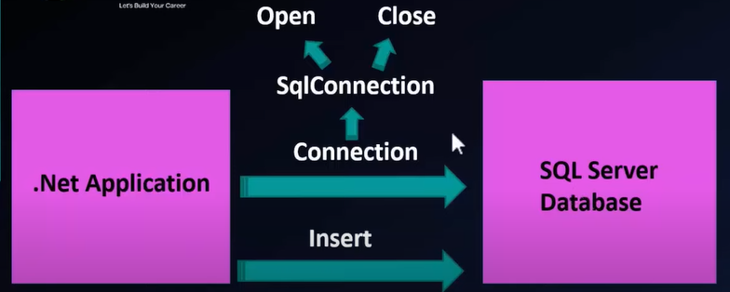

* It is used to establish an open connection to the SQL Server database.
* A **SqlConnection** object represents a unique session to a SQL Server data source.
* ADO.NET connection is an object that provides database connectivity and the entry point to a database.
* It is a sealed class so that cannot be inherited.
* **Definition**
  + **Namespace:** 
    - System.Data.SqlClient
  + **Assembly:**
    - System.Data.SqlClient.dll
* public sealed class SqlConnection :
  + System.Data.Common. DbConnection, ICloneable
* **Inheritance:** 
  + Object -> DbConnection -> SqlConnection
* **Implements:** 
  + ICloneable
* **Creating Object Of SQLConnection Class**
  + SqlConnection con = new SqlConnection(cs);
  + **cs** is a string variable which holds **connection string**.
  + The connection string that includes the source database name, and other parameters needed to establish the initial connection.
  + The default value is an empty string.
* **Things in Connection String Connection String has:**
  + 1. Data Source (Database Server Name)
  + 2. Initial Catalog (Database Name)
  + 3. Integrated Security = True ] => Windows Authentication
  + 4. Username ] => SQL Server Authentication
  + 5. Password ] => SQL Server Authentication
* **Data Source:** This identifies the Server name, which could be the local machine, machine domain name or IP address
* **Initial Catalog:** This identifies the database name. Integrated Security: When you have started database authentication login with Windows authentication, Integrated Security specifies Integrated Security-"True" in connection string, else when you have started the database authentication login with Server authentication Integrated Security specifies Integrated Security="false" in connection string.
* **User Id:** Name of the user configured in SQL Server.
* **Password:** Password matching SQL Server User ID.
* **Creating Object Of SQLConnection Class:**
  + The following example illustrates a typical connection string.
    - "Data Source=MyServerName; Initial Catalog-MyDatabaseName;Integrated Security=true;"
  + **Connecting to SQL Server using SQL authentication** 
    - "Data Source=MyServerName;Initial Catalog=MyDatabaseName;User Id=MyUserName;Password=MyPassword;"
* **Creating Object Of SQLConnection Class** 
  + String cs = "Data Source=MyServerName;Initial Catalog=MyDatabaseName;Integrated Security=true;";
  + SqlConnection con = new SqlConnection(cs);
* **SQLConnection Class of ADO. Net**
  + When we have to perform an operation on database, we must have Open and close the connection.
  + Example:
  + SqlConnection con = new SqlConnection(cs);
  + Con.Open();
  + ....Execute Database Queries Here...
  + Con.Close();
  + At this stage we have to use State Property of Connection Class.
  + To ensure that connections are always closed, open the connection inside of a using block, as shown in the following code fragment
  + Doing so ensures that the connection is automatically closed when the code exits the block.

using (Sq|Connection con = new SqlConnection(connectionString))

{

con.Open();

// Do work here; connection closed on following line.

}

* **Interview Questions Related to Using Keyword**
* **Tell the 2 usage of using keyword ?** 
  + 1. Using is used for adding namespace in a file.
    - Example: Using System.Data.SqlClient
  + 2. Using is used for automatically closing of the Connection.
    - Using block is used to close the connection automatically. We don't need to call close () method explicitly, using block do this for ours implicitly when the code exits the block.
* **Constructors Of SQLConnection Class** 
  + **SqlConnection()**
    - Initializes a new instance of the SqlConnection class.
  + **SqlConnection(String)**
    - Initializes a new instance of the SqlConnection class when given a string that contains the connection string.
  + **SqlConnection(String, SqlCredential)**
    - Initializes a new instance of the SqlConnection class given a connection string, that does not use Integrated Security = true and a SqlCredential object that contains the user ID and password.
* SqlConnection class uses **SqlDataAdapter** and **SqlCommand** classes together to increase performance when connecting to a Microsoft SQL Server database.
* Connection does not close implicitly even it goes out of scope. Therefore, you must explicitly close the connection by calling Close() method.
* When the connection of an object is instantiated, the constructor takes a connection string that contains the information about the database server, server type, database name, connection type, and database user credentials.
* Once the connection string is passed and the connection object is created, you can establish a connection with the database.
* A connection string is usually stored in the **web.config** file or **app.config** file of an application.
* Now, we have to declare a connection string, which is usually defined in the **App. Config** or **Web.Config** file, so it’s available in your application. The typical entry of a connection string is written below:

<connectionStrings>

<add name="" connectionString="" providerName=""/›

</connectionStrings>

* **Establish connection string in Web Config file using the below code:**

<connectionStrings>

<add name-"dbcs" connectionString= "Data Source= AdilSERVER;Initial Catalog= EmployeeDataBase;Uid=sa;Pwd=sa123" providerName="System.Data.SqlClient"/>

</connectionStrings>

* **ConnectionString Property** 
  + SqlConnection.ConnectionString Property
  + SqlConnection.ConnectionString Property :Gets or Sets used to open a SQL Server database.
* Before working with the database, you must import a data provider namespace, by placing the following in the beginning your code module.
* For SqlClient .NET data provider namespace import code:
  + Using System.Data.SqlClient

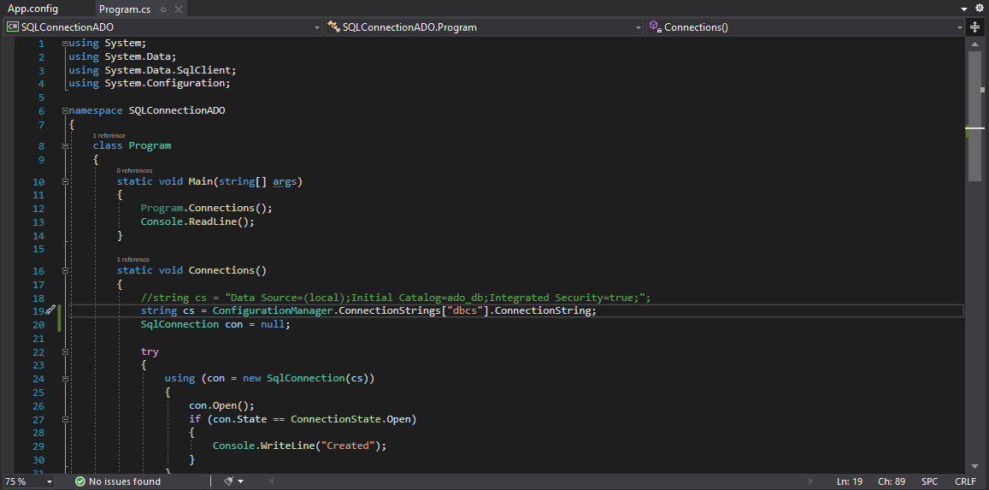

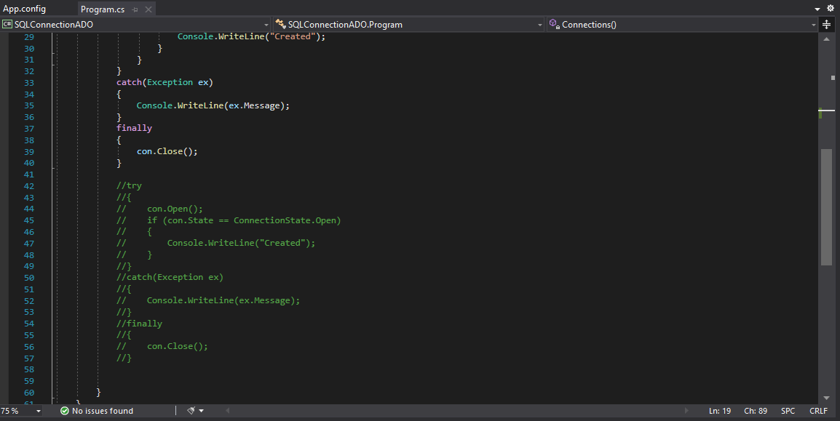

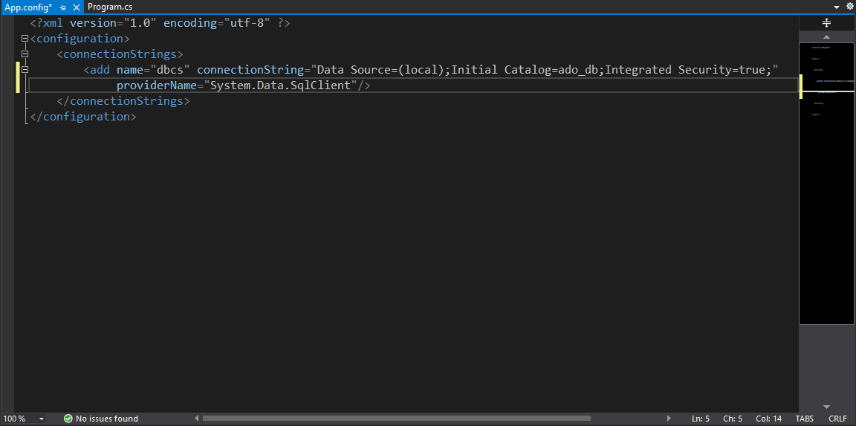

**SqlCommand Class:**

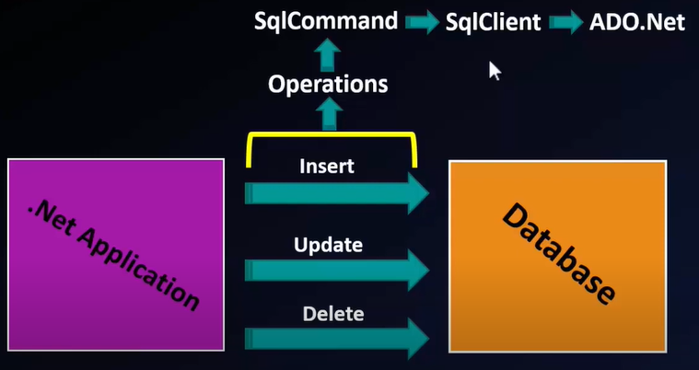

* The ADO.NET SqlCommand class in C# is used to store and execute the SQL statement against the SQL Server database.
* **SqlCommand** class is used to prepare an SQL statement or **StoredProcedure** that we want to execute on a SQL Server database.
* It is a sealed class means it cannot be inherited.
* public sealed class **SqlCommand**: System.Data.Common.**DbCommand**

**ICloneable**, **Disposable**

* If a .NET application (Web, Desktop, Console etc.) has to retrieve data, then the application needs to
  + 1. Connect to the Database
  + 2. Prepare an SQL Command
  + 3. Execute the Command sqlcommand
  + 4. Retrieve the results and display in the application
* This is the normal flow which is used by any .Net application, not only to retrieve data but also to insert, update or Delete data.
* **The SqlCommand class in C# provides the following five Overloaded constructors.**
* **SqlCommand()**
  + This constructor is used to initializes a new instance of the System.Data.SqlClient.SqlCommand class.
* **SqlCommand(string cmdText)** 
  + It is used to initializes a new instance of the System.Data.SqlClient.SqlCommand class with the text of the query. Here, the cmdText is the text of the query that we want to execute.
* **SqlCommand(string cmdText, SqlConnection connection):**
  + It is used to initializes a new instance of the System.Data.SqlClient.SqlCommand class with the text of the query and a System.Data.SqlClient.SqlConnection.
  + Here, the cmdText is the text of the query that we want to execute and the parameter connection is the connection to an instance of SQL Server.
* **SqlCommand(string cmdText, SqlConnection connection, SqlTransaction transaction):**
  + It is used to initializes a new instance of the System.Data.SqlClient.SqlCommand class with the text of the query, a SqlConnection instance, and the SqlTransaction instance.
  + Here, the parameter cmdText is the text of the query.
  + The parameter connection is a SqlConnection that represents the connection to an instance of SQL Server and the parameter transaction is the SqlTransaction in which the SqlCommand executes.
* **SqlCommand(string cmdText, SqlConnection connection, SqlTransaction transaction, SqlCommandColumnEncryptionSetting columnEncryptionSetting):**
  + It is used to initializes a new instance of the System.Data.SqlClient.SqlCommand class with specified command text, connection, transaction, and encryption setting.
  + We already discussed the first three parameters which are the same as the previous. Here, the fourth parameter i.e. columnEncryptionSetting is the encryption setting.
* **Important Methods Of SqlCommand Class**
* Among all specified methods, following are the most commonly used methods of the SqlCommand class.
  + ExecuteReader()
  + ExecuteNonQueryl)
  + ExecuteScalar()

**ExecuteReader():**

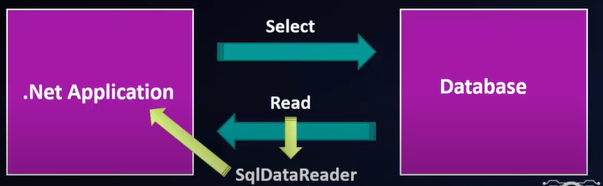

* It is used when the T-SQL statement returns more than a single value. For example, if the query returns rows of data like all employee details.
* We must have Open and close the connection. To ensure that connections are always closed, open the connection inside of a **using block**.
* ADO.NET DataReader object is used for accessing data from the data source.
* String query = "select * from Employee";
* SqlCommand cmd = new SqlCommand(query, con);
* SqlDataReader dr = cmd.ExecuteReader();

This will return SqldataReader Instance

* The **DataReader** object in C# ADO.NET allows you to retrieve data from database in **read-only** and **forward-only** mode.

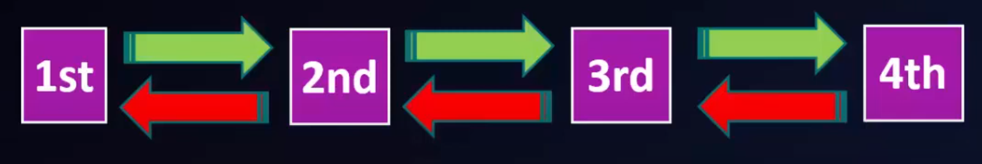

* ADO.Net SqlDataReader Class Signature

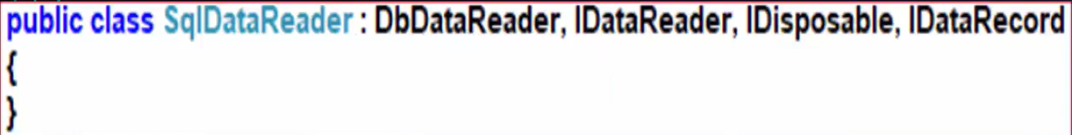

* It means you can only read and display data but can't update or delete data.
* If you want to make modification in retrieved data you need to use **DataAdapter** instead of DataReader.
* SqlDataReader Object provides a **connection oriented** data access to the SQL Server data Sources from C# applications.
* **ExecuteReader()** in the SqlCommand Object sends the SQL statements to the SqlConnection Object and populate a SqlDataReader Object based on the SQL statement or Stored Procedures.
* **Object** of SqlDataReader cannot be created using **new** keyword.
* SqlData Reader dr = new SqlData Reader();
* **ExecuteReader()** method of SqlCommand create and returns an object of SqlDataReader.
* **SqlDataReader is read-only**. It means it is also not possible to change the data using SqlDataReader.
* You also need to open and close the connection explicitly.
* **WHY AND WHEN TO USE DATAREADER?**
* When you want to only display information or search result, you can use DataReader. There are various advantages of using DataReader like:
  + The retrieved data is stored in the network buffer in the client and then the client can read data using Read method. As data gets stored in the client network buffer it increases application performance significantly.
  + By default DataReader stores only one row at a time in memory. It reduces system overhead.

**Properties Of SqlDataReader Class:**

* **FieldCount (int):** It gets the number of columns in the current row.

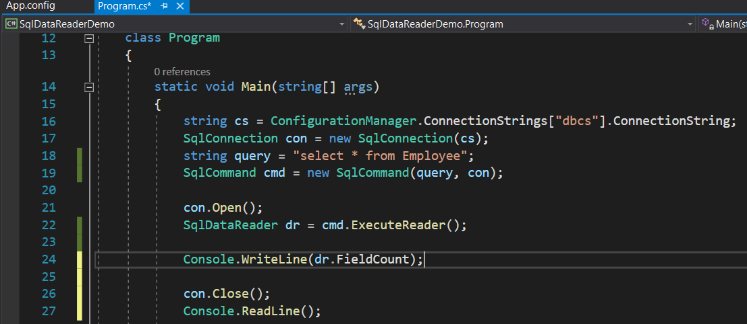

* **HasRows (boolean):** It gets a value that indicates whether the System.Data.SqlClient.SqlDataReader contains one or more rows. It return Boolean value.

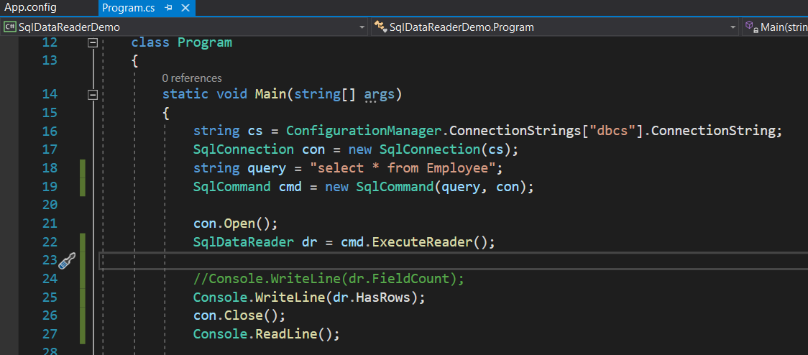

* **IsClosed:** It retrieves a Boolean value that indicates whether the specified System.Data.SqlClient.SqlDataReader instance has been closed.

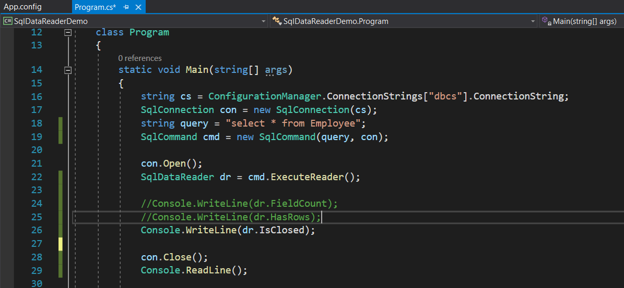

* **Item [String]:** It gets the value of the specified column in its native format given the column name.



* **Item [Int32]:** It gets the value of the specified column in its native formativen the column ordinal.



**Methods Of SqlDataReader Class:**

* **Read():** It Advances the System.Data.SqlClient.SqlDataReader to the next record and returns true if there are more rows; otherwise false
  + +You can read data by using **concatenation** and **placeholder** syntax in console application.

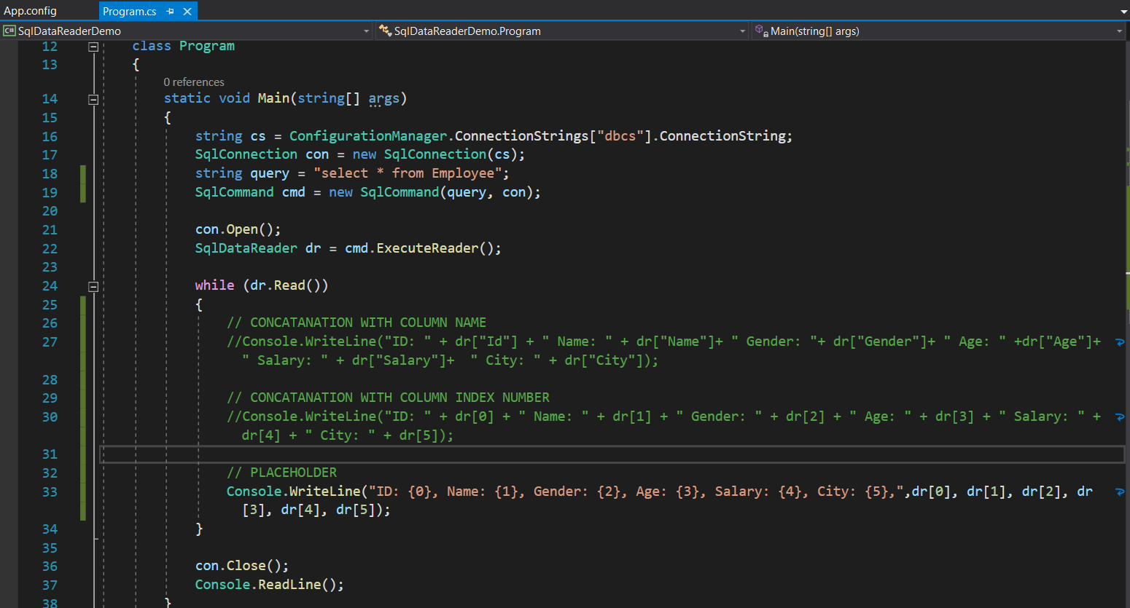

* **GetName(int i):** It gets the name of the specified column name. Here, parameter i is the zero-based column ordinal.

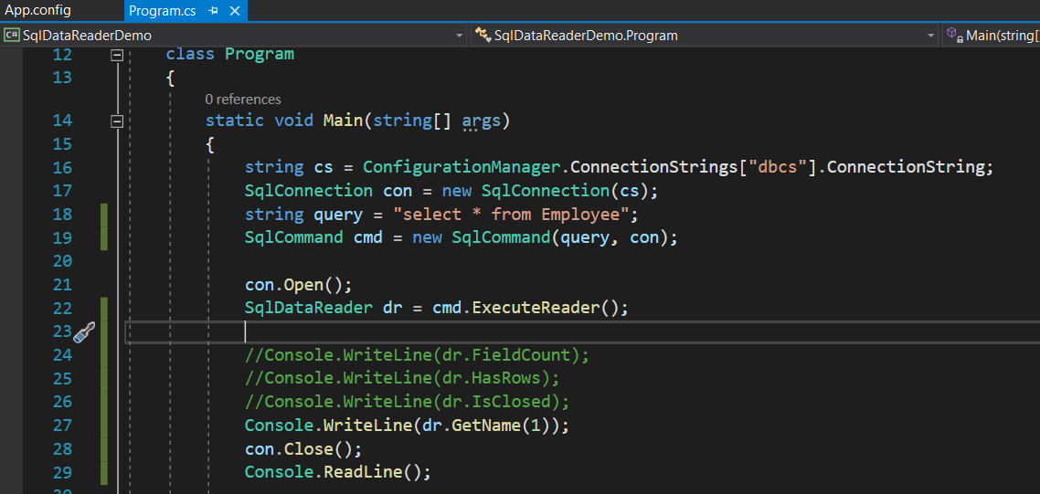

* **NextResult():** It advances the data reader to the next result when reading the results of batch Transact-SQL statements.

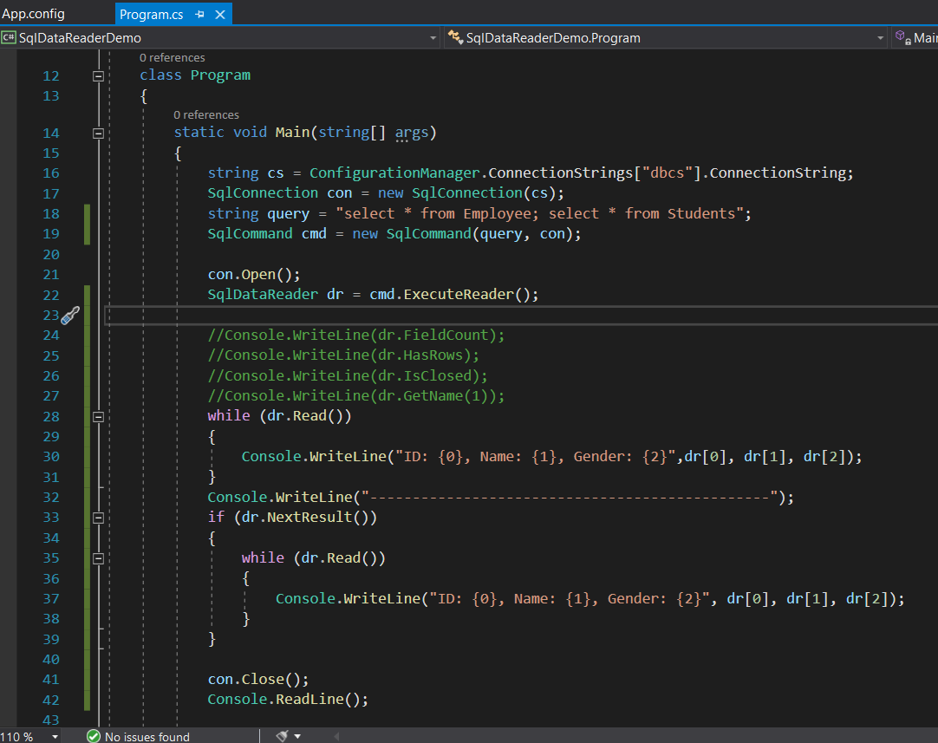

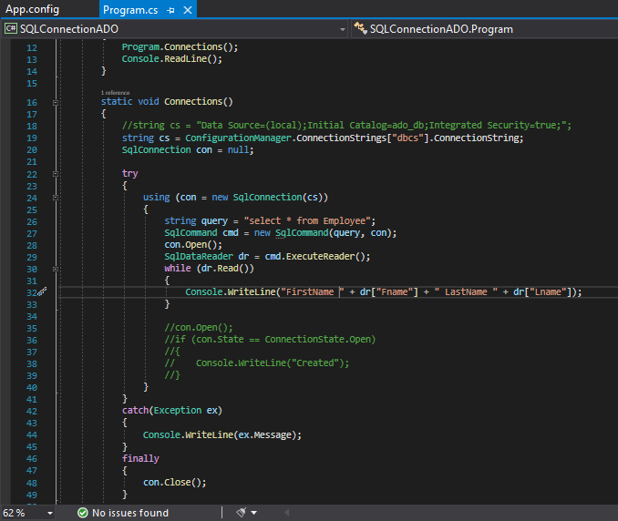

* 3 Properties
  + CommandText
  + Connection
  + CommandType : Calling for store procedure

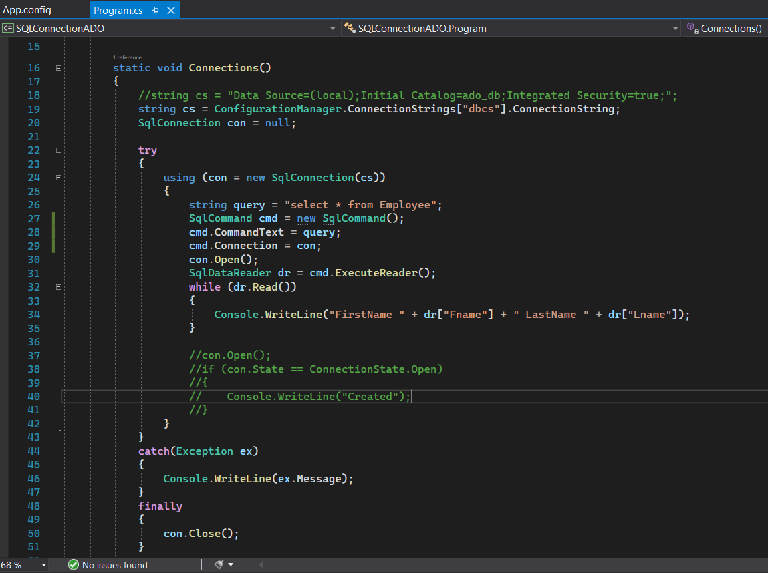

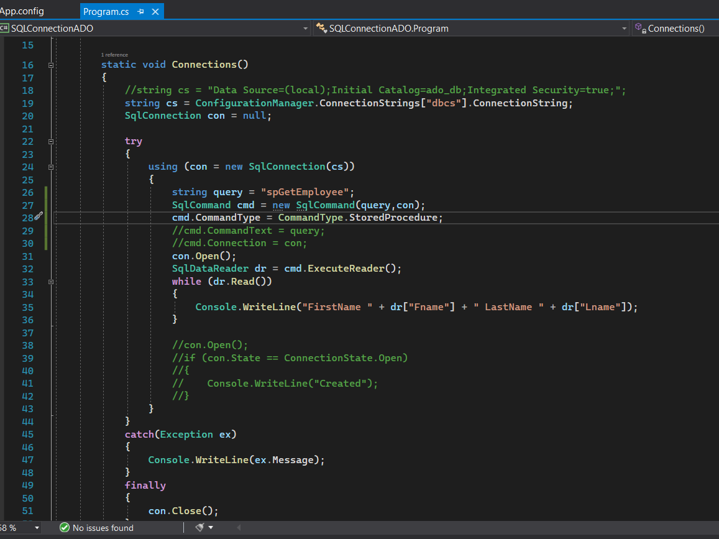

**ExecuteNonQuery():**

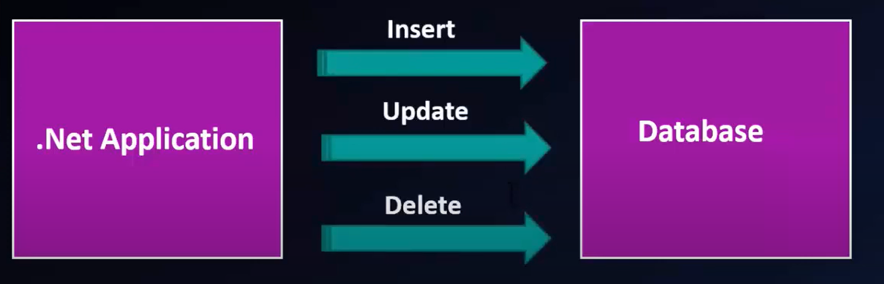

* It returns Int value.
* it is used when you want to perform an Insert, Update or Delete operation like update or delete an employee detail or insert employee data.

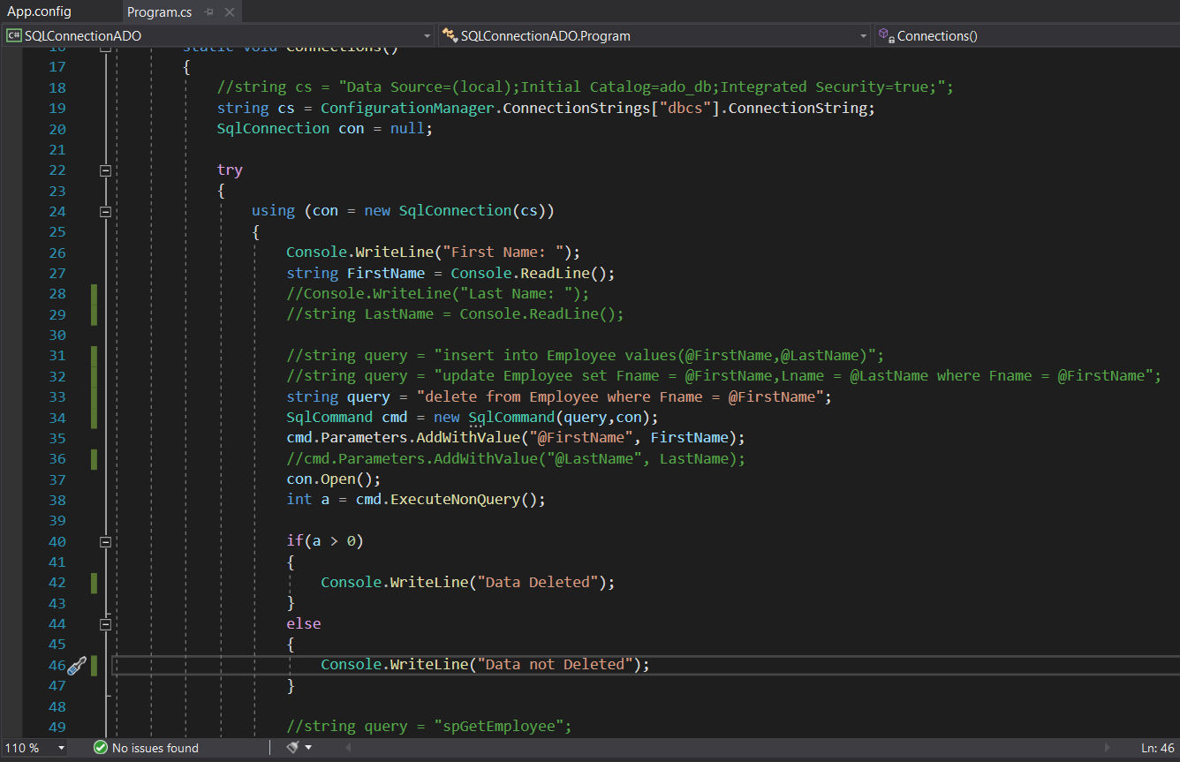

**ExecuteScalar():**

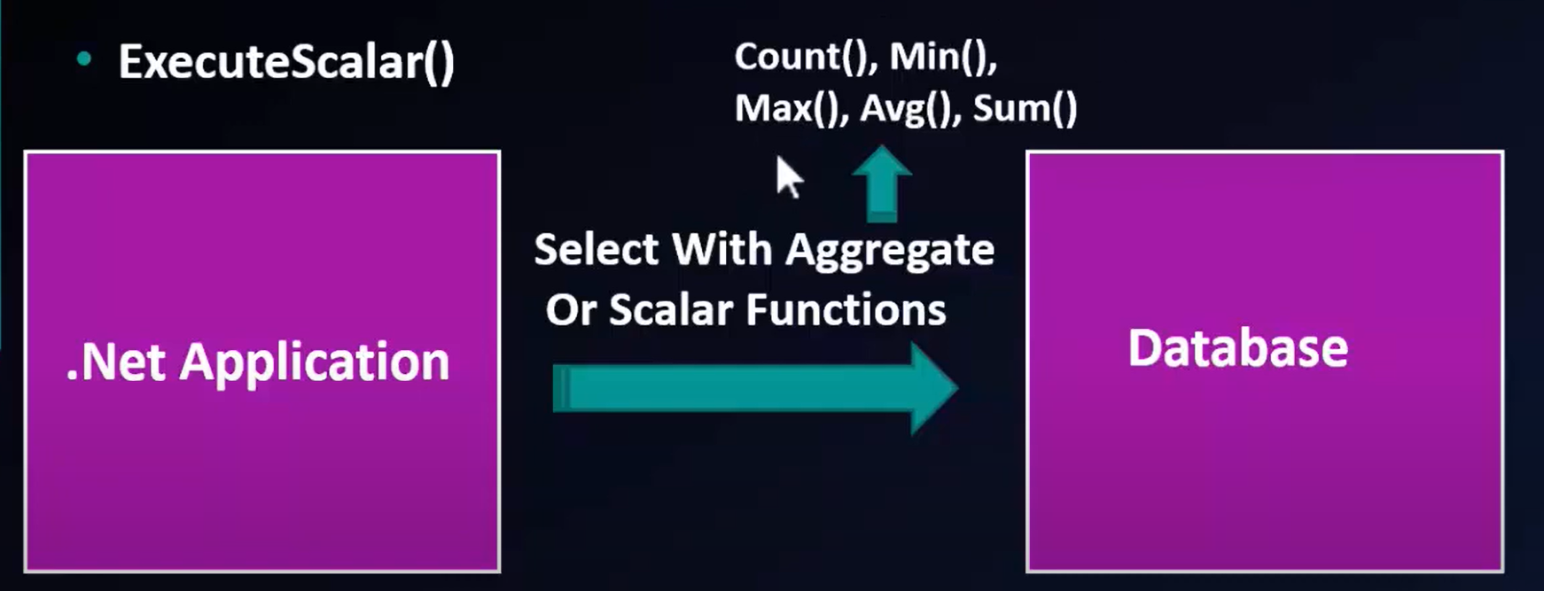

* it is used when the query returns a single(scalar) value. For example, queries that return the total number of rows in table, or the employee who gets highest salary etc.

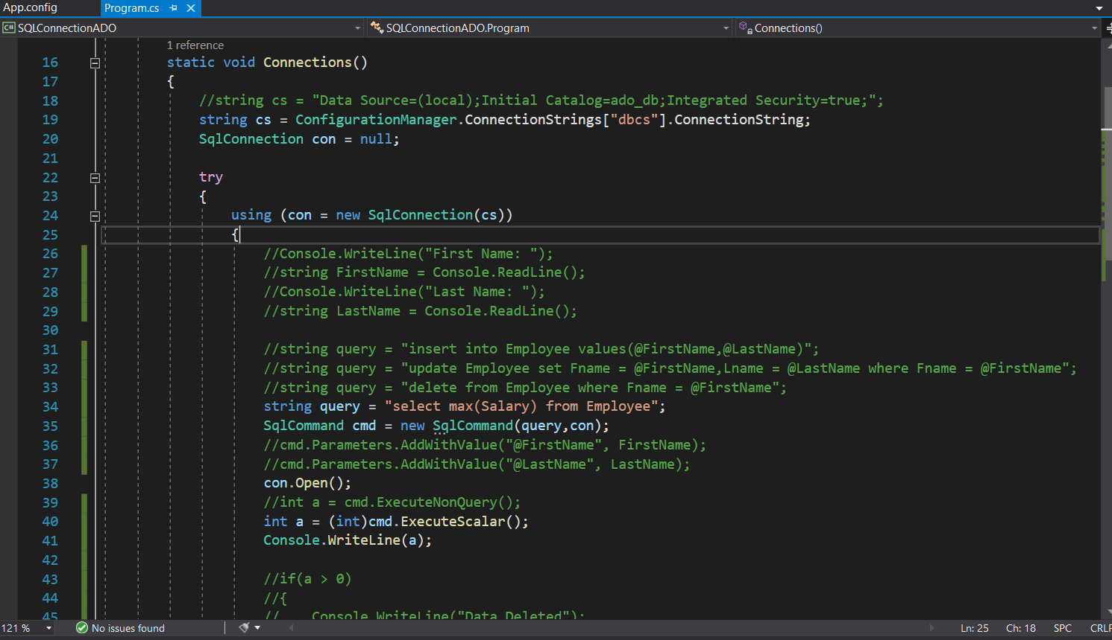

**SqlDataAdapter Class in ADO.Net:**

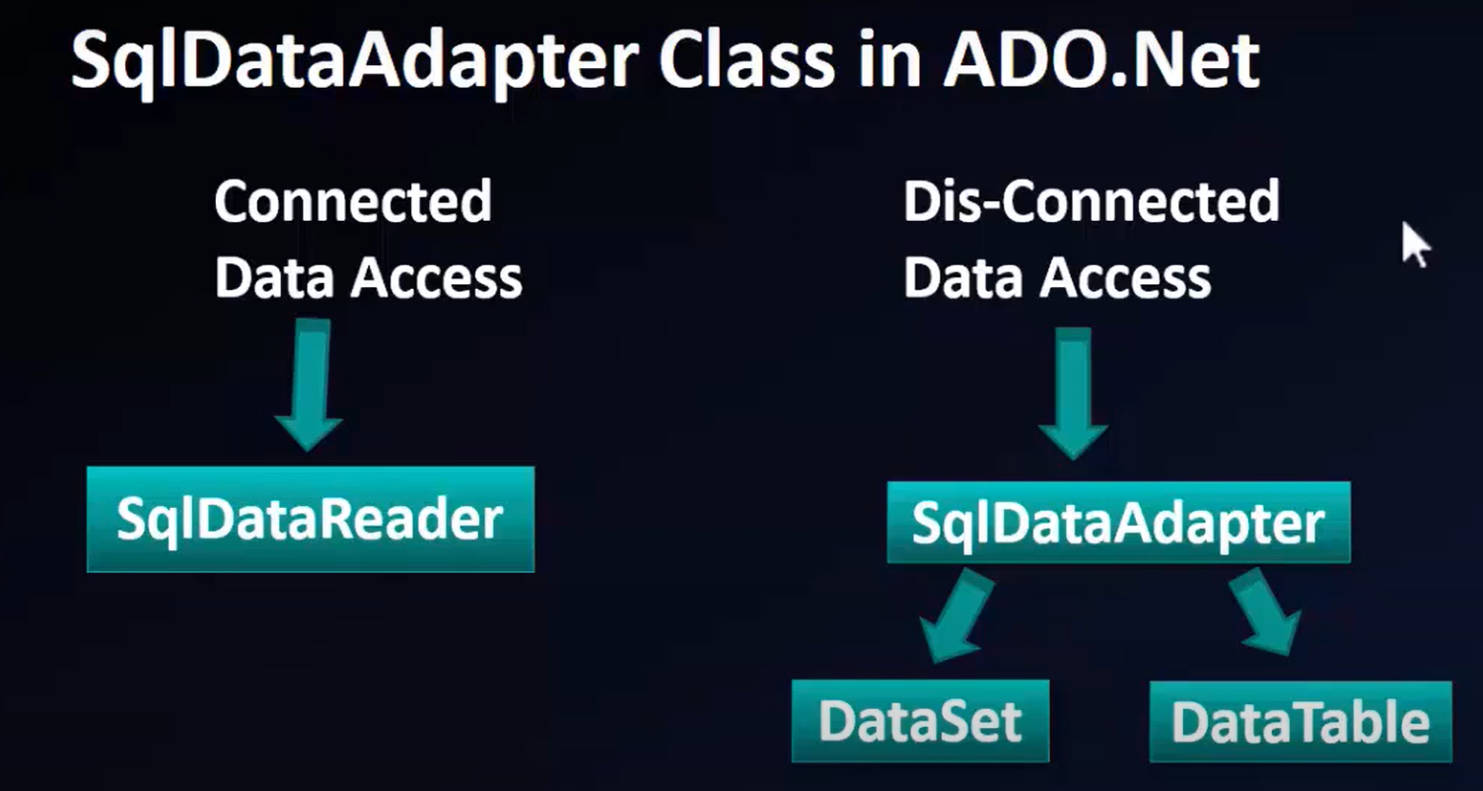

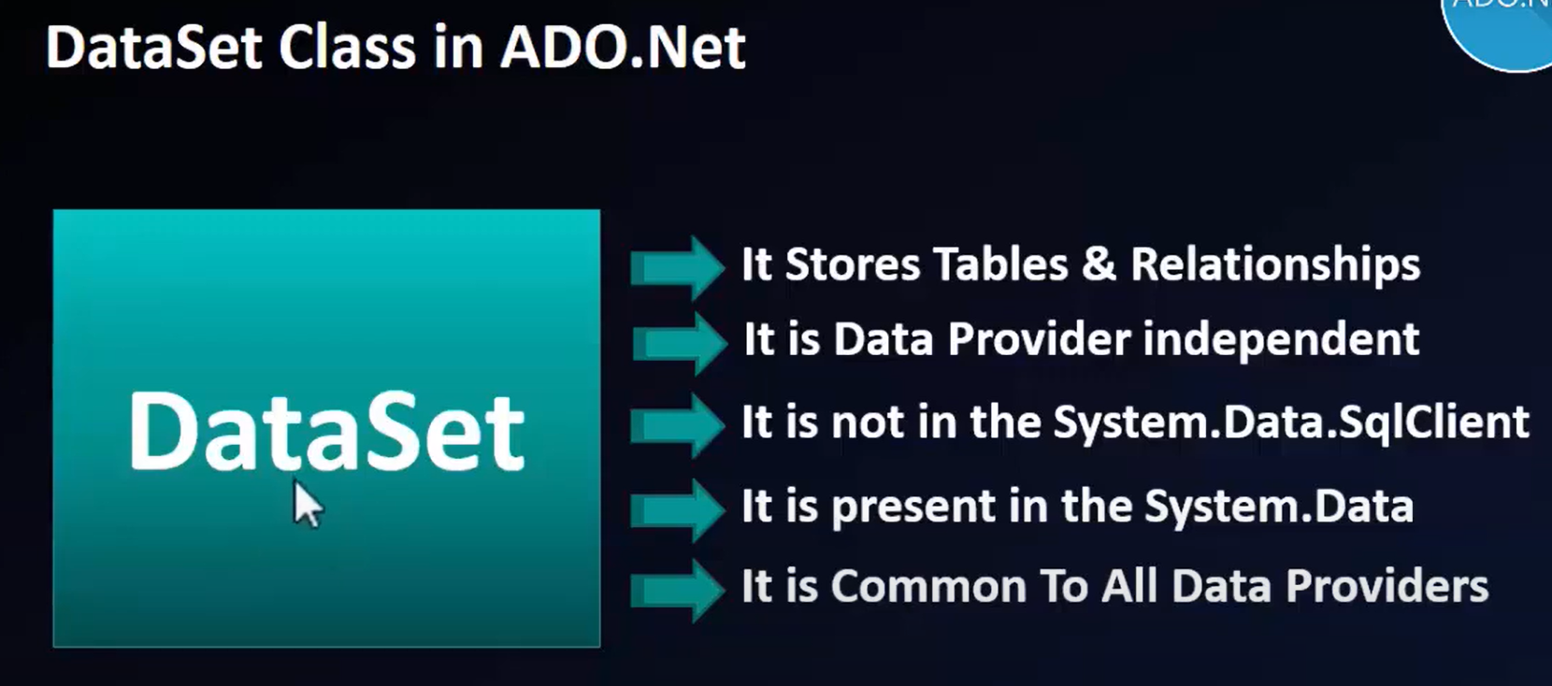

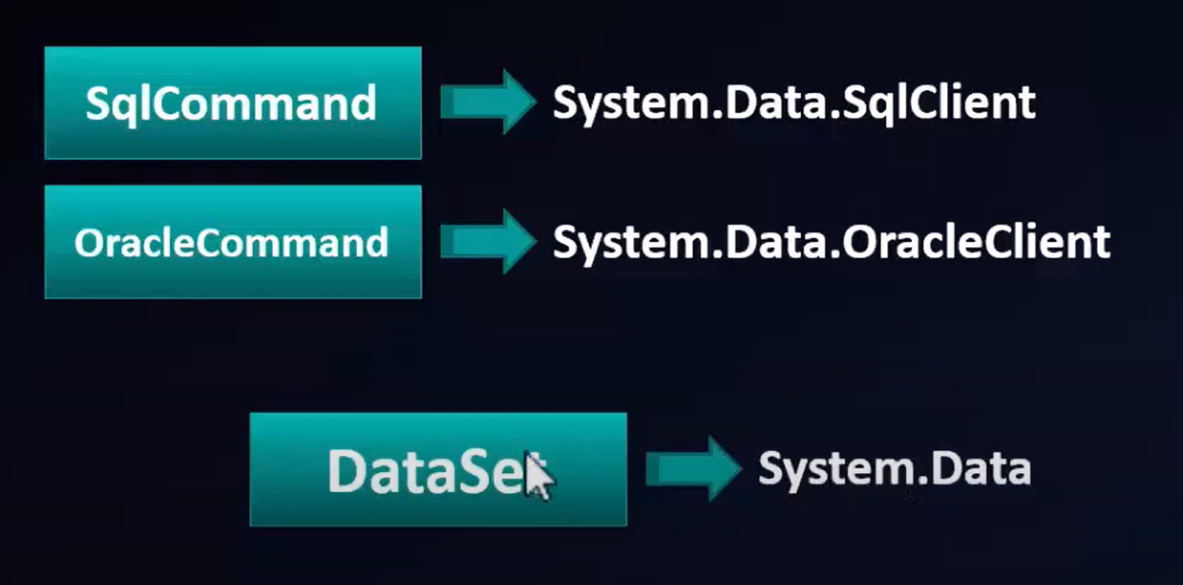

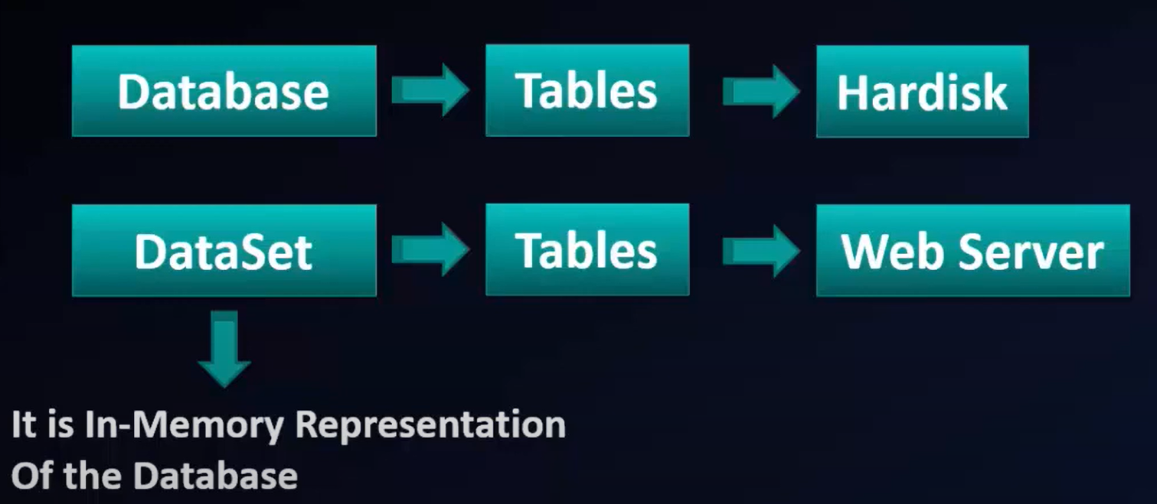

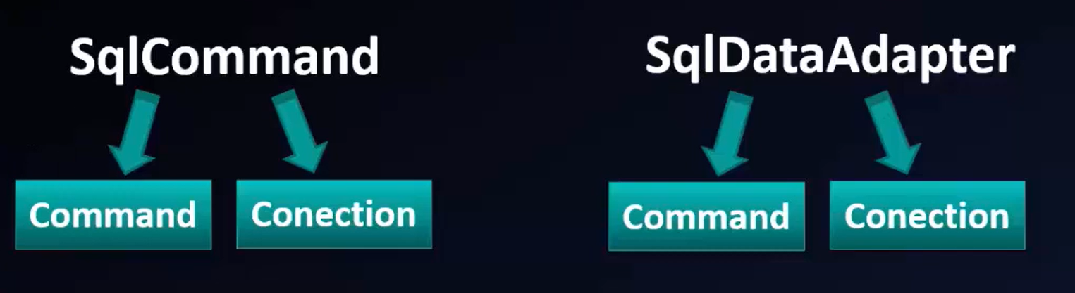

* The SqlDataAdapter class is found in the **System.Data.SqlClient** namespace.
* It is a very important class in the .NET framework.
* It works as a bridge between **DataSet** and **Database**.
* It opens the database connection, executes the SQL statements and closes the connection at last. There is no need to open and close the connection.
* The SqlDataAdapter is a class that represents a set of SQL commands and a database connection.
* It can be used to fill the DataSet and update the data source.
* Both DataSet and DataTable are in-memory data stores, that can store tables, just like a database.

**Fill Method of SqlDataAdapter:**

* This method does most of the work behind us.
* It opens the connection to the database, executes the SQL command, fills the dataset and data tables with the data, and closes the connection.
* This method handles the Opening and Closing of the database connections automatically for us.
* The connection is kept open only as long as it is needed. That means once the Fill method completes its execution, then the connection closes automatically.
* Finally, we are using DataRow to loop through each record and print the data on the console.
* Once the dataset or data table is filled, then no active connection is required to read the data.

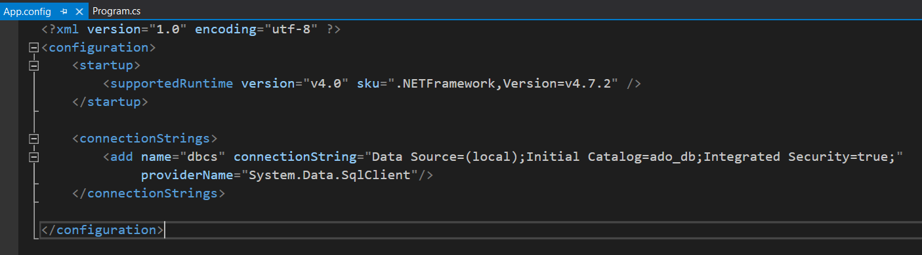

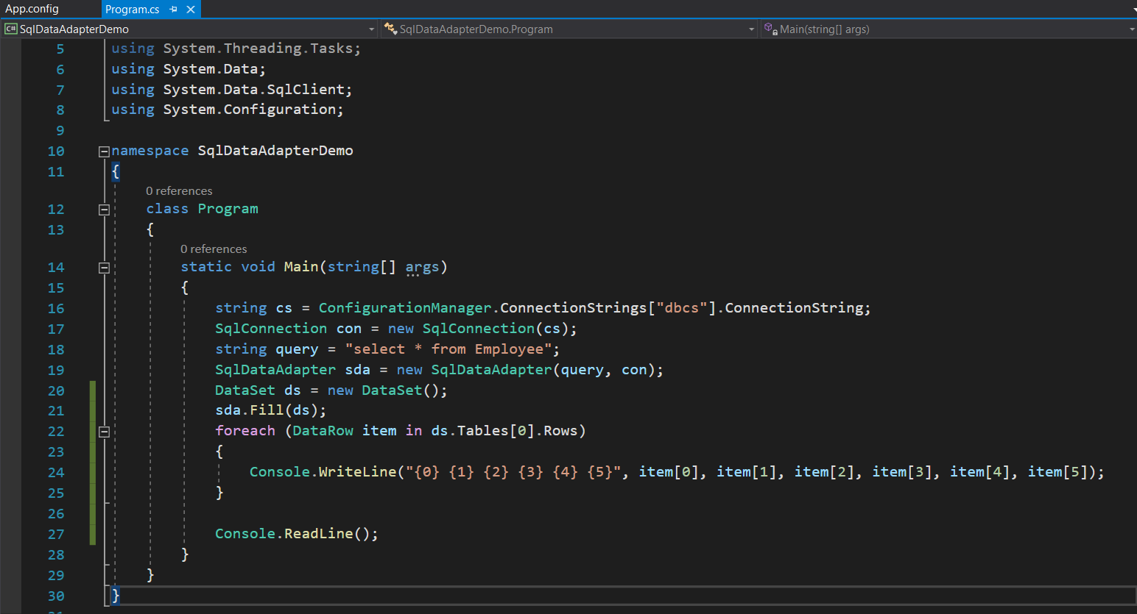

**Sq|DataAdapter Signature:**

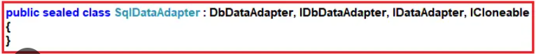

**How to call a stored procedure using SqlDataAdapter in C#?**

* In order to execute a stored procedure using SqlDataAdapter in C#, we just need to specify the name of the stored procedure instead of the in-line SQL statement and then we have to specify the command type as StoredProcedure using the command type property of the SqlDataAdapter object.

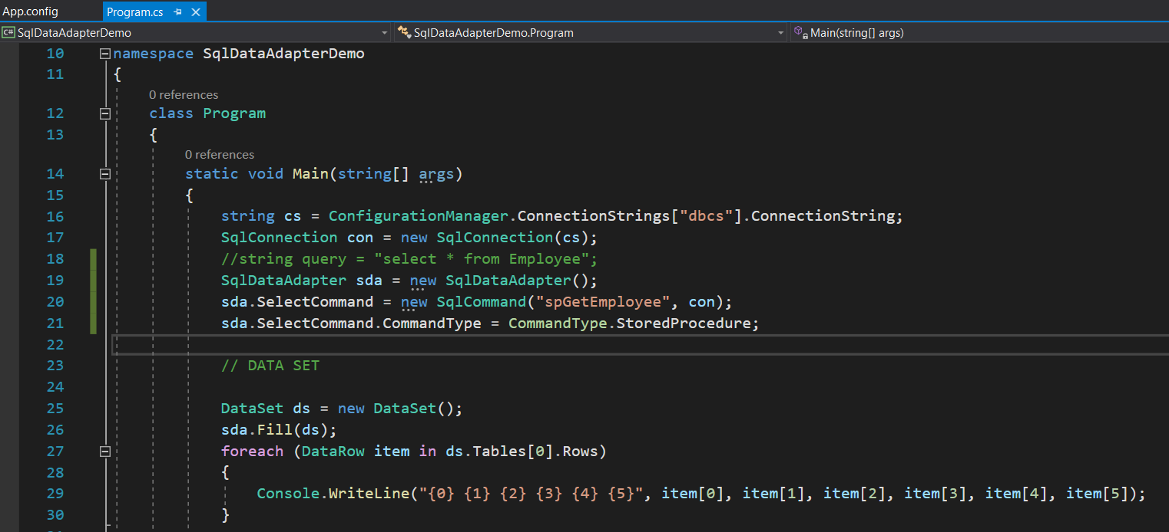

* We can call stored procedure with input parameters.

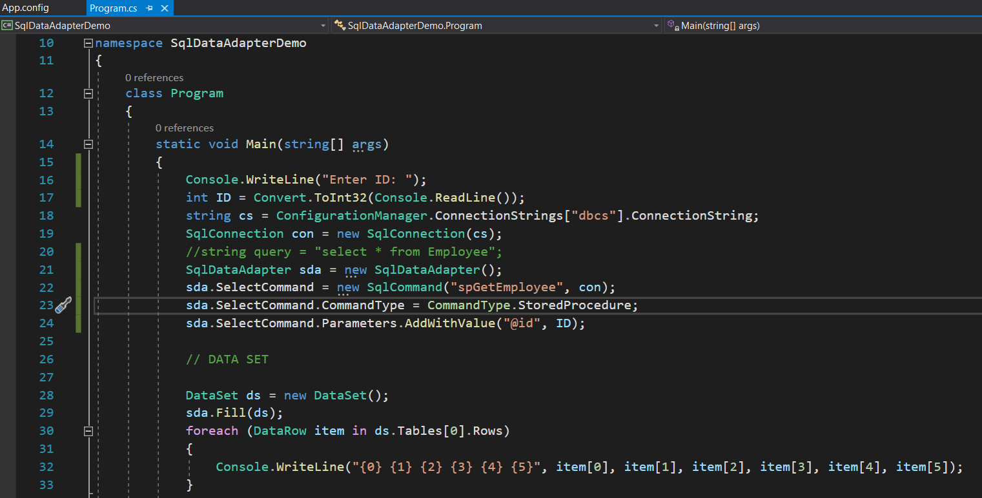

**DataTable in ADO.Net:**

* DataTable represents relational data into **Tabular Form**.
* DataTable in C# is similar to the Tables in SQL.
* ADO.NET provides a DataTable class to create and use data table independently or we can get data from database table in DataTable.
* It can also be used with **DataSet** also.
* Initially, when we create **DataTable**, it does not have **table schema (table structure).**
* We can create table schema by adding **columns** and **constraints** to the table.
* After defining table **schema (table structure)**, we can add rows to the table.
* DataTable is a combination of **DataColumn** and **DataRow**.
* We must include **System.Data** namespace before creating DataTable.

**Properties Of DataColumn in ADO.Net:**

* Caption
* DataType
* AllowDBNull
* MaxLength
* PrimaryKey -> Property of DataTable
* AutoIncrement
  + AutoIncrementSeed -> Starting Value
  + AutoIncrementStep -> Incremented Value
* Default
* Unique

Data provide manually:

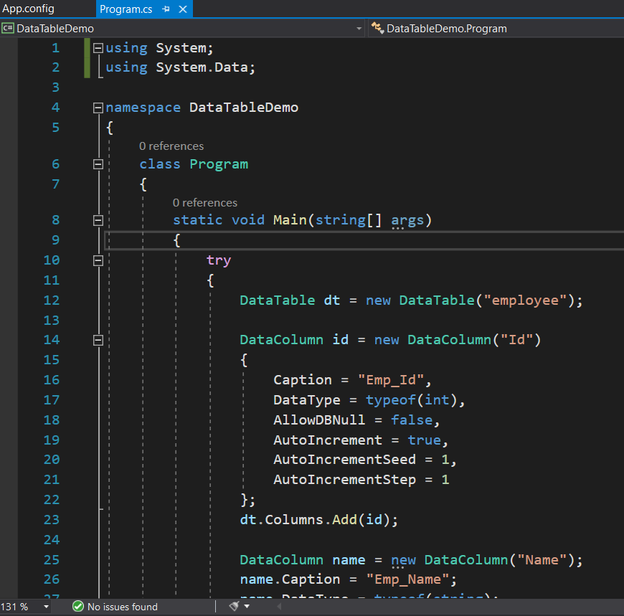

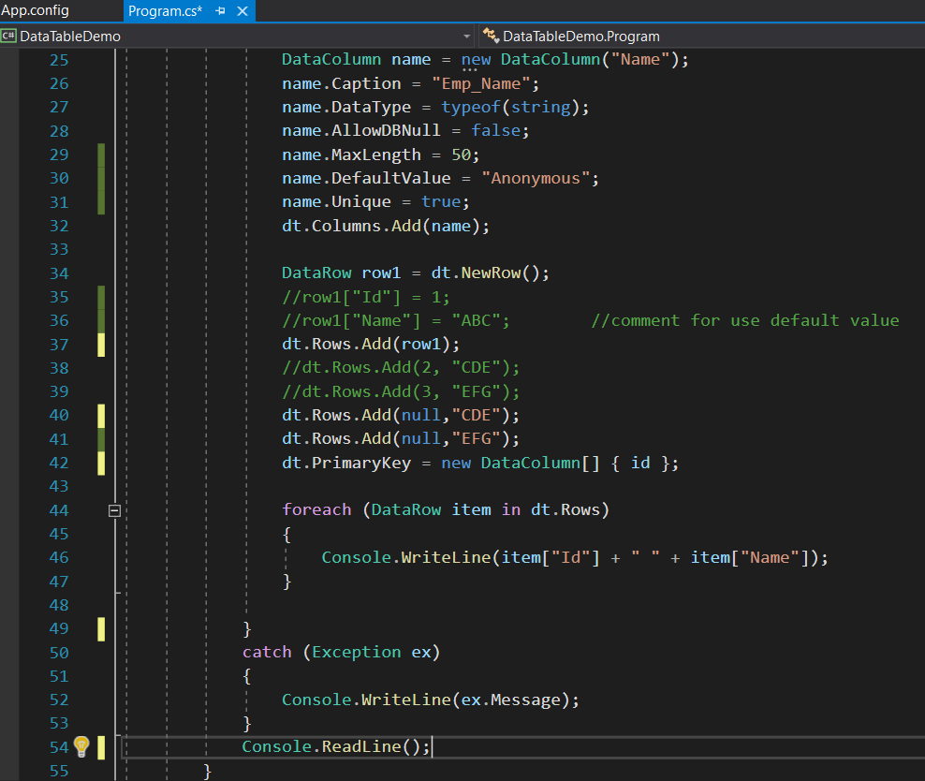

Data provide by Database:

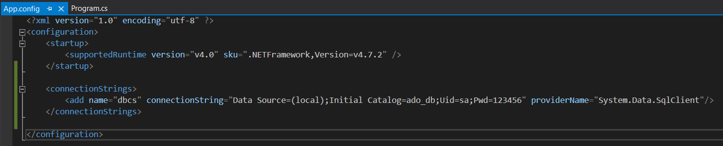

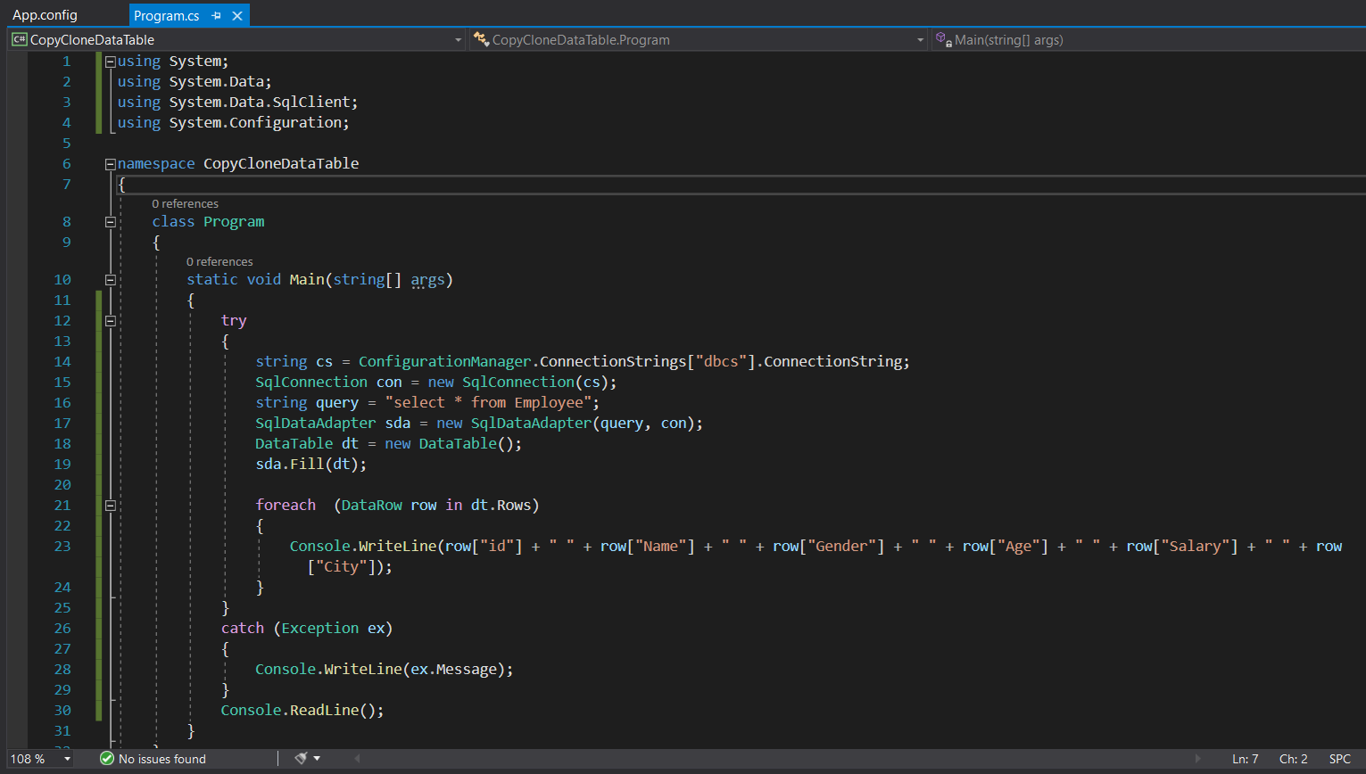

**Copy() & Clone() Methods Of DataTable in ADO.Net:**

* **DataTable.Copy()** returns a DataTable with the **structure** and **data** of the DataTable.

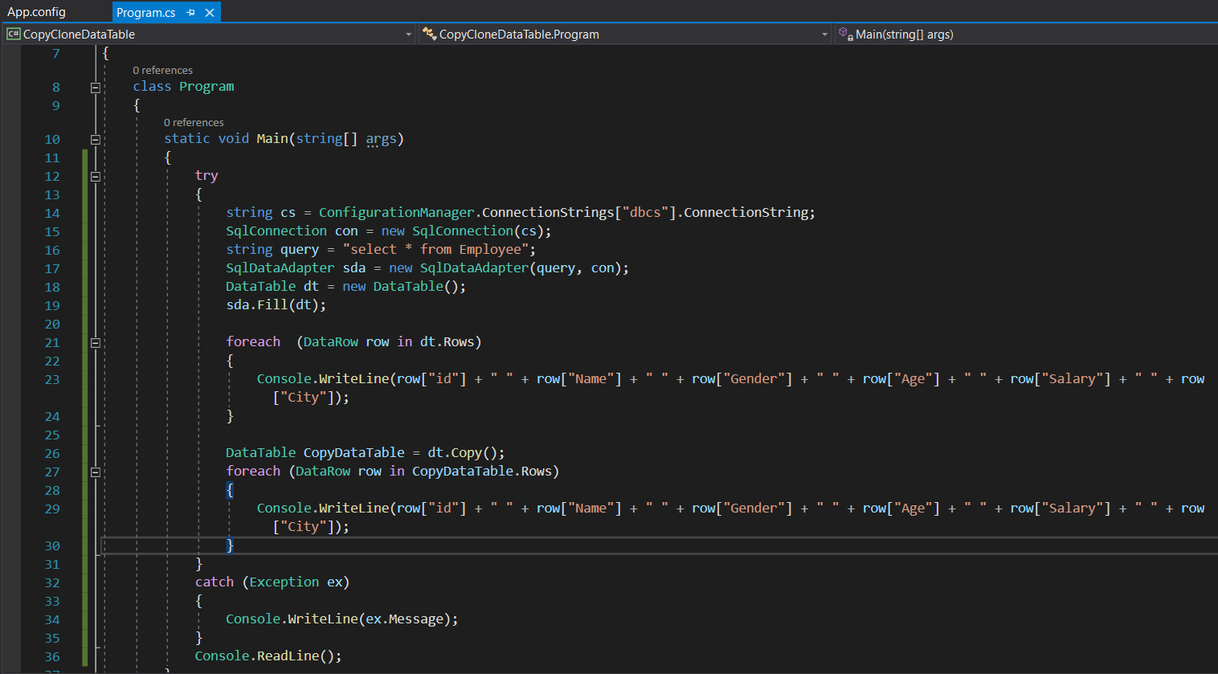

* **DataTable.Clone()** only returns the structure of the DataTable, not the rows or data of the DataTable.

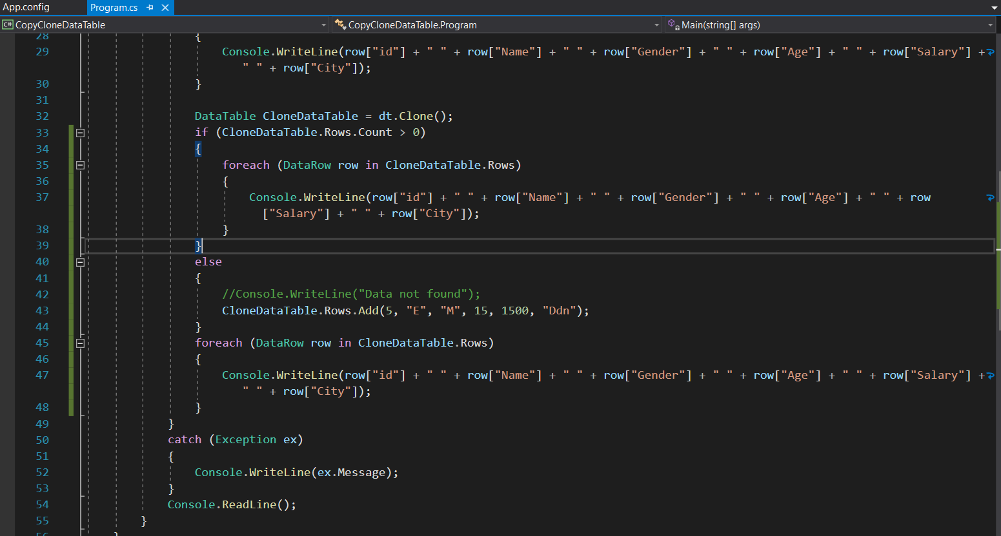

**DataSet in ADO.Net:**

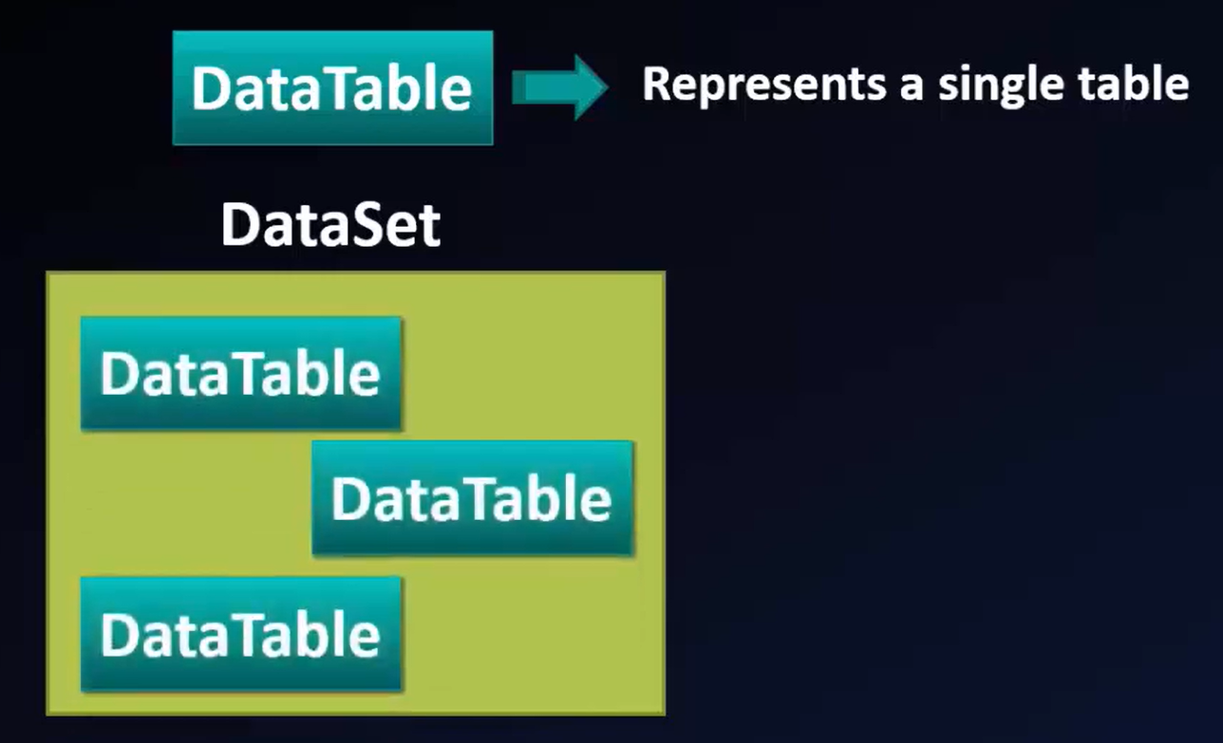

* DataSet represents multiple tables As DataTable objects.
* Both DataTable & DataSet resides In Dis-Connected Architecture.
* In Both cases SqlDataAdapter class is used To fill the data in DataSet & DataTable.
* The **DataSet** class is a very **important** class of ADO.NET.
* It is used in **disconnected architecture**.
* It does not require a open or active connection to the database.
* It stores record of one or more **data tables**.
* It is a **collection** of data tables that contain the data.
* DataSet is **tabular** representation of data.
* Tabular representation means it represents data into row and column format.
* It represent records in the form of Database table (Row and Column) format.
* We can use Dataset in combination with **DataAdapter Class.**
* The Dataset contains the copy of the data we requested.
* The Dataset contains more than one Table at a time.
* A **DataSet** is a local copy of your Database Table that gets populated in client PC.
* It is independent of Data Source and because it exists in the local system, it makes application fast and reliable.
* We can set up **Data Relations** between these tables within the DataSet.
* The **DataAdapter Object** allows us to populate **DataTables** in a DataSet.
* We can use Fill method of the **DataAdapter** for populating data in a Dataset.
* The ADO.NET DataSet class belongs to the **System.Data** namespace.
* DataSet is an in-memory representation of a collection of database objects including related tables, constraints and relationships among the tables.
* We can say that the DataSet is a small database because it stores the schema and data in the application memory area.

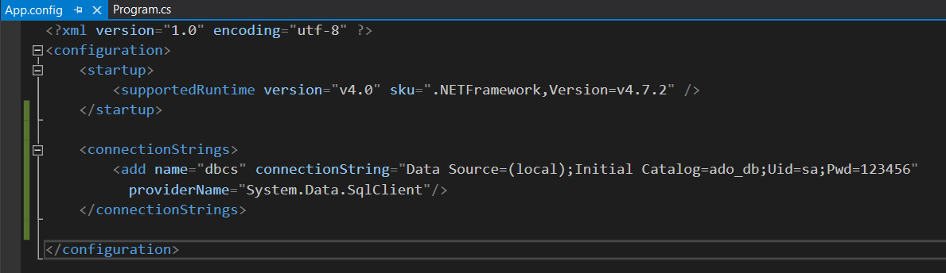

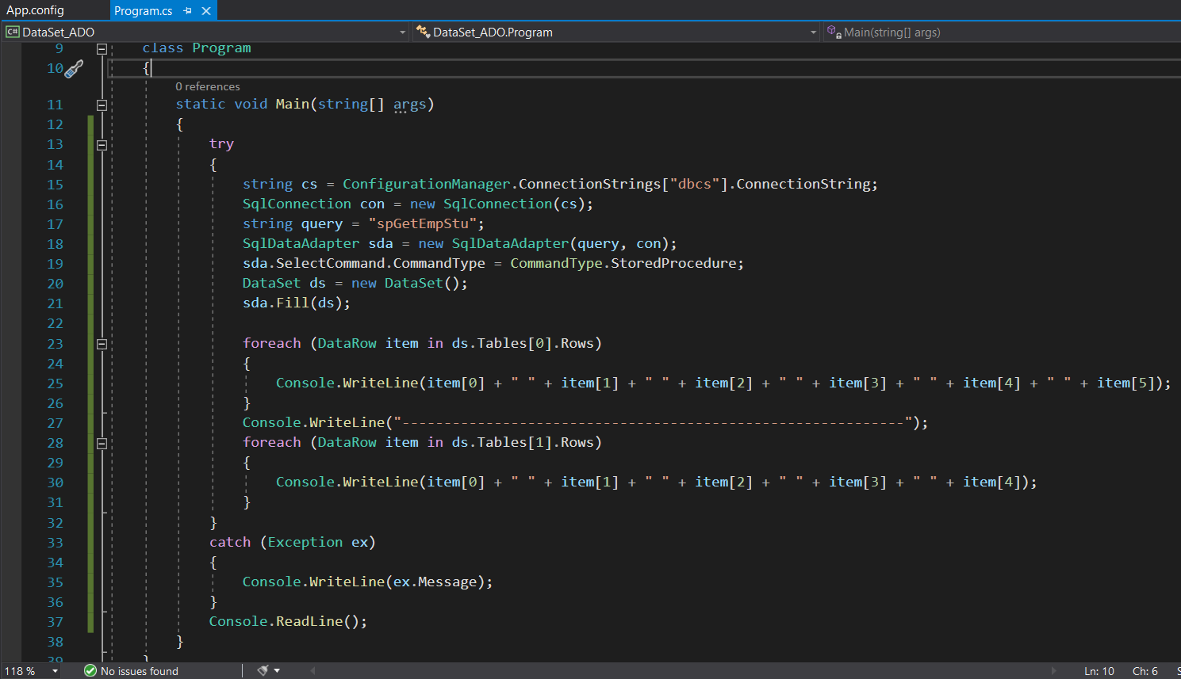

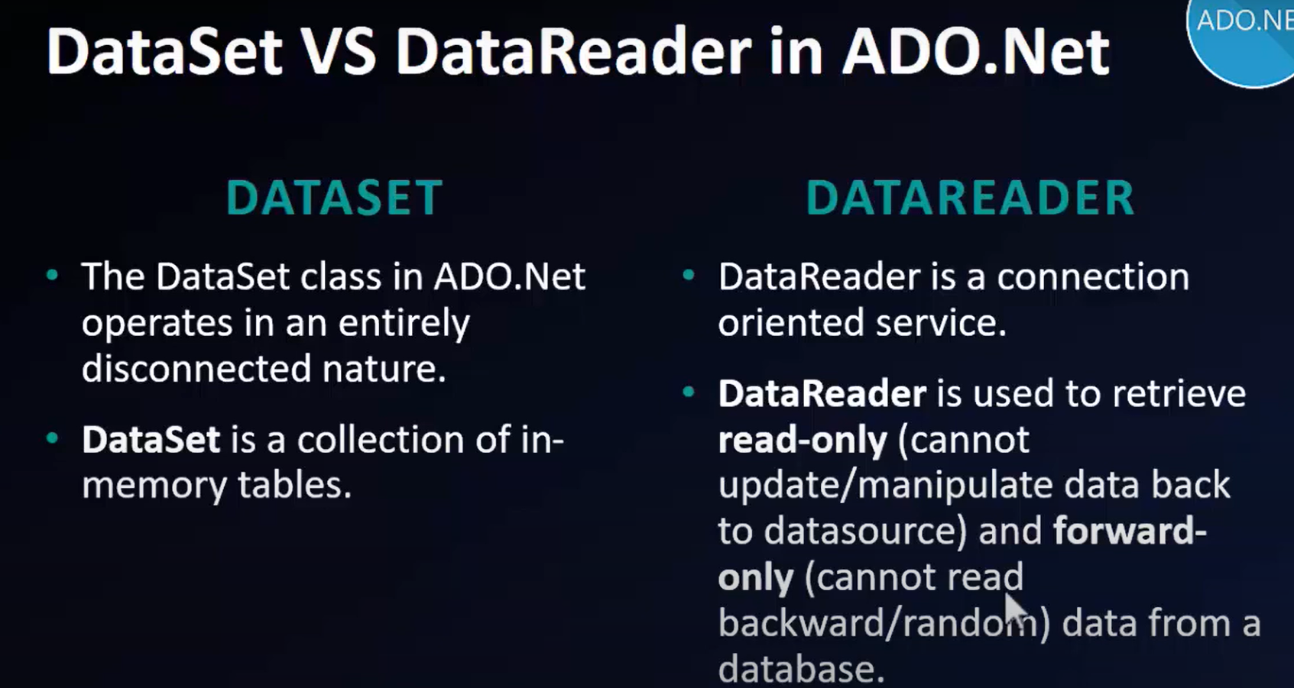

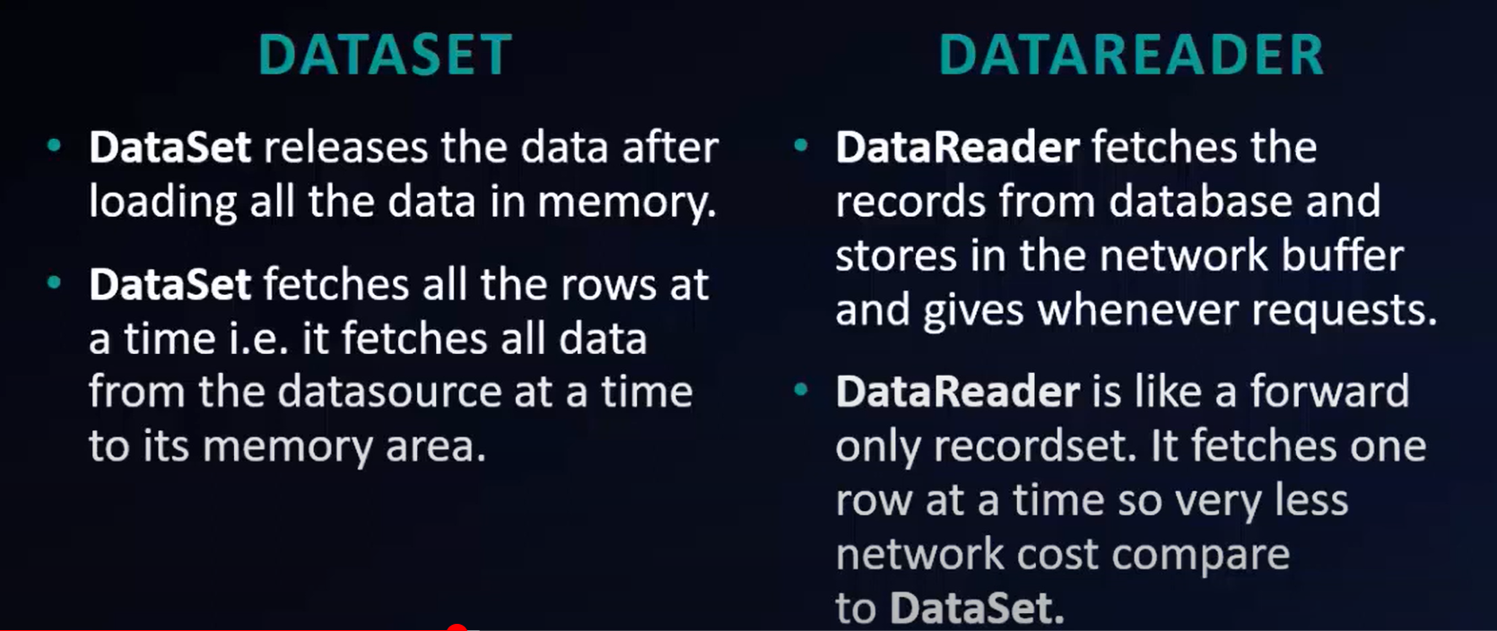

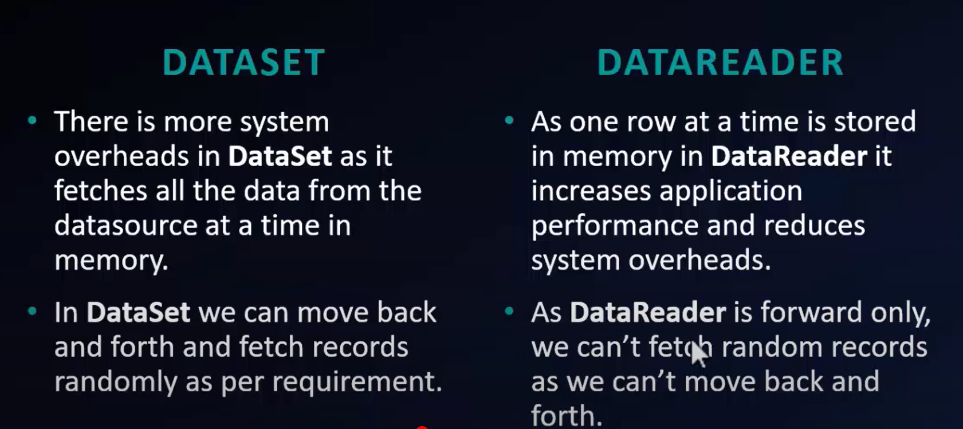

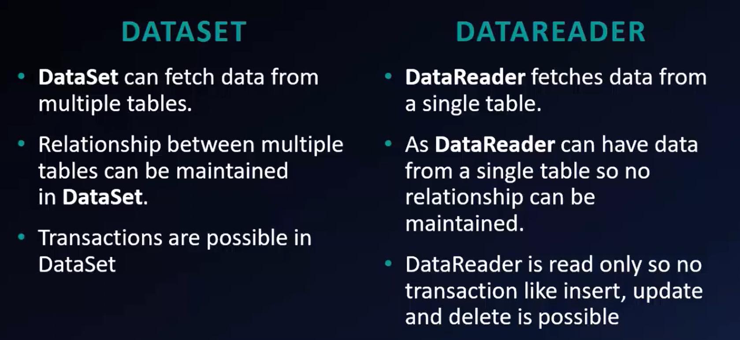

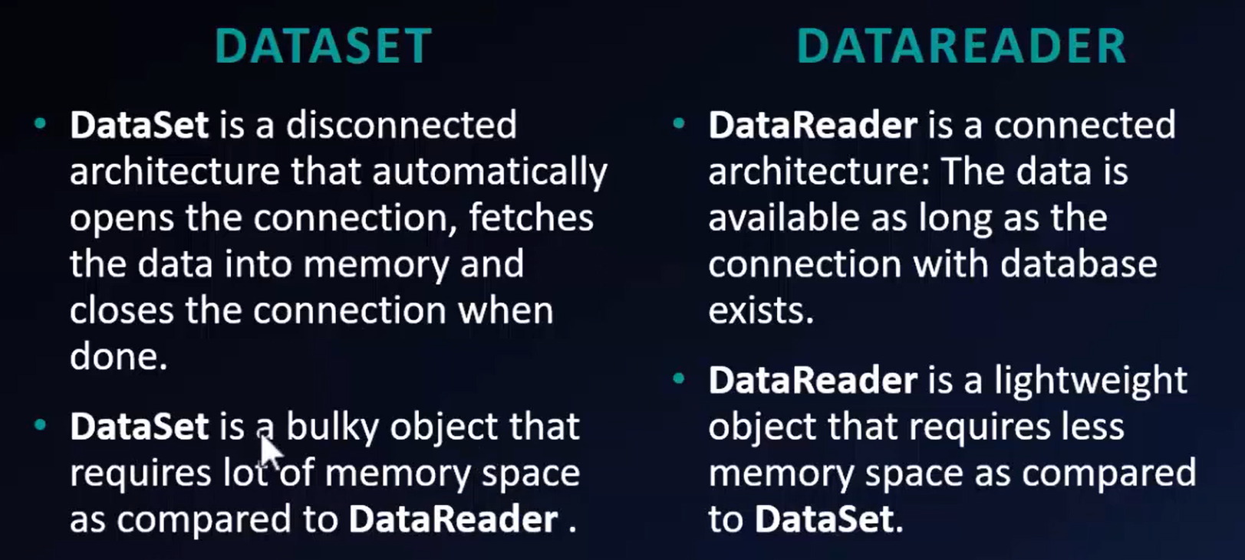

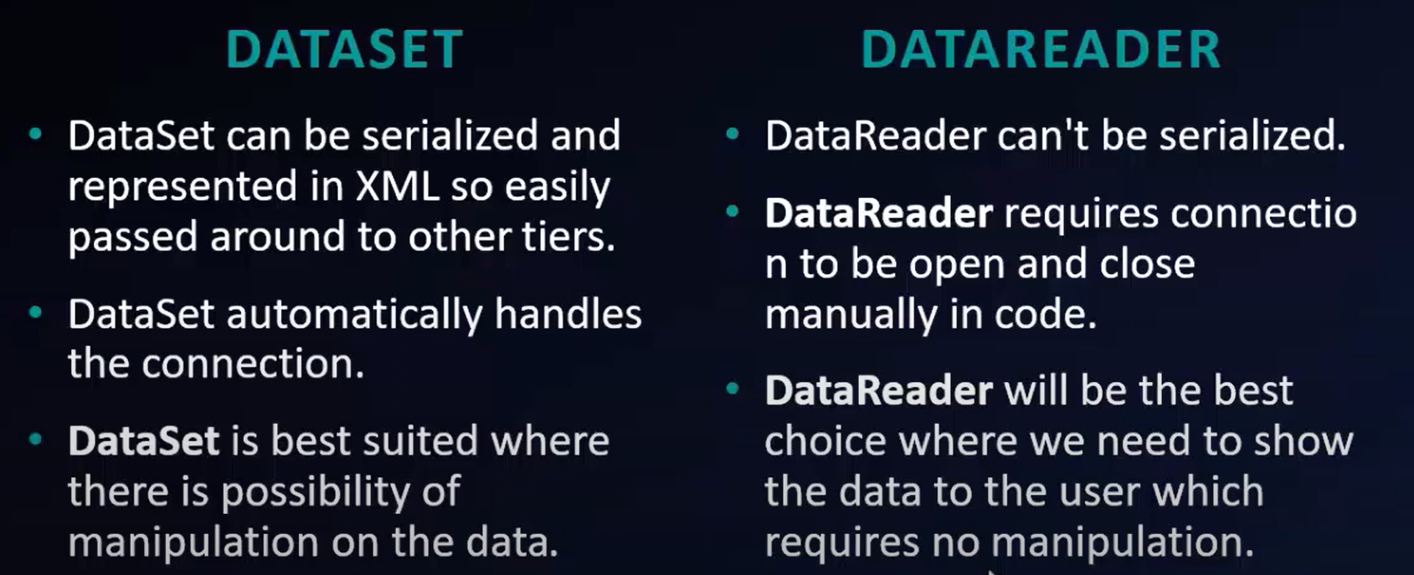

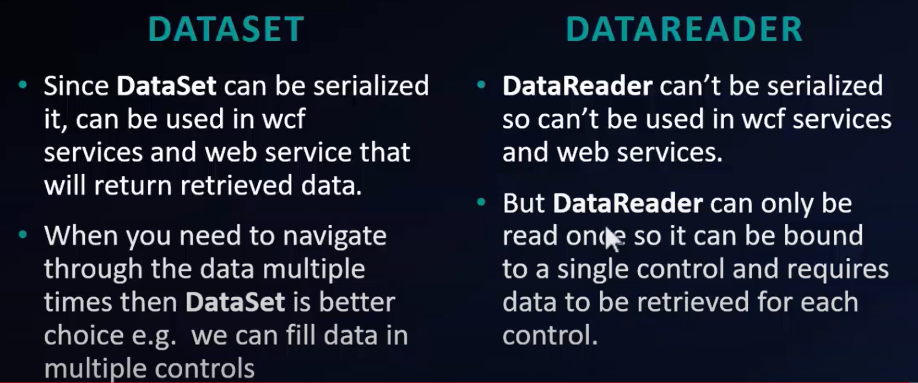

**Crud Operations In ASP.Net MVC Using ADO.Net:**

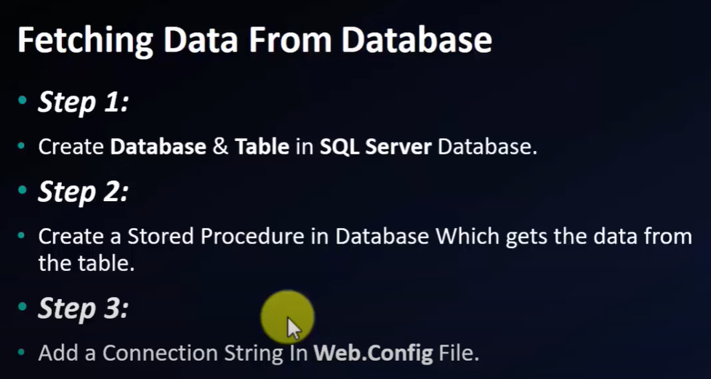

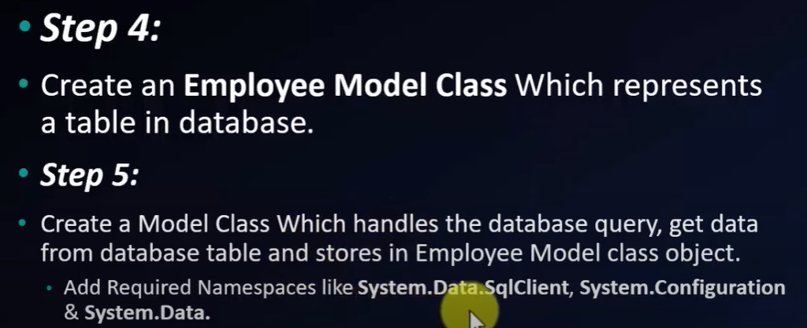



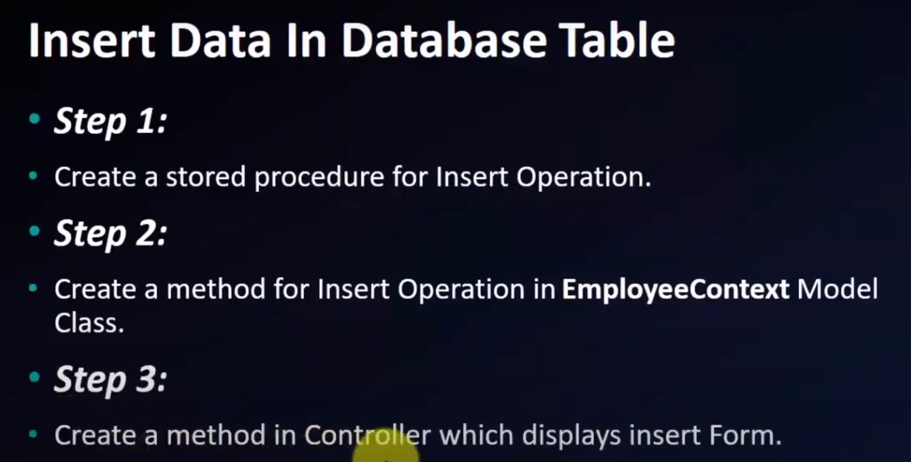

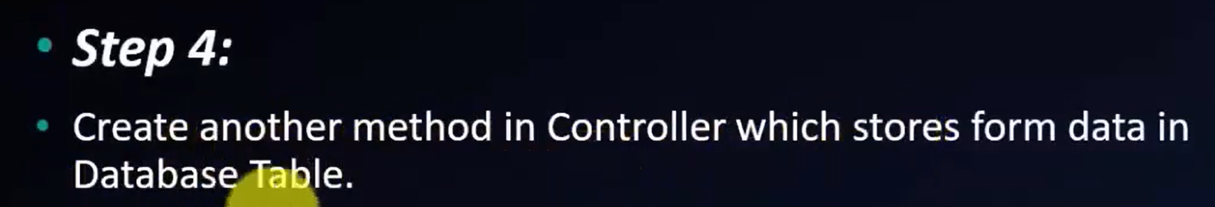

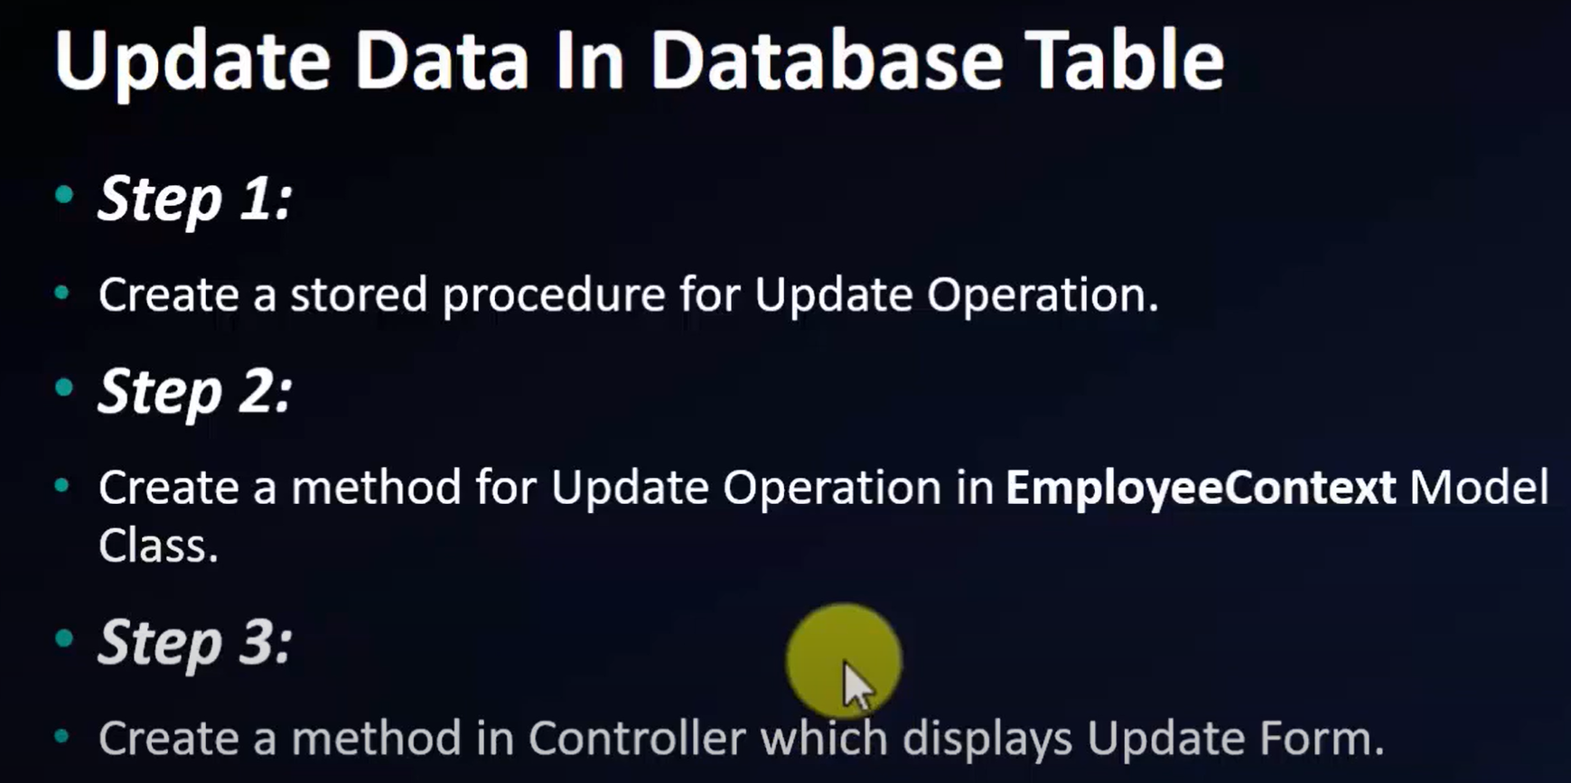

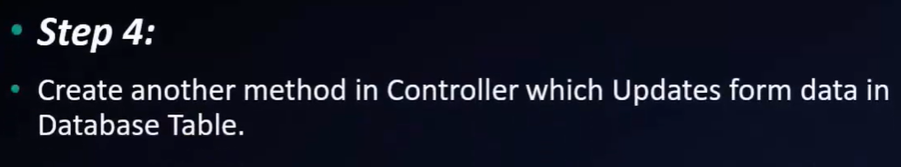

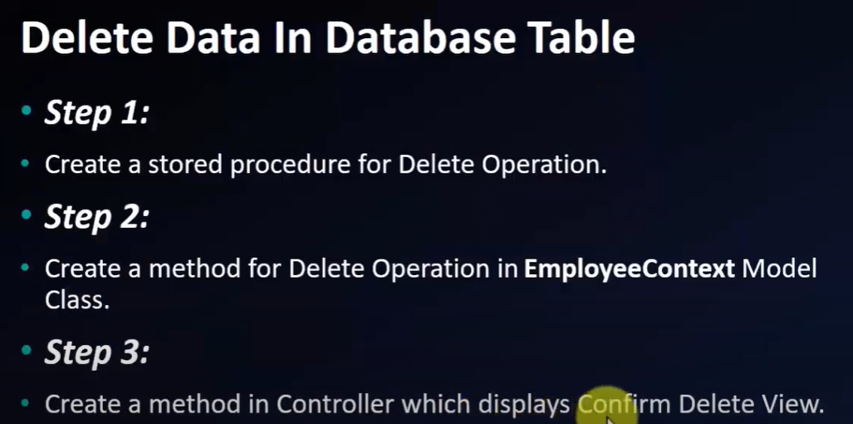

===========================================================================



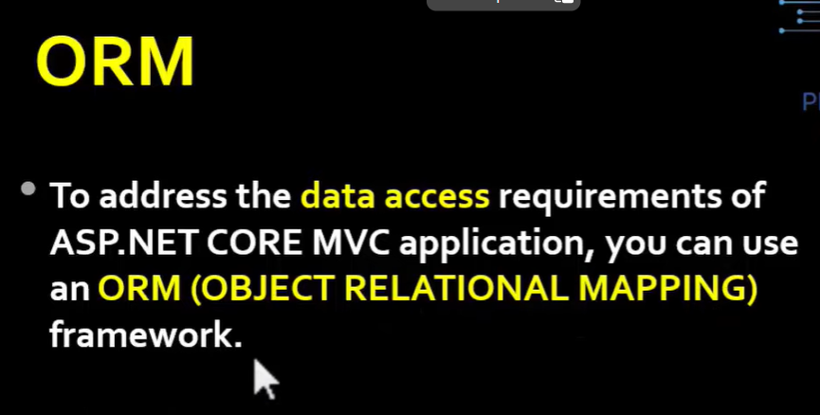

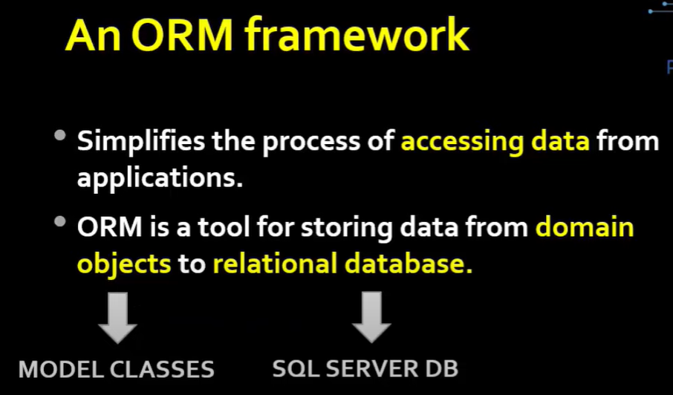

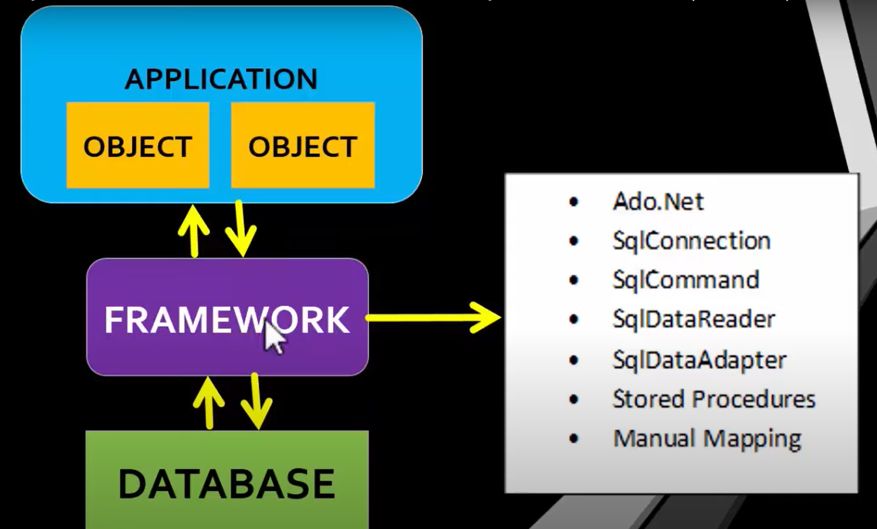

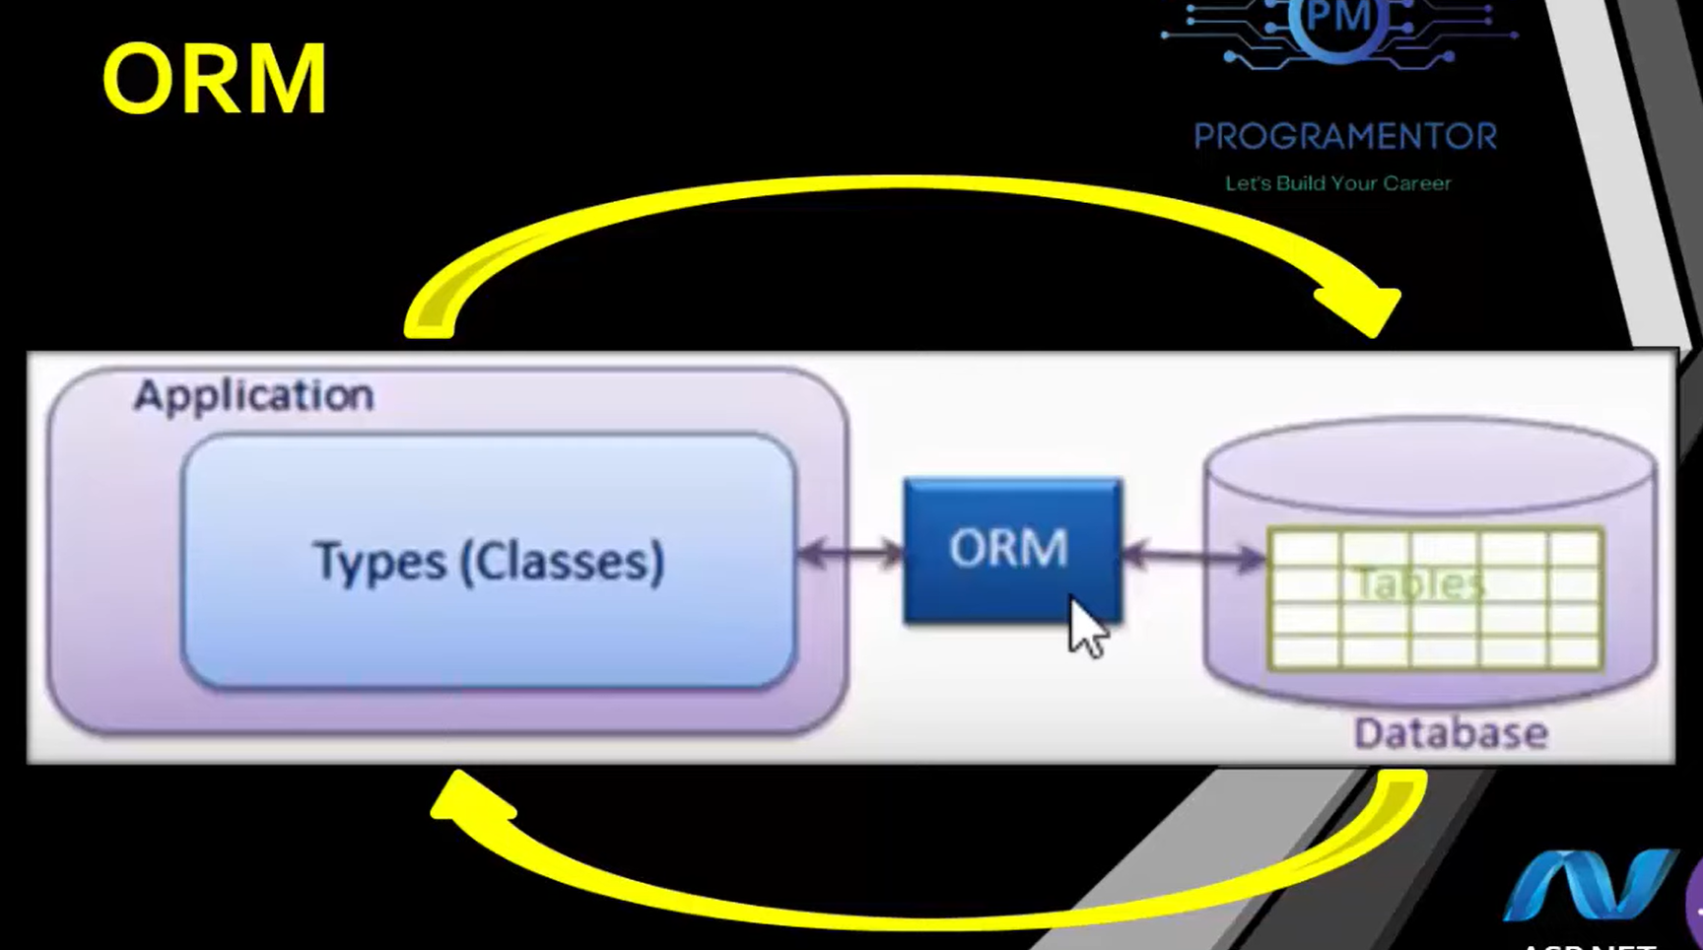

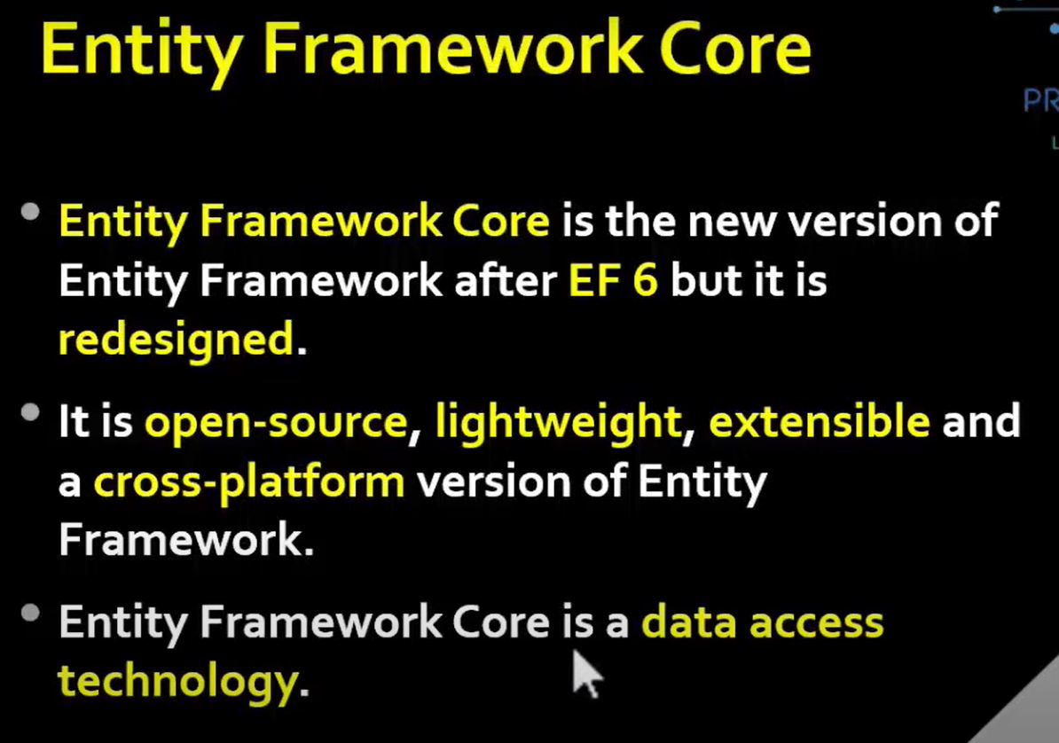

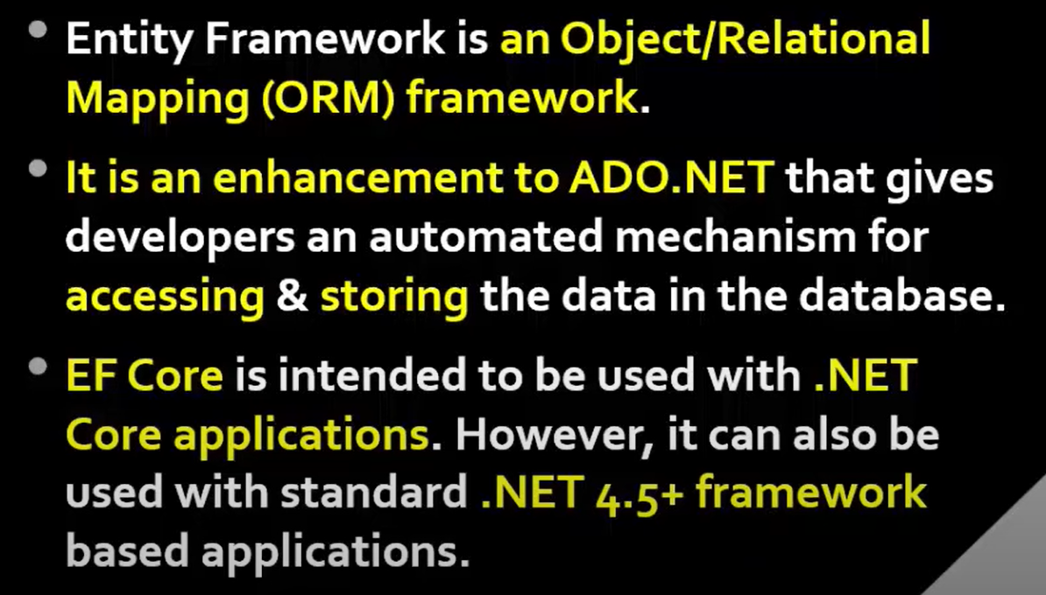

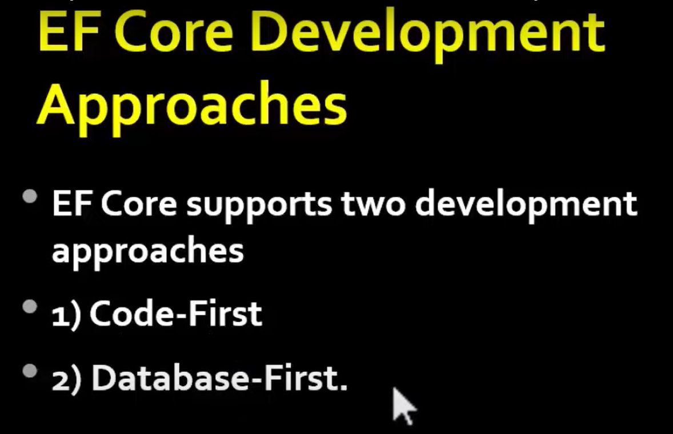

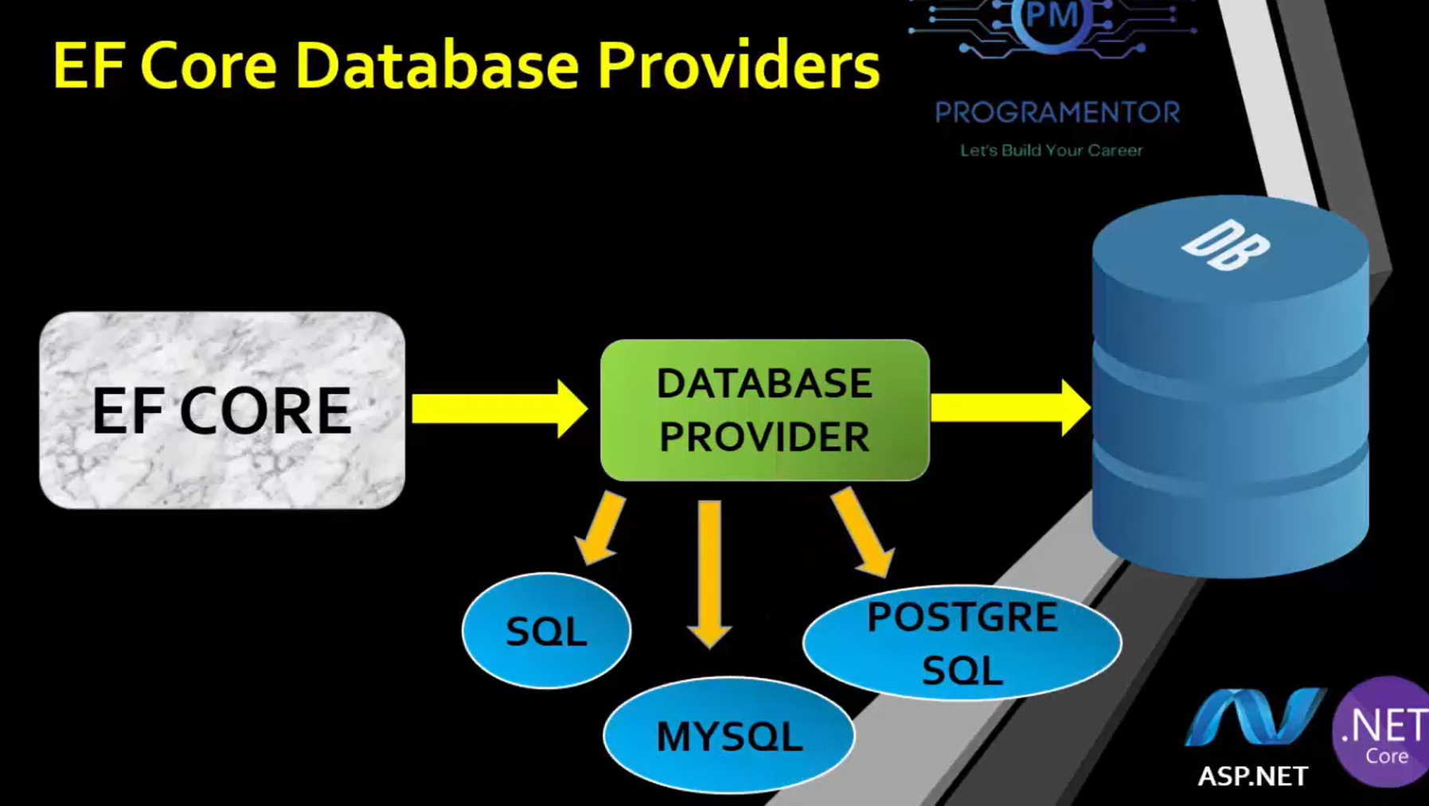

===========================================================================



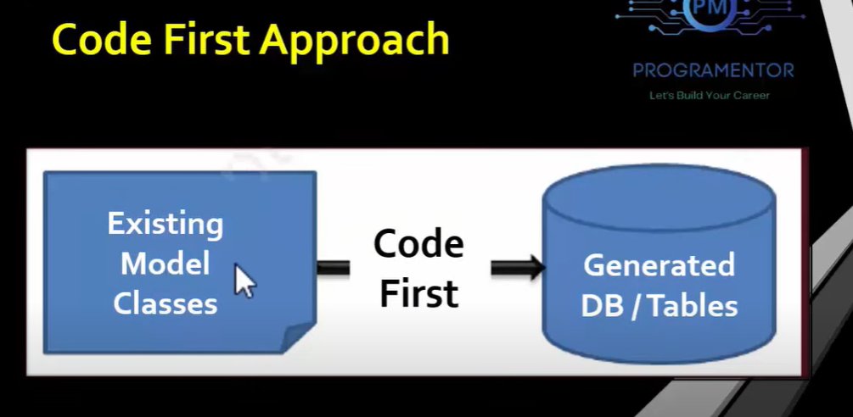

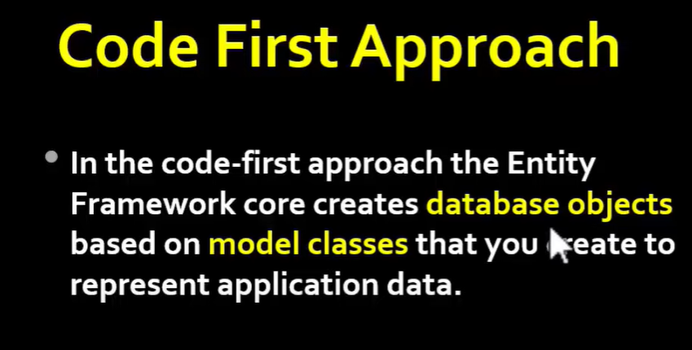

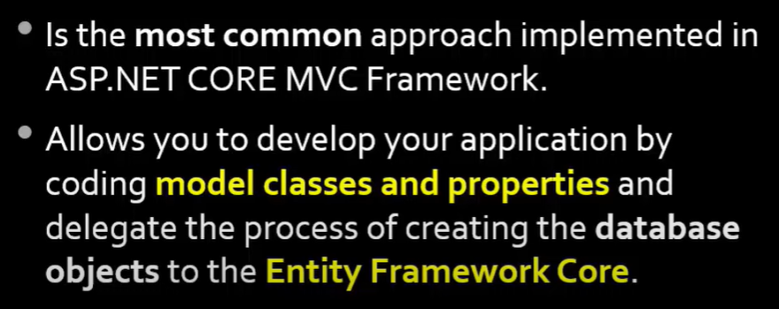

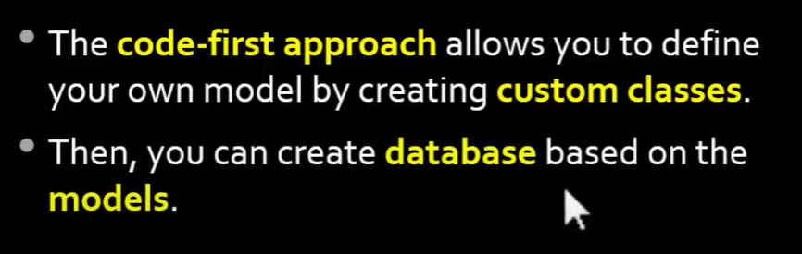

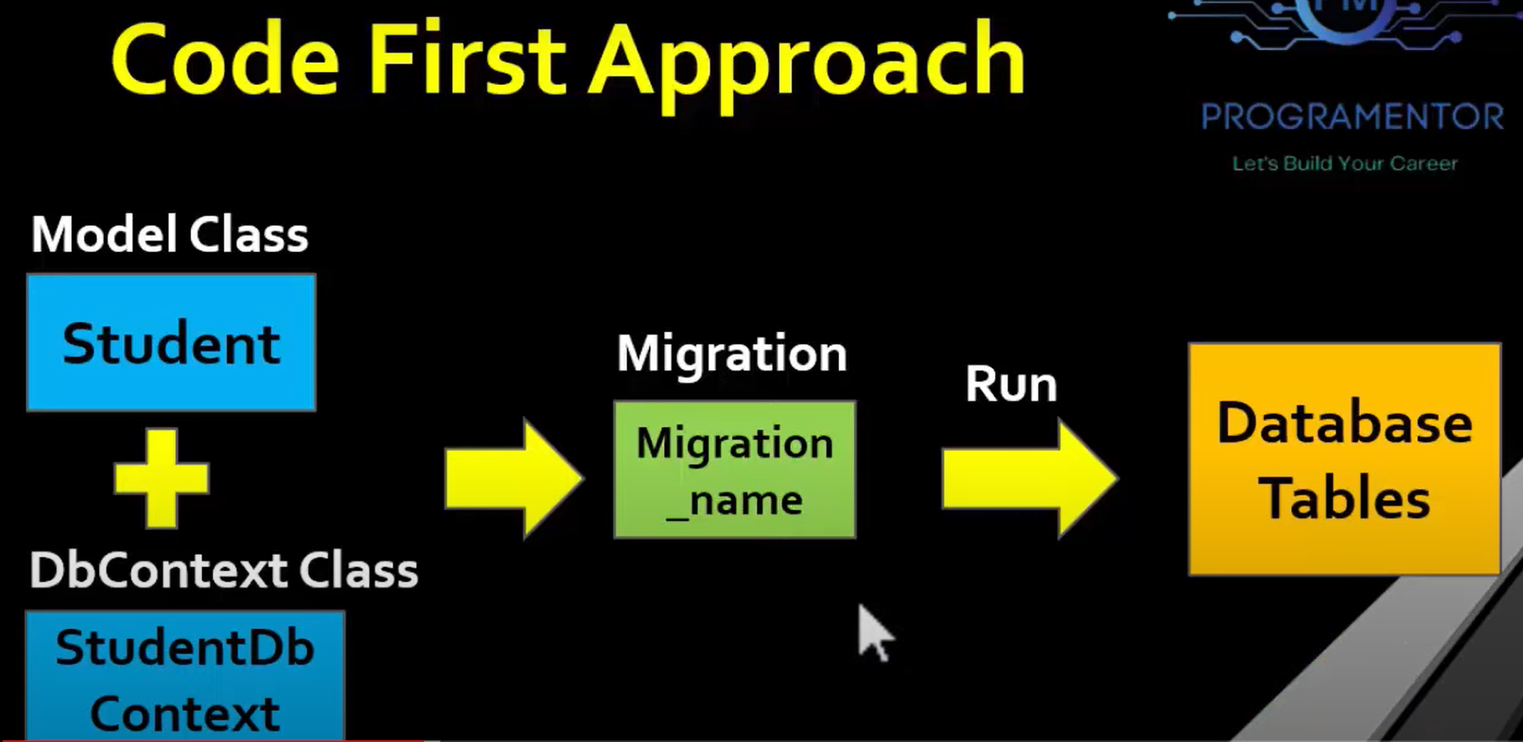

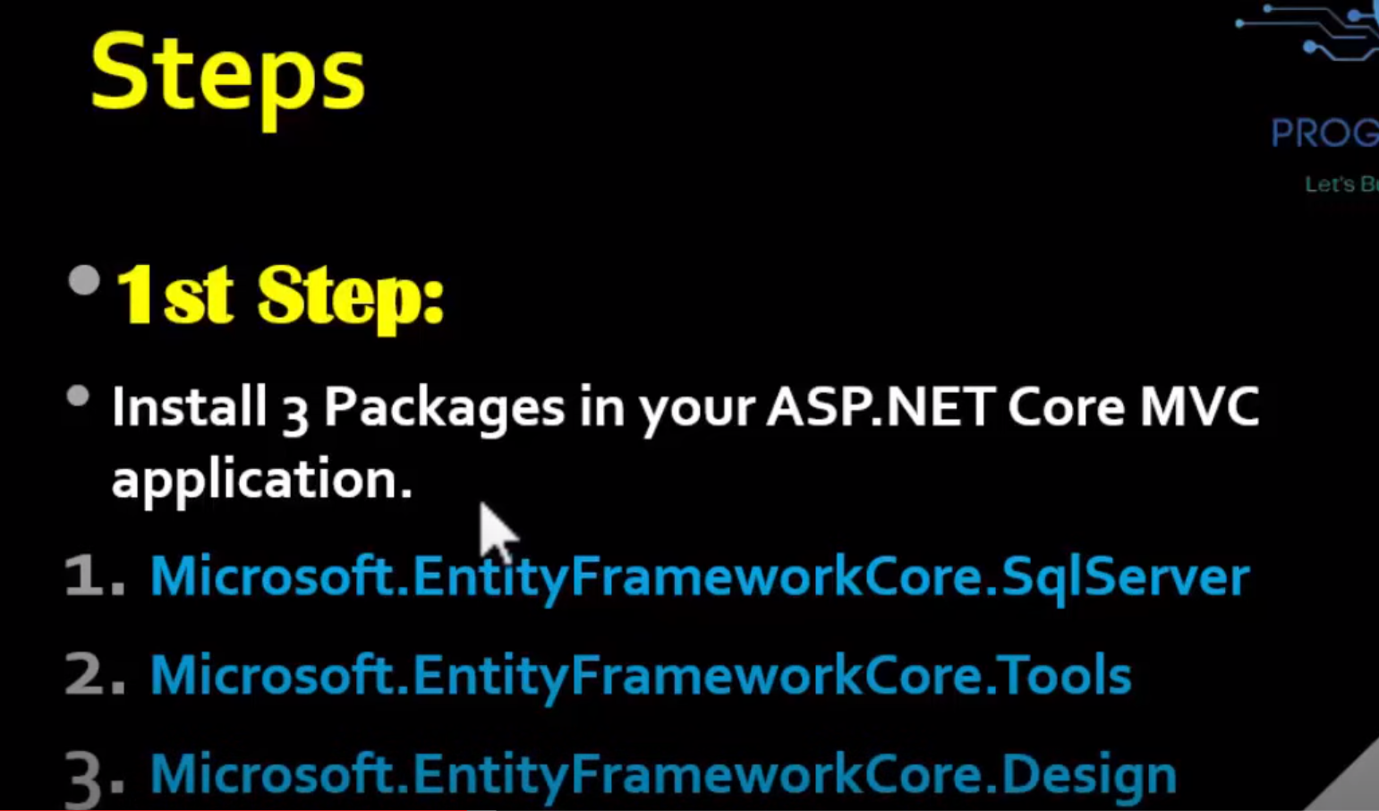



Scaffold: Automatic generation code like View code of insert, Delete, Update and Read.

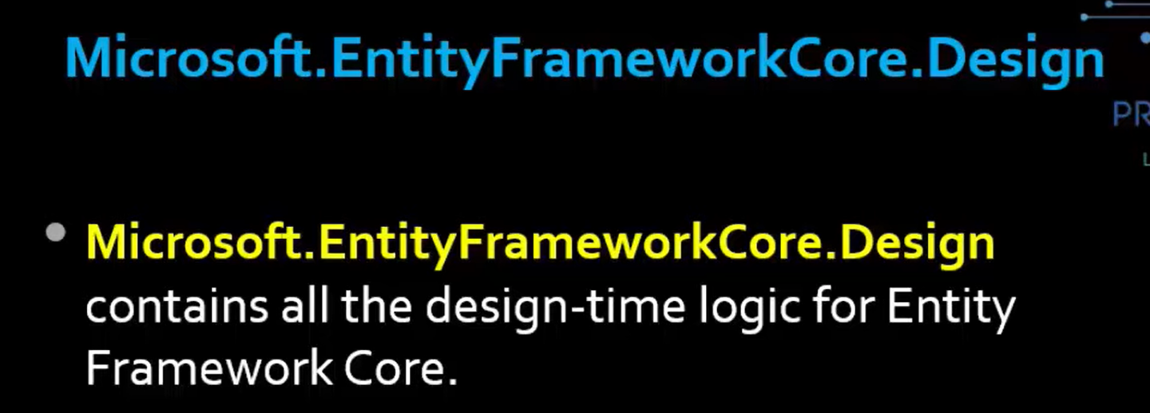

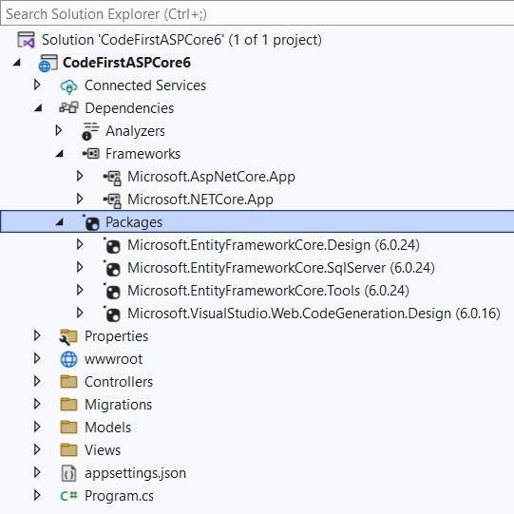

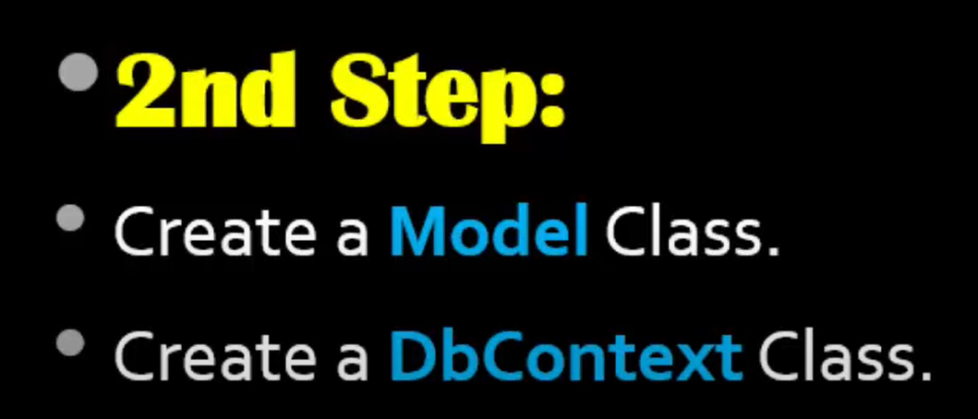

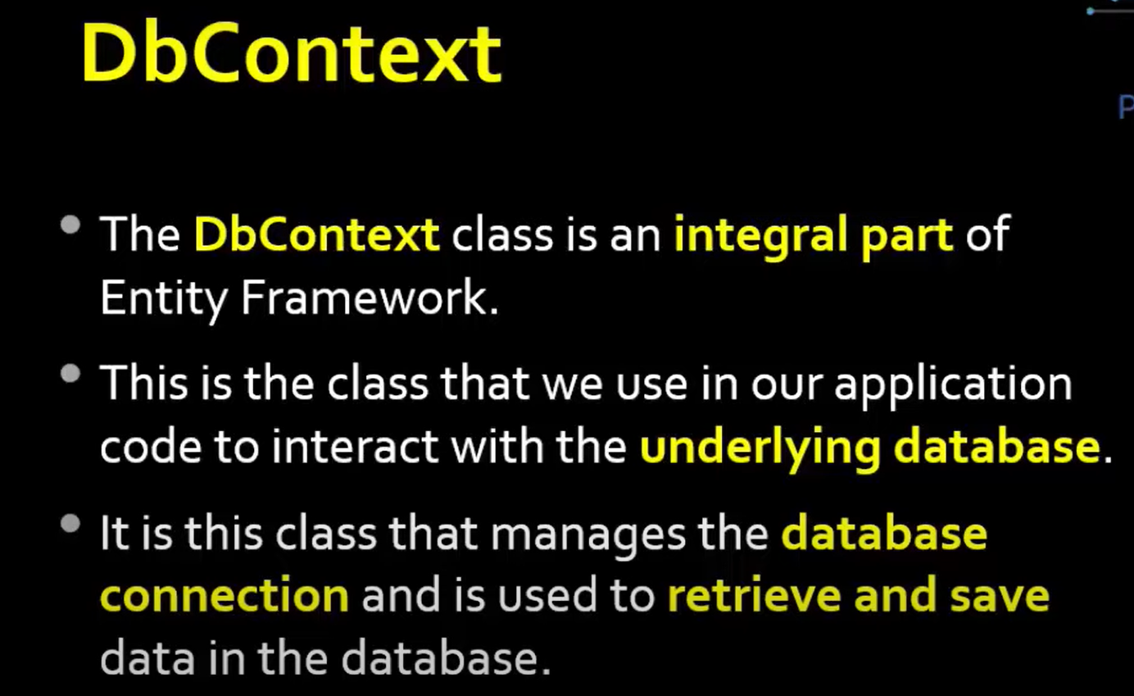

Integral part: Important part

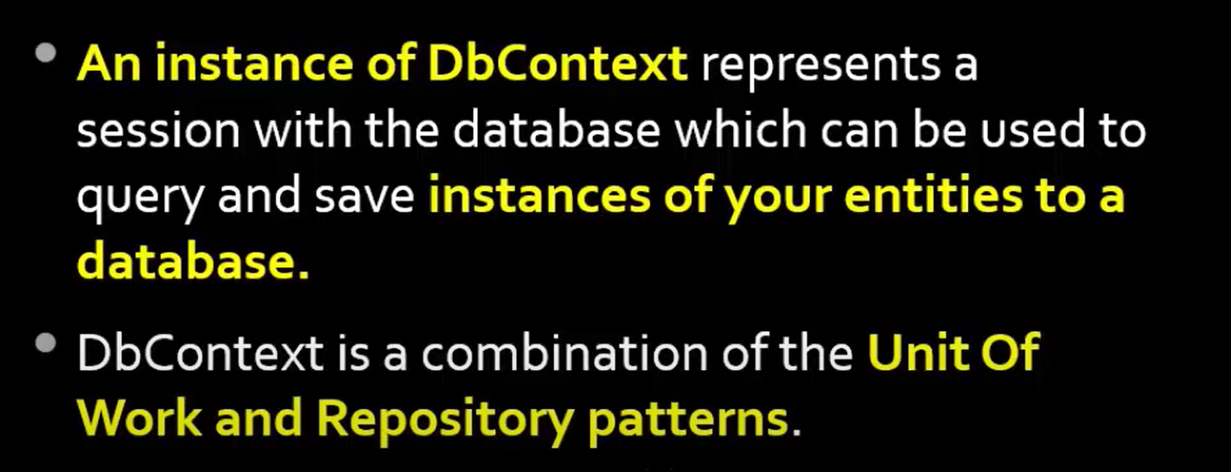

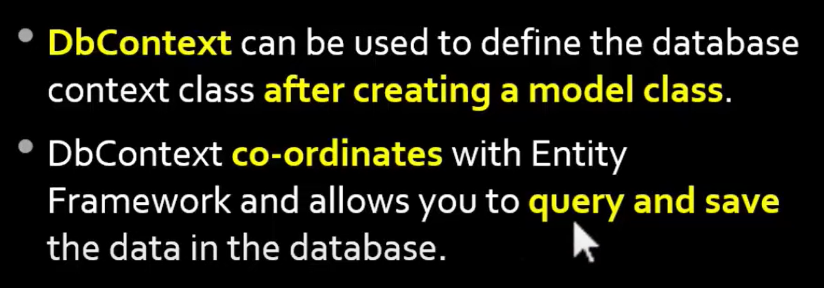

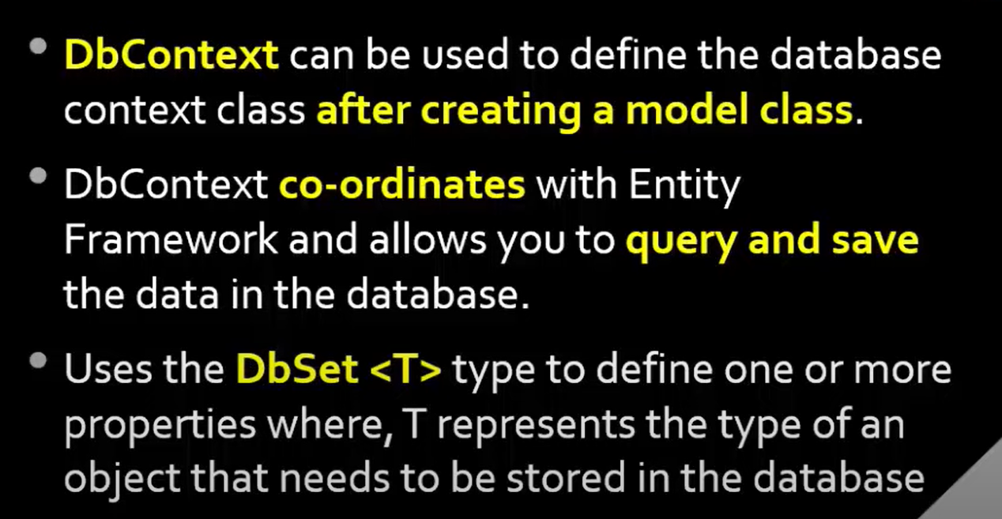

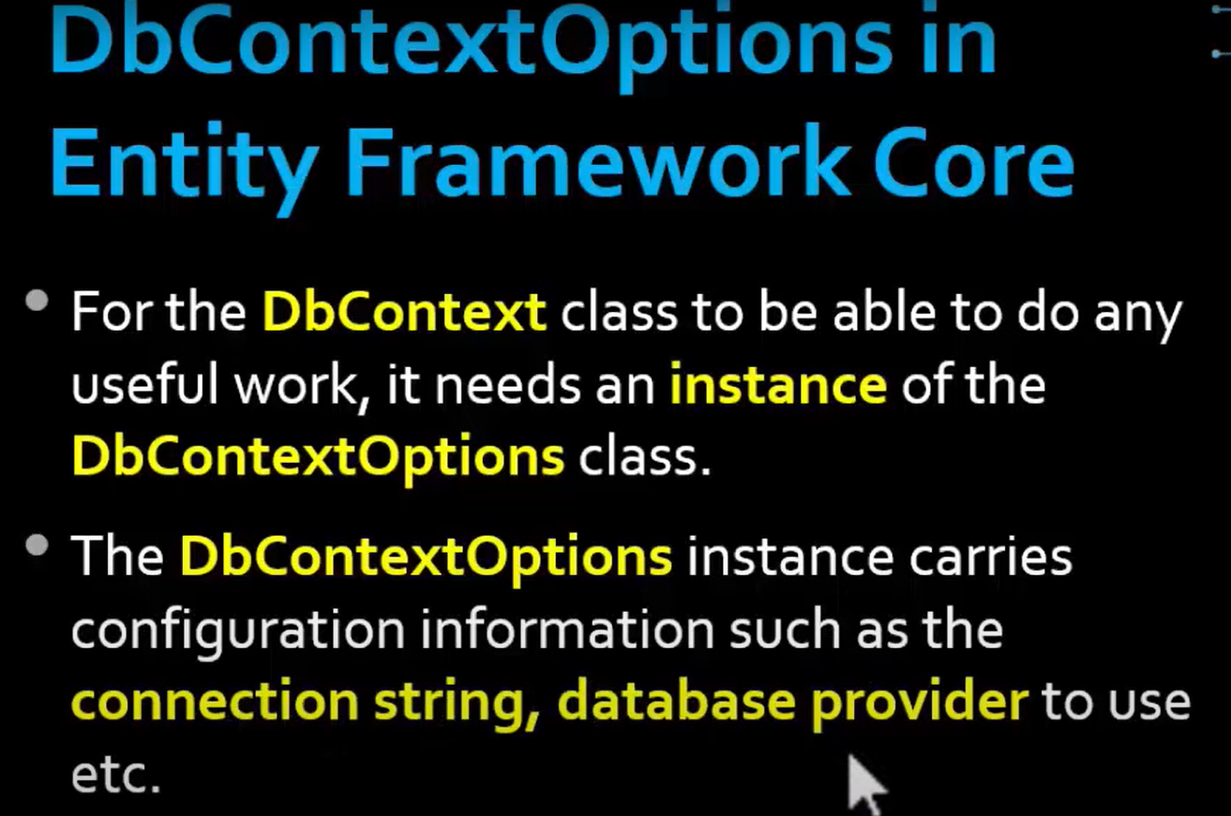

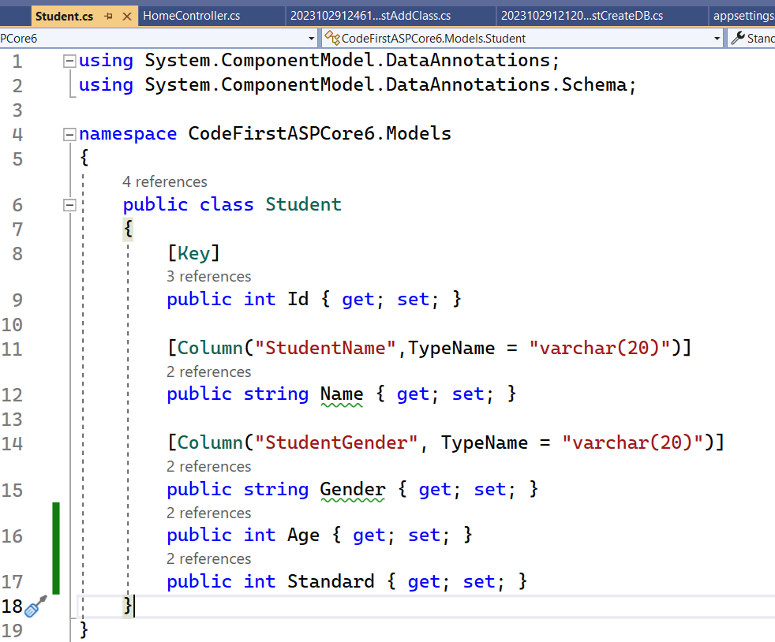

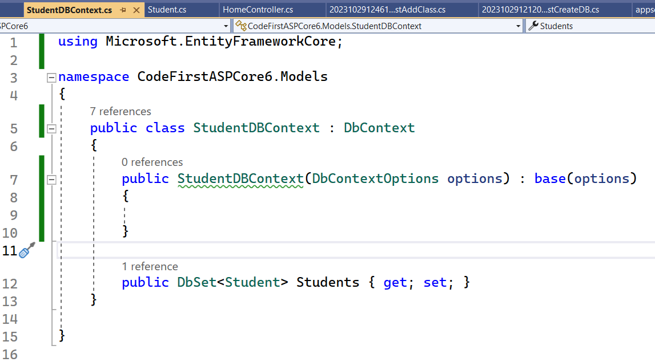

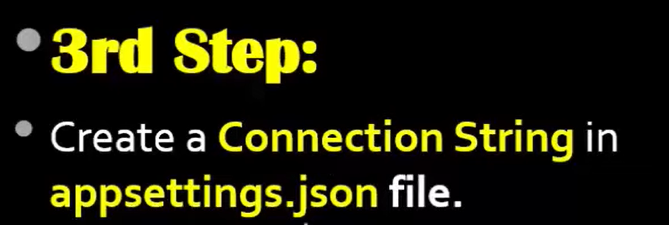

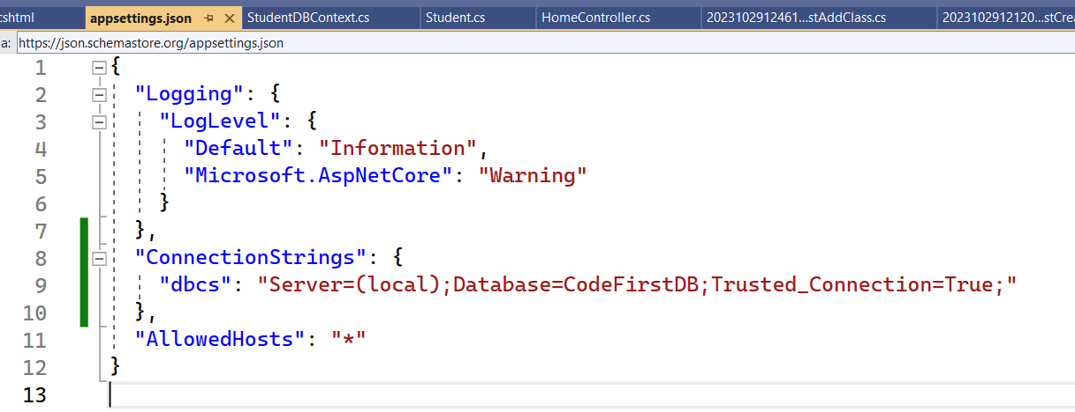

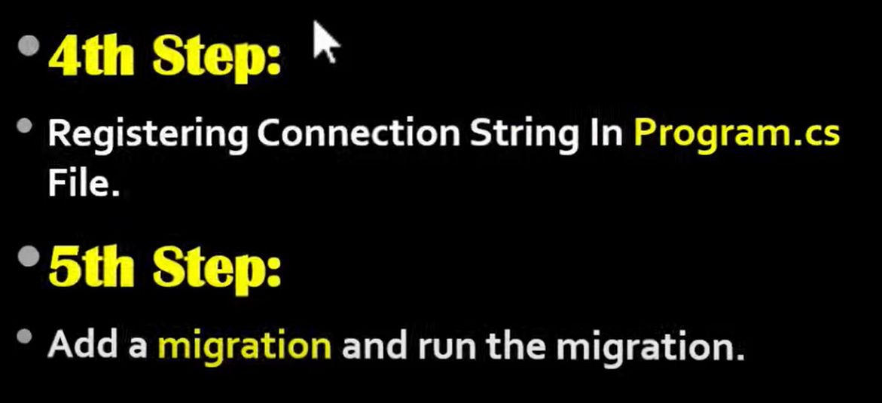

* add-mirgration MigrationName like CodeFirstCreateDB
* update-database

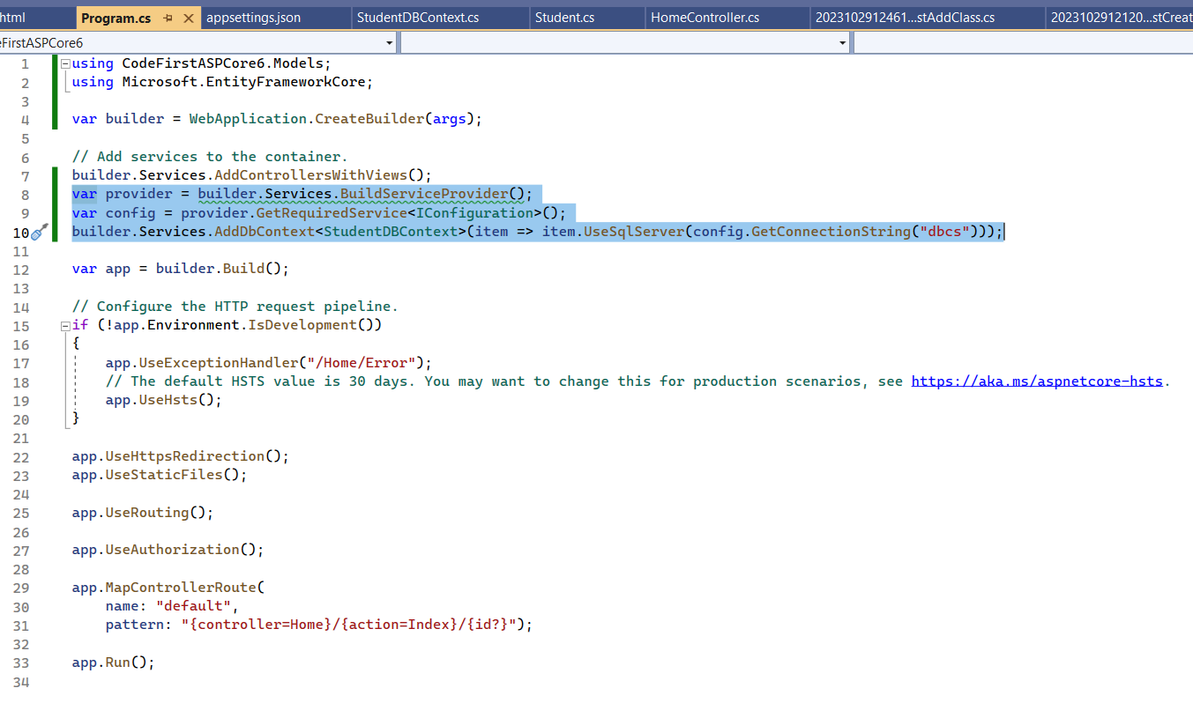

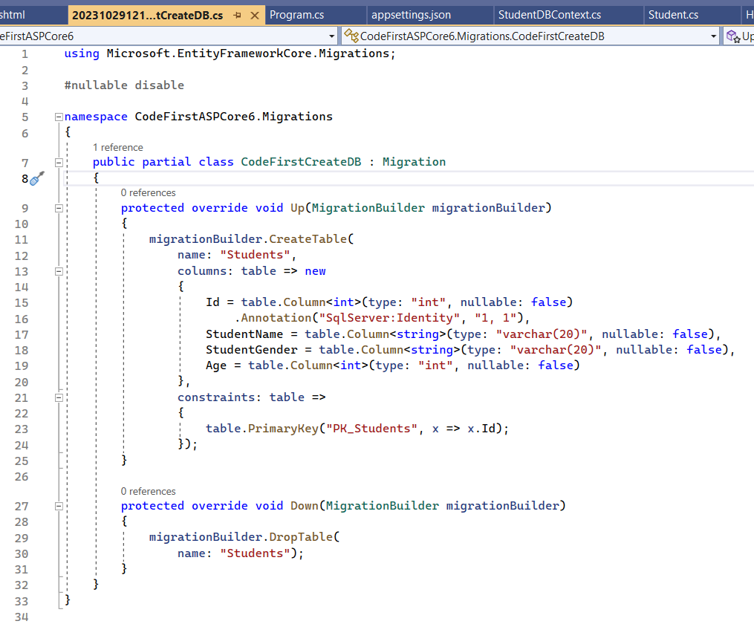

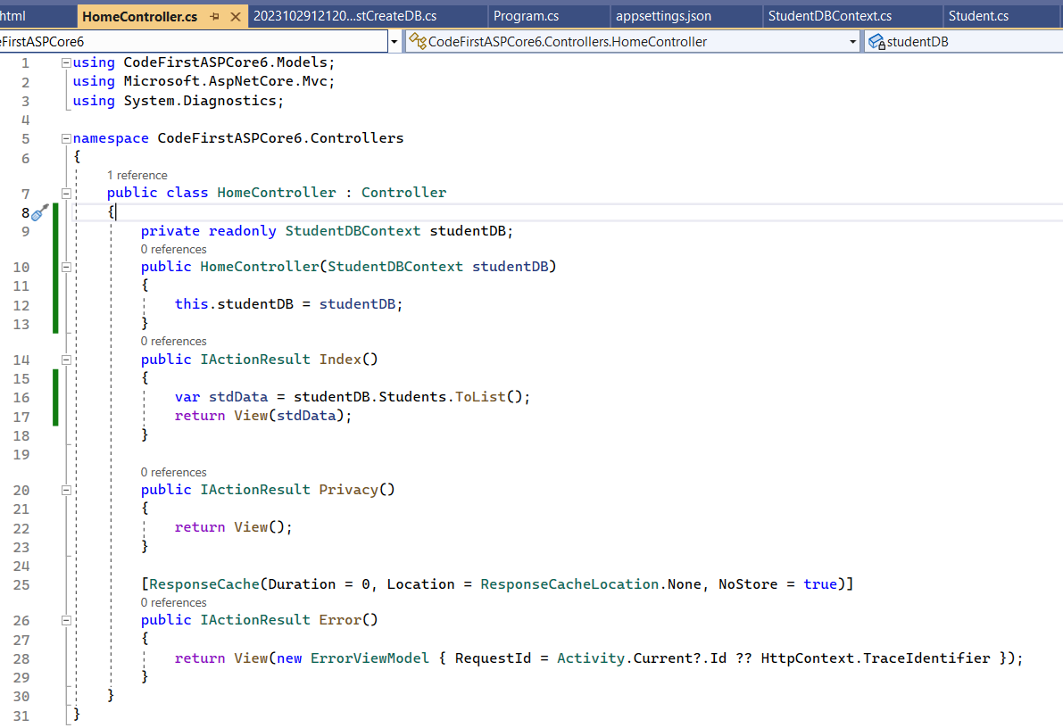

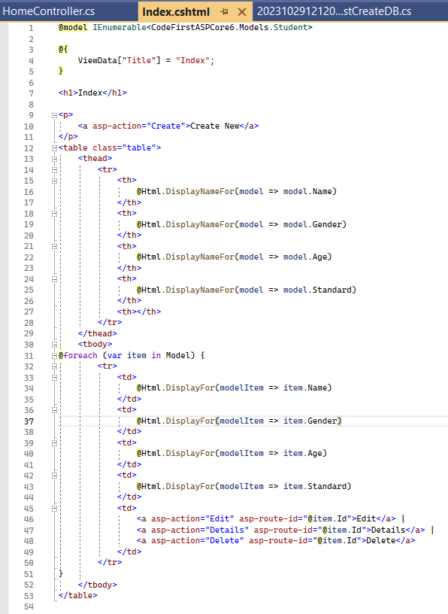

===========================================================================

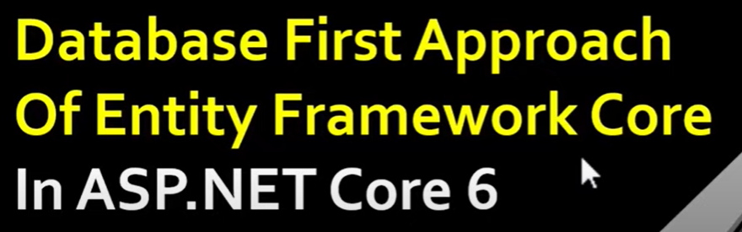

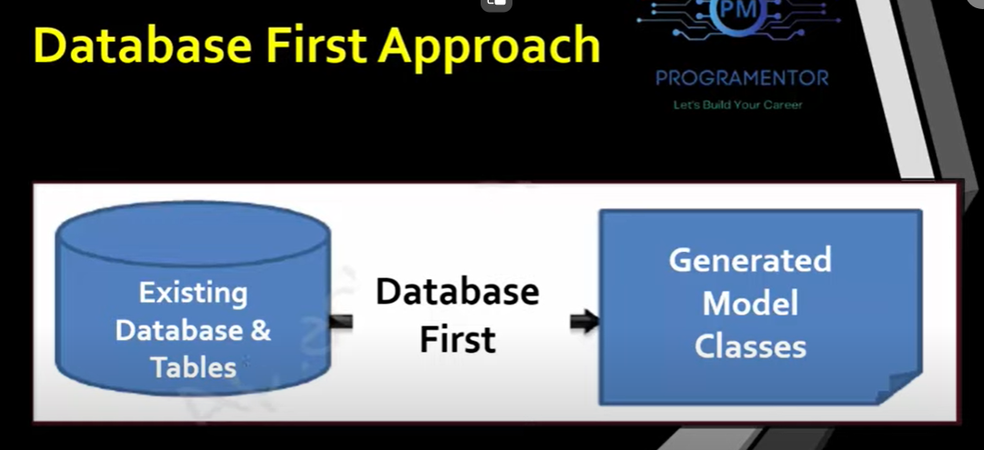

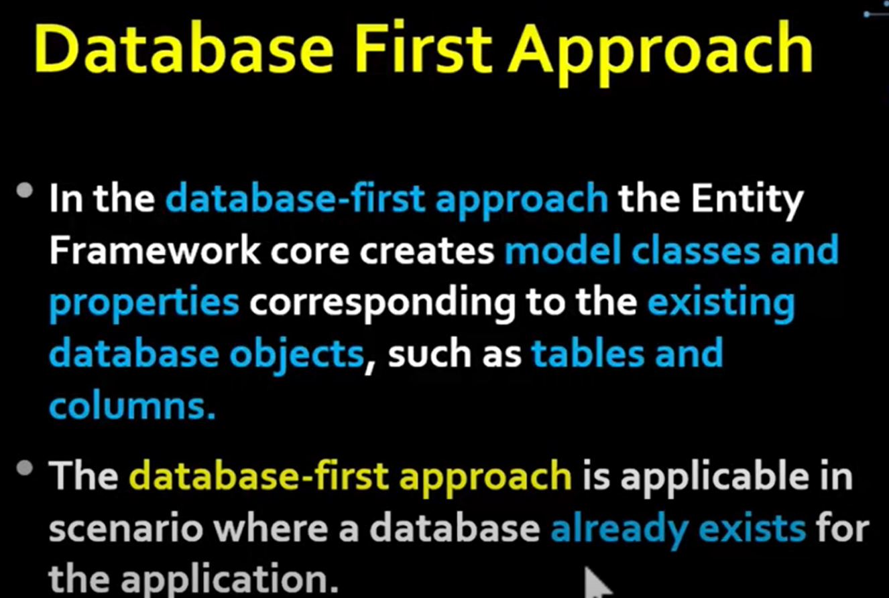

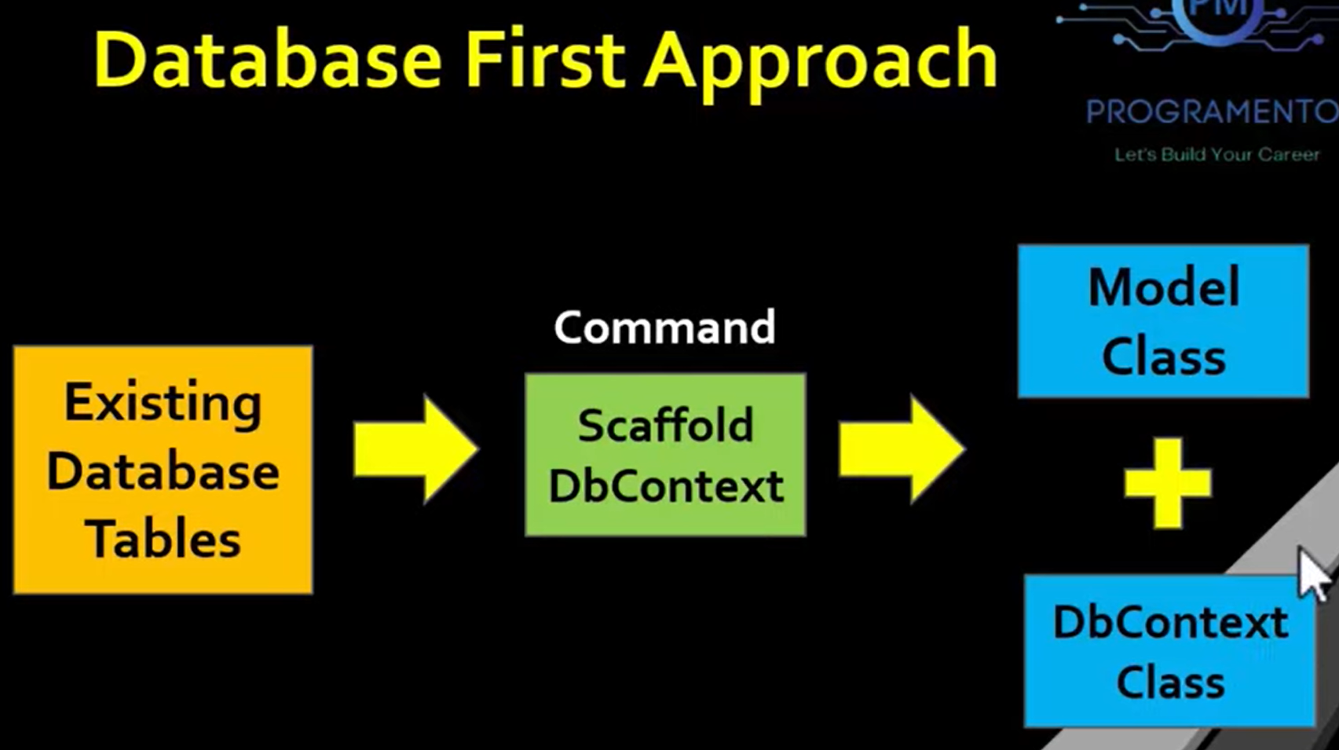

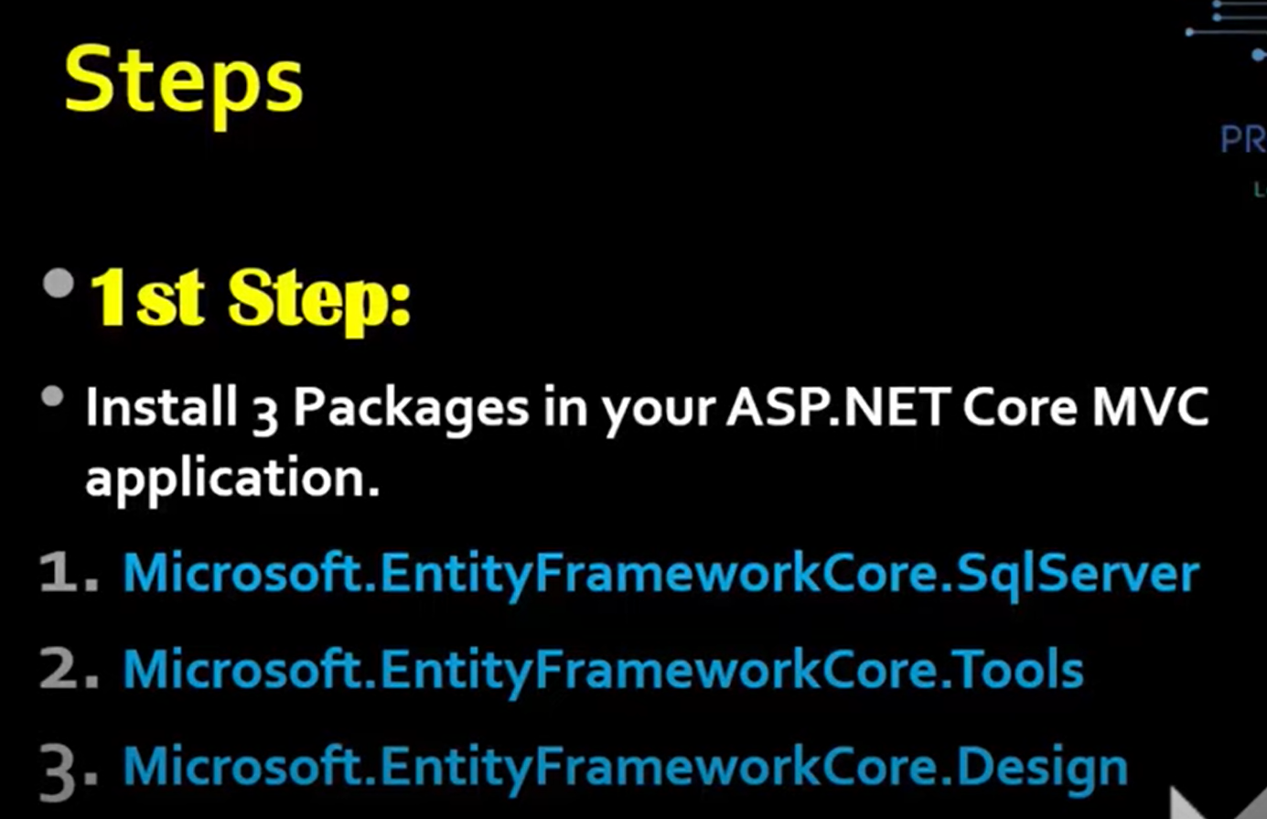

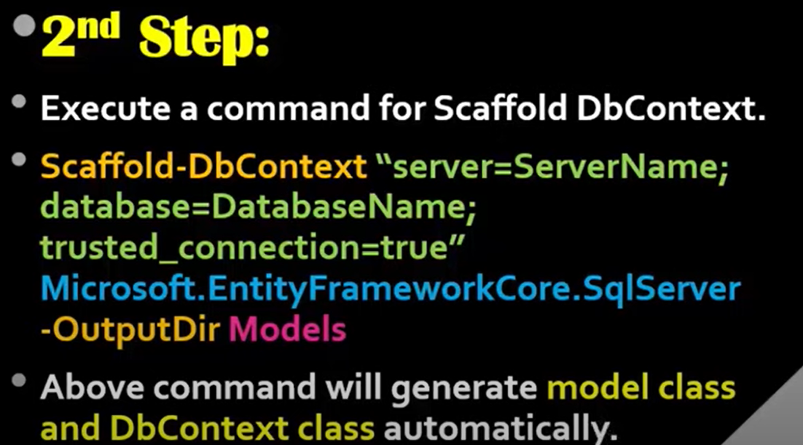

* Scaffold-DbContext"server=(local);database=CodeFirstDB;trusted_connection=true;" Microsoft.EntityFrameworkCore.SqlServer -OutputDir Models

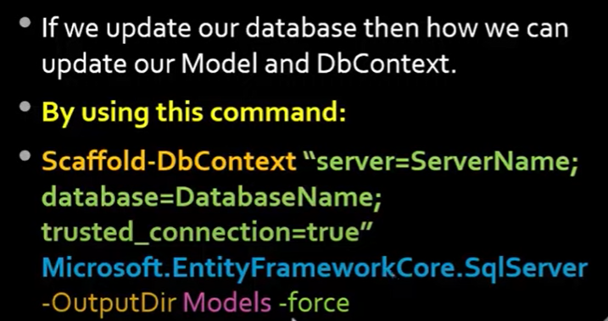

* Scaffold-DbContext"server=(local);database=CodeFirstDB;trusted_connection=true;"

Microsoft.EntityFrameworkCore.SqlServer -OutputDir Models -force

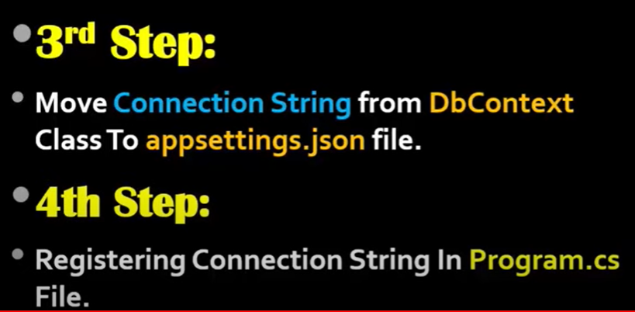

===========================================================================

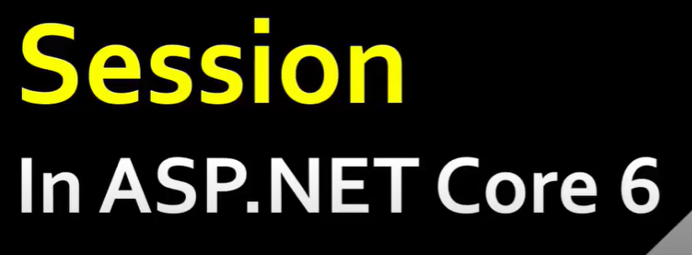

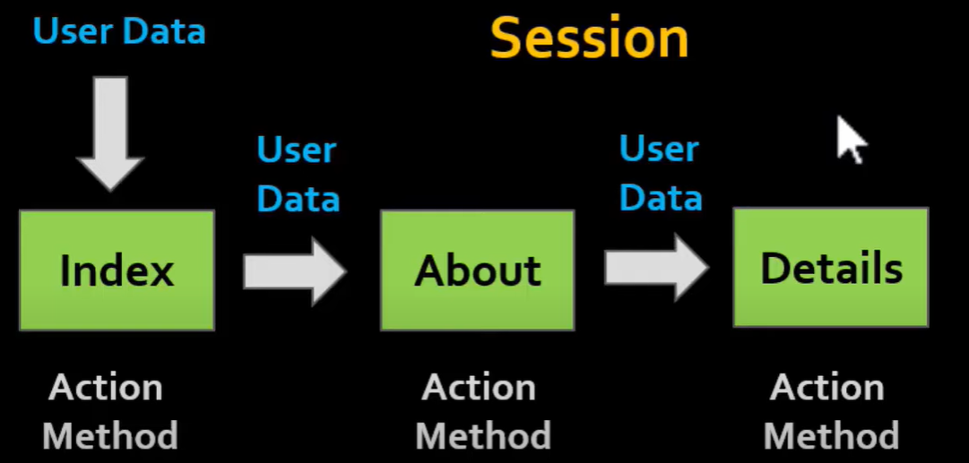

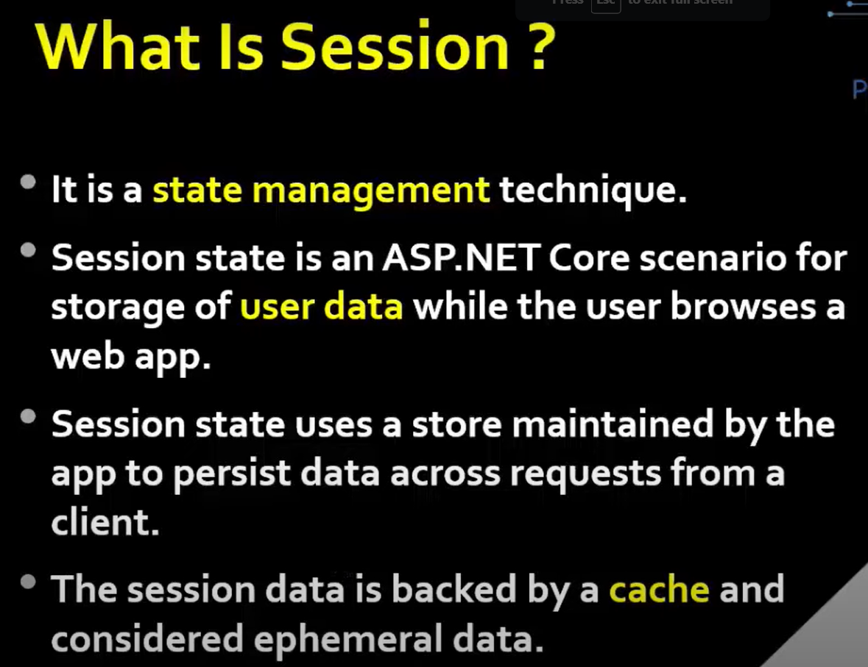

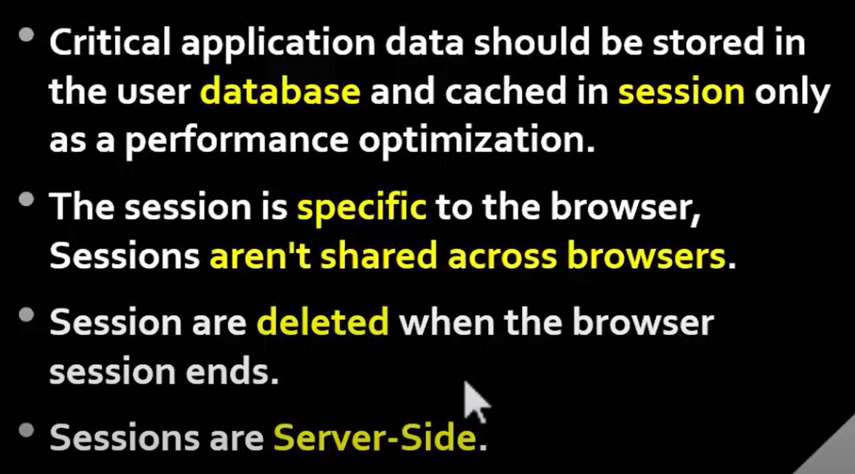

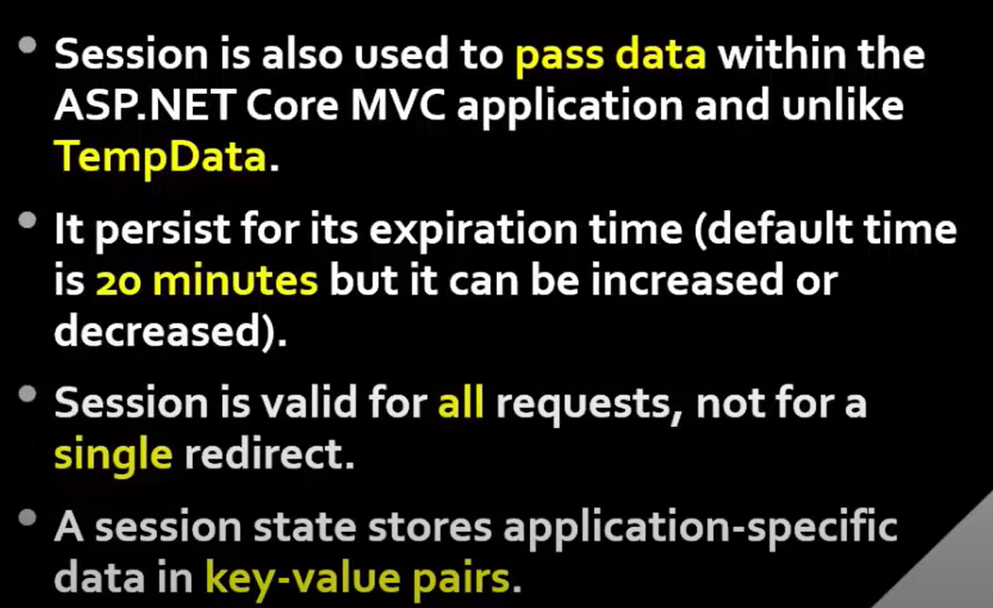

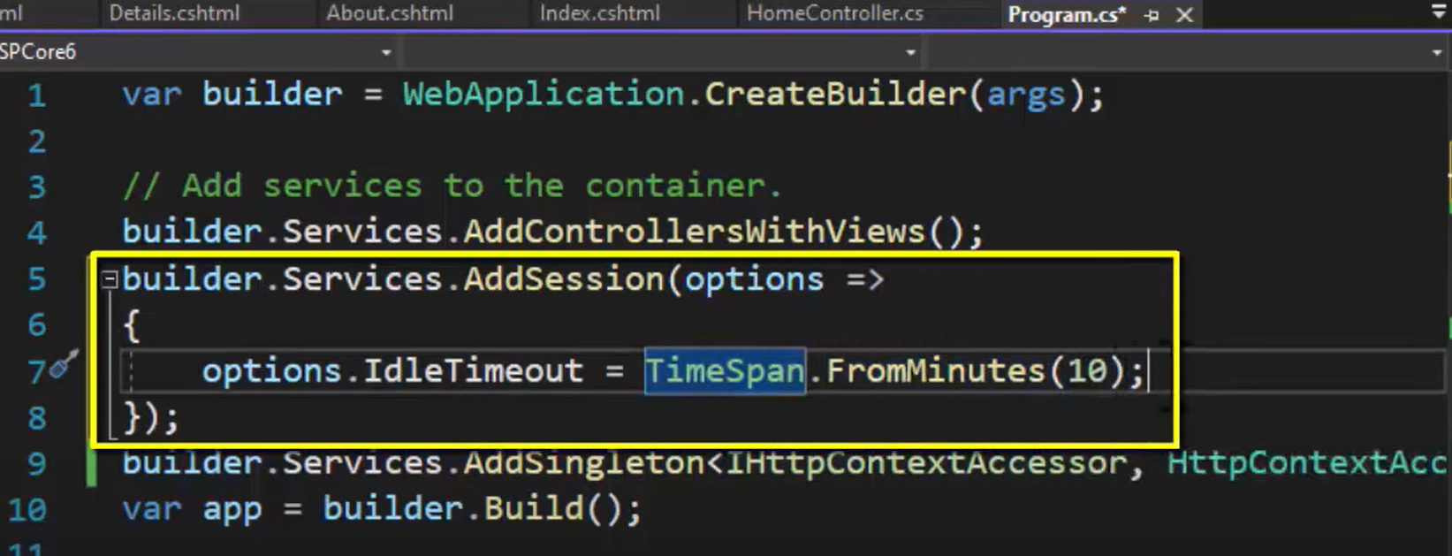

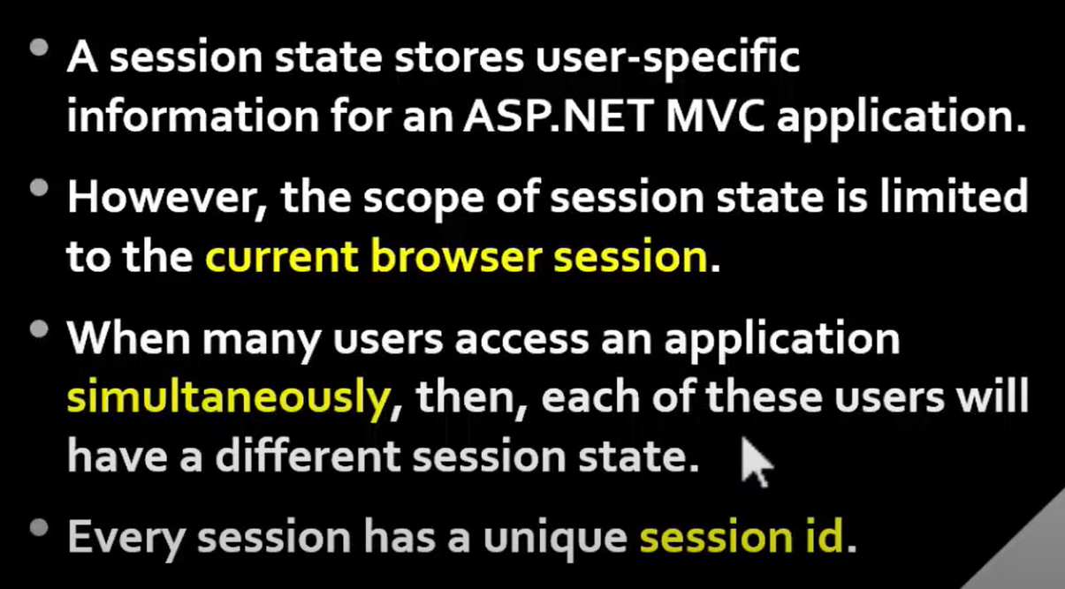

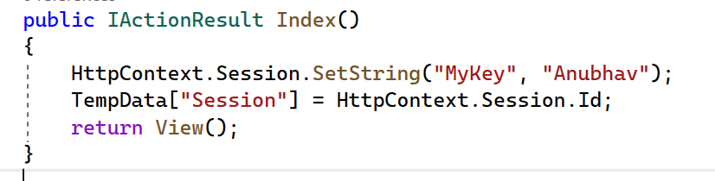

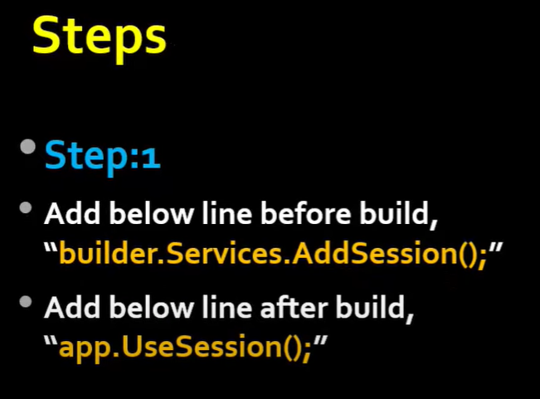

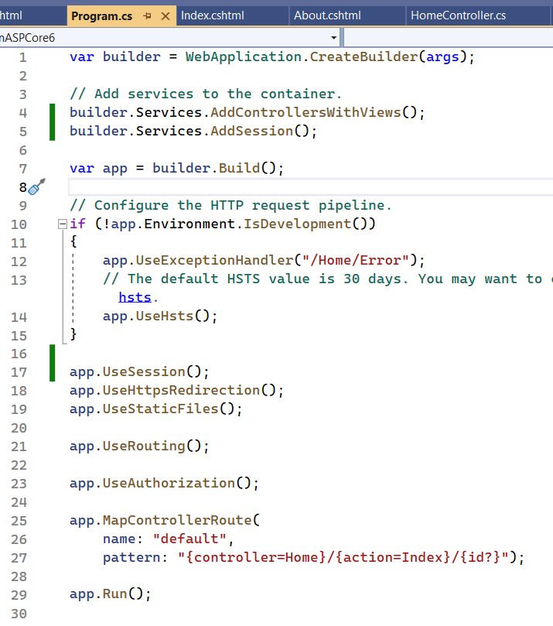

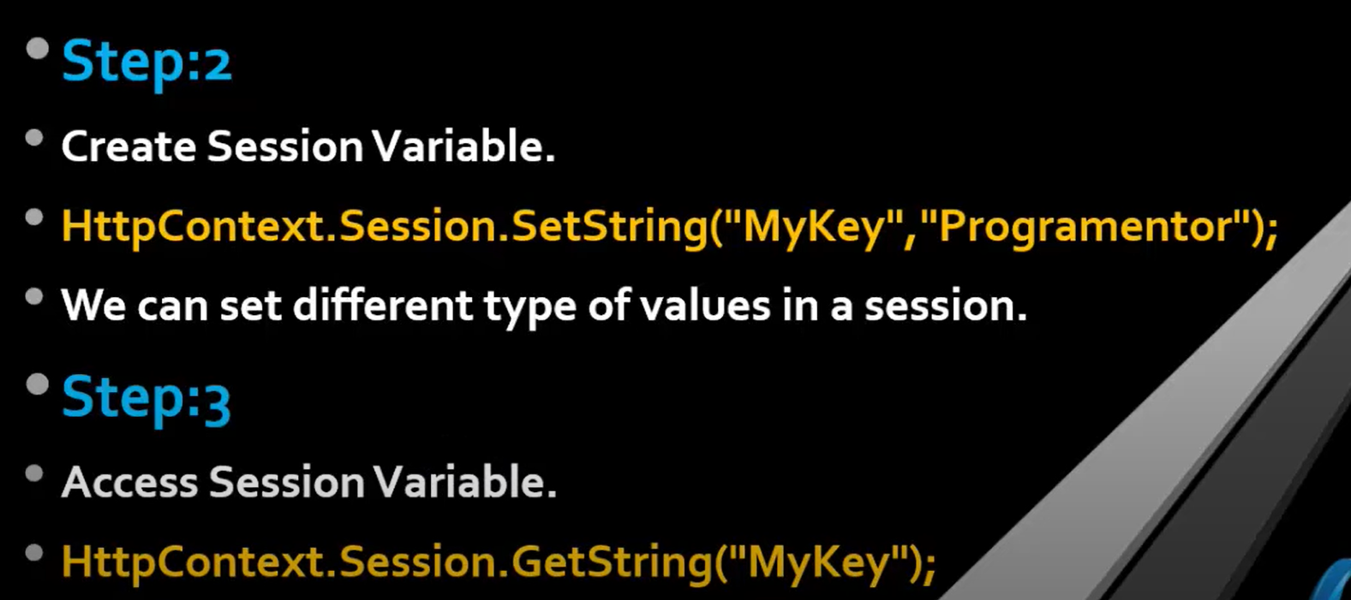

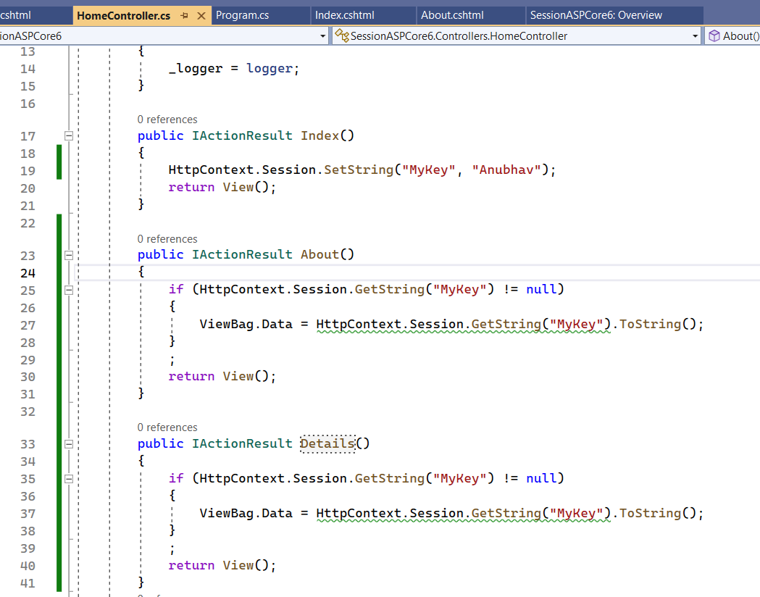

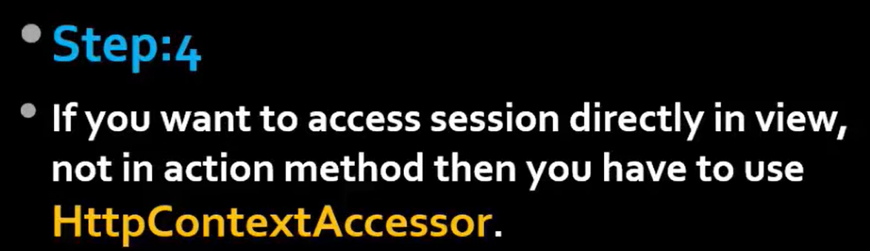

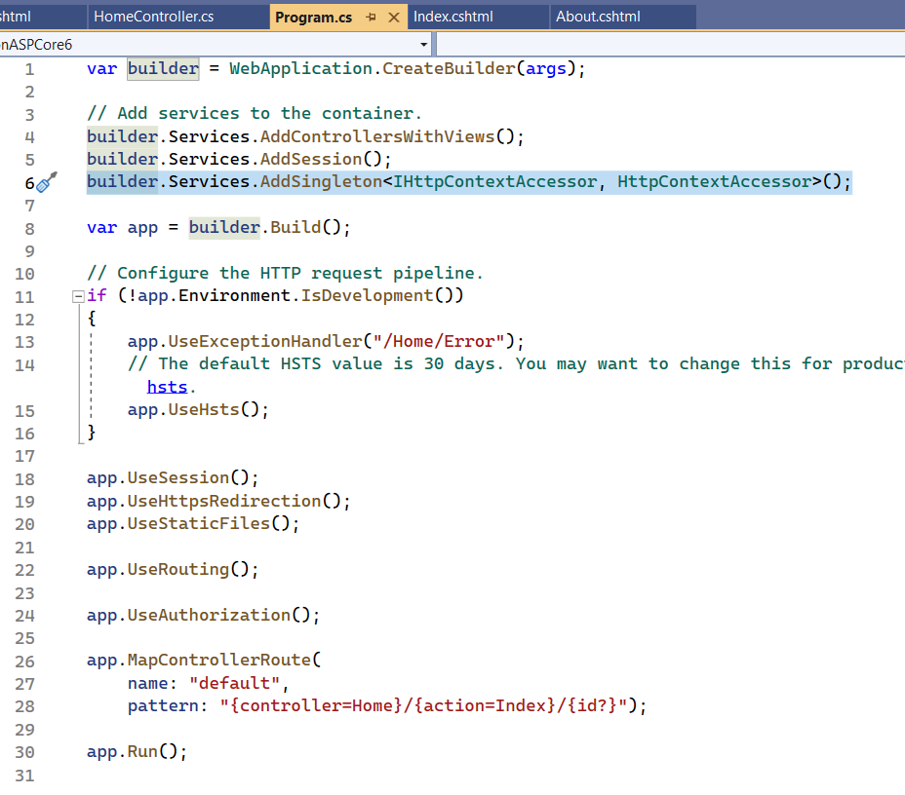

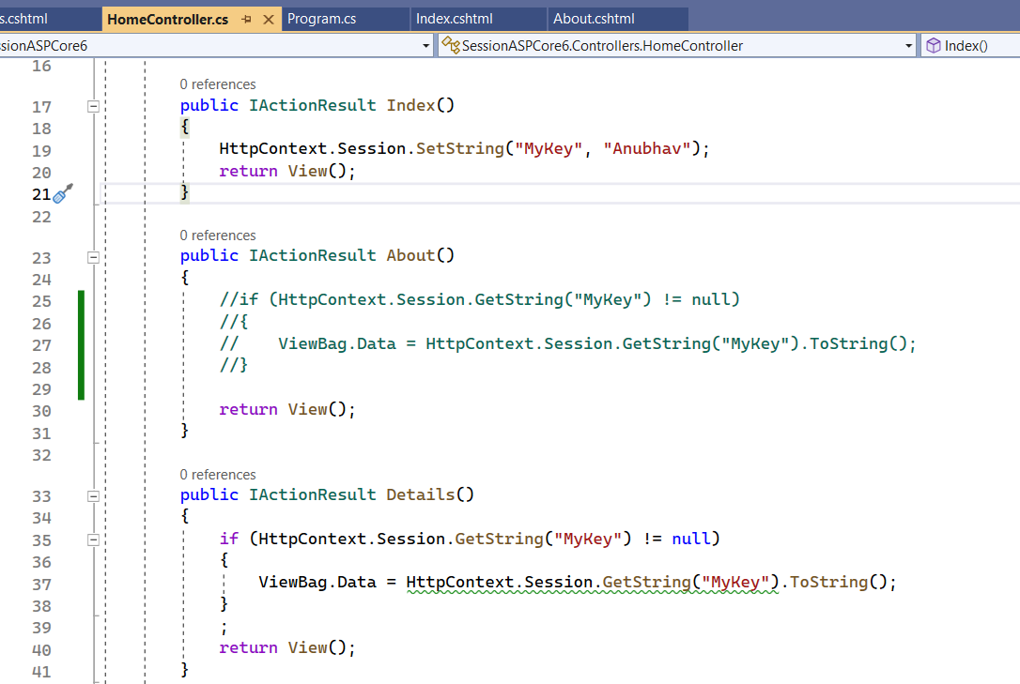

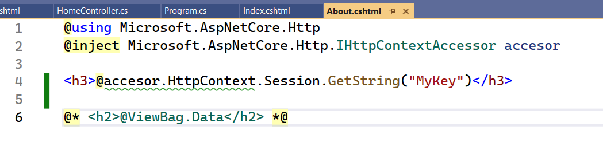

===========================================================================

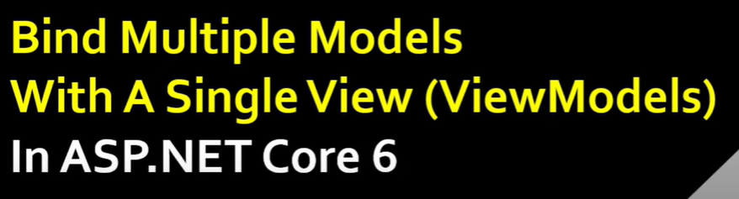

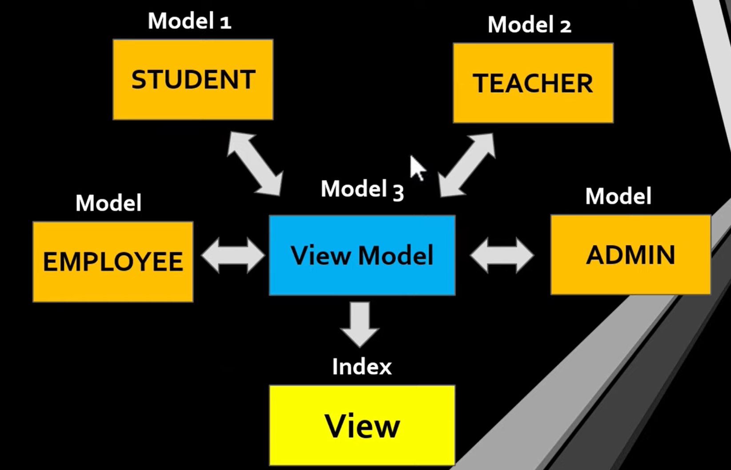

**Extra Material**

ENum (enumeration): collection of constant like month, date.

DataRow: Hold the data of whole single row.

Sealed Class: We can not create child class this class.

IEnumerable: Get the List Collection.